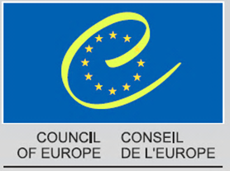

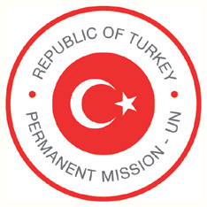

**Stop Violence against Women**

**by Implementing International Standards**

A Side Event at the 23rd Session of the UN Human Rights Council

co-organised by the Council of Europe and the Permanent Mission of Turkey

to the United Nations Office at Geneva

30 May 2013, 1.15 – 3.00 pm

Geneva, Conference Room XVI

Building A, 5th Floor, Access by elevators on the right and left side of the Assembly Room

(*sandwiches and refreshments will be served as of 12.45 pm*)

Violence against women is one of the most flagrant violations of human rights; an issue which concerns all countries in the world. It touches women from all walks of life, irrespective of cultural, religious, economic, social or geographical backgrounds. It happens everywhere: in the “safety” of their own homes, at work, in the streets and in the media among others. Every day, women are stalked, harassed, raped, mutilated, forced by their family to enter into a marriage, sterilised against their will or psychologically and physically abused. The examples of violence against women are endless, its victims countless. Many women are too afraid or ashamed to seek help, often paying for their silence with their lives. Those that do speak out are not always heard. With the adoption of the Istanbul Convention in 2011, the 47 member States of the Council of Europe made an important step towards the recognition of their responsibilities in addressing this concern.

The objective of the side event will be to present the Council of Europe Convention on preventing and combating violence against women and domestic violence (Istanbul Convention) as a global tool to end gender based violence.

**Keynote speakers:**

* **Ms Marja Ruotanen,** Director, Justice and Human Dignity Directorate, Council of Europe
* **Ms Mona Rishmawi**, Chief, Rule of Law, Equality and Non-Discrimination Branch, Office of the High Commissioner for Human Rights
* **H.E. Mr Oğuz Demiralp,** Ambassador Extraordinary and Plenipotentiary, Permanent Representative of Turkey to the United Nations Office at Geneva
* **Ms Gauri van Gulik**, Global Advocate, Women's Rights Division, Human Rights Watch

**Discussion**

******

**Moderator:** **H.E. Petru Dumitriu**, Ambassador, Permanent Observer of the Council of Europe to the United Nations Office at Geneva

**Council of Europe Convention on preventing and combating violence against women and domestic violence (Istanbul Convention)**

Opened for signature in May 2011, the Istanbul Convention is the first legally binding instrument in Europe to prevent and combat violence against women and domestic violence. In terms of scope, it is the most far-reaching international treaty to tackle this serious violation of human rights.

Preventing violence, protecting its victims and prosecuting the perpetrators are the cornerstones of the Convention, as is the requirement to co-ordinate any such measures through comprehensive and integrated policies. The Convention covers victims from any background, regardless of their age, race, religion, social origin, migrant status or sexual orientation.

The Istanbul Convention was drafted in Europe, but is not meant for Europe only. Any state can accede to it or use it as a model for national and regional legislation and policies.

The Istanbul Convention will enter into force following its ratification by 10 countries. An independent group of experts (GREVIO) will monitor the implementation of the Convention.

32012 GBR 2026 Logoviolence 55X25 Violence against Women and Domestic Violence

Council of Europe

F-67075 Strasbourg Cedex

[www.coe.int/conventionviolence-geneva2013](http://www.coe.int/conventionviolence-geneva2013)

[www.coe.int/conventionviolence](http://www.coe.int/conventionviolence)

[conventionviolence@coe.int](mailto:conventionviolence@coe.int)