人权理事会
第八届会议
议程项目3

增进和保护所有人权、公民、政治、经济、
社会和文化权利，包括发展权

人权与跨国公司和其他工商企业问题
秘书长特别代表的报告

增 编*

公司与人权：指称的涉及公司的侵犯
人权行为范围与形式调查**

内 容 提 要
本报告对指称的与公司有关的侵犯人权行为，对其范围和表现形式做了概述，这些侵犯人权行为选自2005年2月至2007年12月期间企业与人权资料中心网页上登出的320起案件。对案件的归纳显示，所有工业部门据称都对人权有影响，并且据称这种影响发生在所有地区。
对指称的侵权行为，从受到影响的权利入手进行了研究，对照了《世界人权宣言》、《公民权利和政治权利国际公约》、《经济、社会、文化权利国际公约》，和国际劳工组织的一些基本公约所载的权利。还提出了对环境的破坏问题，因为环境的破坏常常引发损害人权的指控。对有关腐败的指控也没有放过，腐败可妨碍实现各项人权。此外，还对受到指称的侵犯人权行为影响的人做了辨认，并将他们归为三组：工人、社区和最终用户，即商品的消费者或服务对象。对公司卷入指称侵权行为的形式，也做了分类，标以“直接”(公司以直接的形式卷入指称的侵权行为)，或“间接”(公司以间接的形式卷入)。报告的第一章对调查结果作了概述。第二章提供了调查结果的进一步背景情况，包括每个部门的案例。

调 查 结 果
调查结果包括：
- 据称公司对所有各项人权都有影响(见以下受影响权利的清单)，包括公民权利和政治权利；经济、社会和文化权利；以及劳工权利；
- 劳工权利和非劳工权利都受到影响(见下表)；

受影响的劳工权利
结社自由 | 同工同酬权
组织和参加集体谈判的权利 | 享有工作平等的权利
不受歧视的权利 | 享受公正和合适报酬的权利
废除奴役制和强迫劳动 | 享有安全工作环境的权利
废除童工 | 休息和娱乐权
工作权 | 享有家庭生活的权利

受影响的非劳工权利
生命权、人身自由和安全权 | 和平集会权 | 享有适当生活水准的权利(包括衣、食和住房)
不受酷刑或残忍、不人道或有辱人格的待遇 | 结婚和组织家庭的权利 | 享有身心健康的权利；得到医疗服务的权利
得到法律平等承认和保护的权利 | 思想、良心和宗教自由 | 受教育权
受到公正审判的权利 | 持有见解、信息和表达自由权 | 参加文化生活的权利、从科学进步中受益和著作权受保护的权利
自决权 | 参加政治生活的权利 | 享有社会保障的权利
迁徙自由 | 隐私权

- 对权利的影响不是孤立的。一项指称的侵犯人权行为，往往会造成对多项人权的影响。例如，在有些情况下，指称的使用童工现象，会影响到受教育权，不受酷刑或残忍、不人道或有辱人格的待遇，而在另外一些情况下，儿童必须完成超出他们身体能力的工作，则影响到他们的健康权和生命权。
- 最初的侵权行为可能会带出进一步与之有关的侵权指称。例如，在据称公司没有对危险工作环境下工作的人提供安全培训或保护装置的情况下，所涉及的问题是享有安全工作环境的权利。但长期不解决这个问题，便会引发新的侵权指称，包括据称因不安全的工作条件造成雇员伤亡的情况，在有些情况下影响到健康权和生命权；
- 环境破坏也关系到对人权的影响。提出的环境关注涉及所有部门，也转化为对一些权利的影响，包括健康权、生命权、获得充足食物和住房的权利、少数群体的文化权，和从科学进步中受益的权利。在20%的案件中，提出了获得清洁水源的问题，据称一些公司阻挠获得清洁水源，或造成清洁水源的污染。
- 腐败也是提出的问题(存在于大约1/4的案件中)，报告最普遍的问题，是透明度和指控公司力求掩盖所造成的影响。指称的缺乏透明度问题，包括不透露政治和交易活动，认为这方面的问题影响利益攸关方无法对公司所做的公开承诺作出判断。保密、不作充分的影响评估或根本不作此类评估，认为这类情况使受影响的社区和其他利益攸关方无法评估公司活动的影响和重要性。很多供货人层面的公司据称伪造记录或销毁记录，或在检查期间教雇员说谎。
- 据称对工人的影响和对社区的影响发生的比例相当，各占45%。每个部门据称都对两者产生影响。对最终用户的影响，本研究报告所选取的事例可能不够全面，但较多地发生在制药公司方面，据称这些公司阻挠获得基本药品；
- 将近60%的案件为公司直接参与指称的侵权行为。在这类情况下，据称由于公司本身的行为或不行为，直接造成侵权；
- 大约40%案件为公司间接参与侵权，在这类情况下，对公司的指控一般是助长或受益于对第三方的侵权，如供货商、个人、国家或国家机关，以及其他工商企业。18%公司间接参与的案件，是公司向侵犯人权的供货商订货；23%的案件是公司与对各种第三方的侵权行为有牵连，包括国家和其他工商企业。

公司影响人权指称的结构

工 人
对工人的影响主要包括以下方面：
- 指称的直接侵权案件34%影响到工人，存在于所有部门，涵盖所有地区。指称的案件影响到各方面的劳工权利。这即强化了一个传统的观点，即公司应在工作场所尊重劳工权利，同时也突出了另外一些问题，如公司有时通过内部的工作场所政策，影响到工人在工作场所之外的权利；
- 指称的间接侵权案件大约有60%影响到工人，四个地区有这方面的报告 — 非洲、亚洲和太平洋、拉丁美洲和中东。将近75%的案件为公司向据称侵犯人权的供应商订货(业务设在上述地区之一)，发生在五个部门：食品和酿造；重型制造；信息技术、电子产品和电信；零售和消费品；和少量的“其他”类。另有14%的案件涉及金融服务部门，据称在一些侵犯劳工权利的公司或项目中持有股份，或为之提供资金。最后一部分案件涉及采掘业公司，这些公司与据称与有虐待工人行为的第三方保安公司有联系。

社 区
指称的直接侵权案件有将近50%影响到社区，涵盖所有区域和8个部门，只是不包括金融服务部门，该部门被列入间接影响社区的案件中。大多数案件为环境破坏，据称对当地人民的生计和健康造成有害影响，提出的这类案件有40%为对水源造成影响。此外，还对很多公司提出了批评，这些公司没有进行影响评估，而另一些公司则被指责进行的评估敷衍了事。在这方面也提到了采掘业的公司，据称他们对土著人社区的权利造成了影响。
指称的间接侵权案件大约40%影响到社区，四个地区有这方面的报告 — 非洲、亚洲和太平洋、拉丁美洲和中东。几乎所有这类案件(90%)都指称公司助长或受益于国家侵犯人权行为。这类指控涉及四个部门：采掘业；金融服务；重型制造；基础设施和公用事业公司。其他一些案件涉及金融服务业公司，为据称侵犯人权的公司项目提供支持。

最 终 用 户
指称对最终用户造成的影响都是直接的，占直接案件的16%。这些案件主要涉及公司在其产品和服务方面的行为。几乎所有这类案件都集中在两个问题上 — 获得基本药品和有关行业不从事主要影响贫困地区人民疾病的研究。
总之，这方面的指称存在于所有部门和所有区域，表明所有公司行为人都必须考虑他们的活动对人权的影响。此外，研究报告表明，需要考虑的问题不是简单的几项权利，而是实际上全方位的各项人权。考虑到间接侵权指称的数量可观，各公司还应考虑与他们打交道的那些方面的人权记录和活动 — 所提出的指称表明，如果公司助长或受益于第三方的侵权行为，利益攸关方也可能要求该公司承担责任。

Annex

REPORT OF THE SPECIAL REPRESENTATIVE OF THE SECRETARY-GENERAL ON THE ISSUE OF HUMAN RIGHTS AND TRANSNATIONAL CORPORATIONS
AND OTHER BUSINESS ENTERPRISES

CORPORATIONS AND HUMAN RIGHTS: A SURVEY OF THE SCOPE
AND PATTERNS OF ALLEGED CORPORATE-RELATED HUMAN
RIGHTS ABUSE
CONTENTS
Paragraphs Page
Introduction 1 - 15 7
I. OVERVIEW OF FINDINGS 16 - 42 12
A. Human rights impacted by business 17 - 28 12
B. Persons affected (workers, communities, end-users) 29 - 34 14
C. Dominant form of company involvement in alleged abuses 35 - 42 16
II. CONTEXTS OF ALLEGED CORPORATE IMPACT ON
HUMAN RIGHTS 43 - 94 17
A. Alleged impacts on workers 44 - 64 18
B. Alleged impacts on communities 65 - 88 22
C. Alleged impacts on end-users 89 - 94 27
III. CONCLUSION 95 - 100 29

Introduction
1. In his 2006 report to the Commission on Human Rights, the Special Representative of the Secretary-General on the issue of human rights and transnational corporations and other business enterprises presented findings from a survey of alleged corporate-related human rights abuses (see E/CN.4/2006/97, paras. 24-30). The sample for that survey was relatively small (65 instances reported by NGOs), providing an overview of patterns of corporate impact on human rights. Since 2006, the Special Representative of the Secretary-General has conducted a number of other surveys, including a comprehensive review of over 300 firms’ publicly available human rights-related policies and practices, which are contained in addendum 4 to the Special Representative’s report to the Human Rights Council in 2007 (A/HRC/4/35/Add.4).
2. At the fourth session of the Human Rights Council, held in March 2007, a group of NGOs questioned how the Special Representative intended to analyse patterns of corporate-related human rights abuses and their impacts on individuals and communities. In response to this question, and wishing to complement the initial survey of alleged abuses with a more comprehensive study of the nature and scope of alleged corporate human rights abuse, the Special Representative is grateful for the resources provided by the Office of the United Nations High Commissioner for Human Rights to undertake the present study. In brief, it reviews 320 cases of alleged corporate-related human rights abuse, providing a study that is equivalent in size to the above-mentioned review of corporate human rights policies and practices completed in early 2007.
3. Preliminary findings of this study were presented in December 2007 at a consultation convened by the Special Representative, in collaboration with the non-governmental organization (NGO) Realizing Rights: The Ethical Globalization Initiative, on the corporate responsibility to respect human rights. This paper is a presentation of the findings.

Context
4. Each day, allegations of human rights abuse make their way to the public through various channels. Increasingly, companies are the subjects of these allegations. Whether through official reports or more informal means, various parties - NGOs, trade unions, States, media outlets, communities, shareholders, and individuals - express concern over corporate-related human rights abuse. These allegations illustrate the scope of rights that companies from a variety of sectors are perceived to impact, as well as the contexts in which such allegations may arise. They may also serve as indicators for business as to what constitutes its social licence to operate and what is expected of it in the global marketplace. Without drawing any conclusions about the merits of the allegations, this report sets out the scope and patterns found in a set of 320 cases of alleged abuse reported in the public domain between February 2005 and December 2007.

Sample
5. The allegations for this study are drawn from a list of allegations maintained by the Business & Human Rights Resource Centre (www.business-humanrights.org), showing cases for which the Resource Centre sought a company response. The Resource Centre seeks a company response to reports that it plans to include in its Weekly Update when the company has not already publicly replied to the allegations. The Resource Centre does not usually seek company responses when a case is being handled in the courts or other formal forums. For the period used for this survey, the list contains nearly 400 entries.
6. In the absence of a universal database that stores allegations of abuse, the Resource Centre’s online library is the most comprehensive, objective source available. The list provided a useful, accessible sampling of the thousands of allegations on the Resource Centre’s website. However, the list is only a sample. Many more allegations exist (both in the Resource Centre’s online library and other sources) and resource constraints precluded looking into national jurisprudence. Nevertheless, the sample chosen was considered sufficient for illustrative purposes, providing a look into a large set of alleged abuses.
7. The sample was narrowed to ensure that only cases of alleged human rights abuse were counted and that such cases were counted only once. At the outset, duplicate allegations were eliminated, e.g., a single company may be the subject of reports by different organizations on the same issue. However, updated reports on the same issue published six months or more after the original report were counted. In this instance, the issue was considered ongoing and not simply a duplication of other reports. In addition, entries that did not allege an actual abuse were eliminated. These included items such as concerns raised about a company’s lobbying activities in relation to labour rights legislation or its participation in collective initiatives - statements that do not accuse the corporation of abuse per se. After subtracting these, 320 entries remained. These entries connected alleged abuses to over 250 firms, ranging from small suppliers to Fortune Global 500 companies, to State-owned enterprises and their subsidiaries.
8. The final sample of allegations was sorted into nine industry sectors: extractive; financial services; food and beverage; heavy manufacturing, infrastructure and utilities; information technology, electronics and telecommunications; pharmaceutical and chemical; retail and consumer products; and a residual category (other). The allegations were also sorted into six regions, according to where the abuse was alleged to have occurred: Africa; Asia and the Pacific; Europe; Latin America; the Middle East; and North America. In addition, a “global” designation was assigned where it was alleged that a company action impacted rights in two or more regions simultaneously. Figures 1 and 2 below illustrate the breakdown of allegations by sector and region.
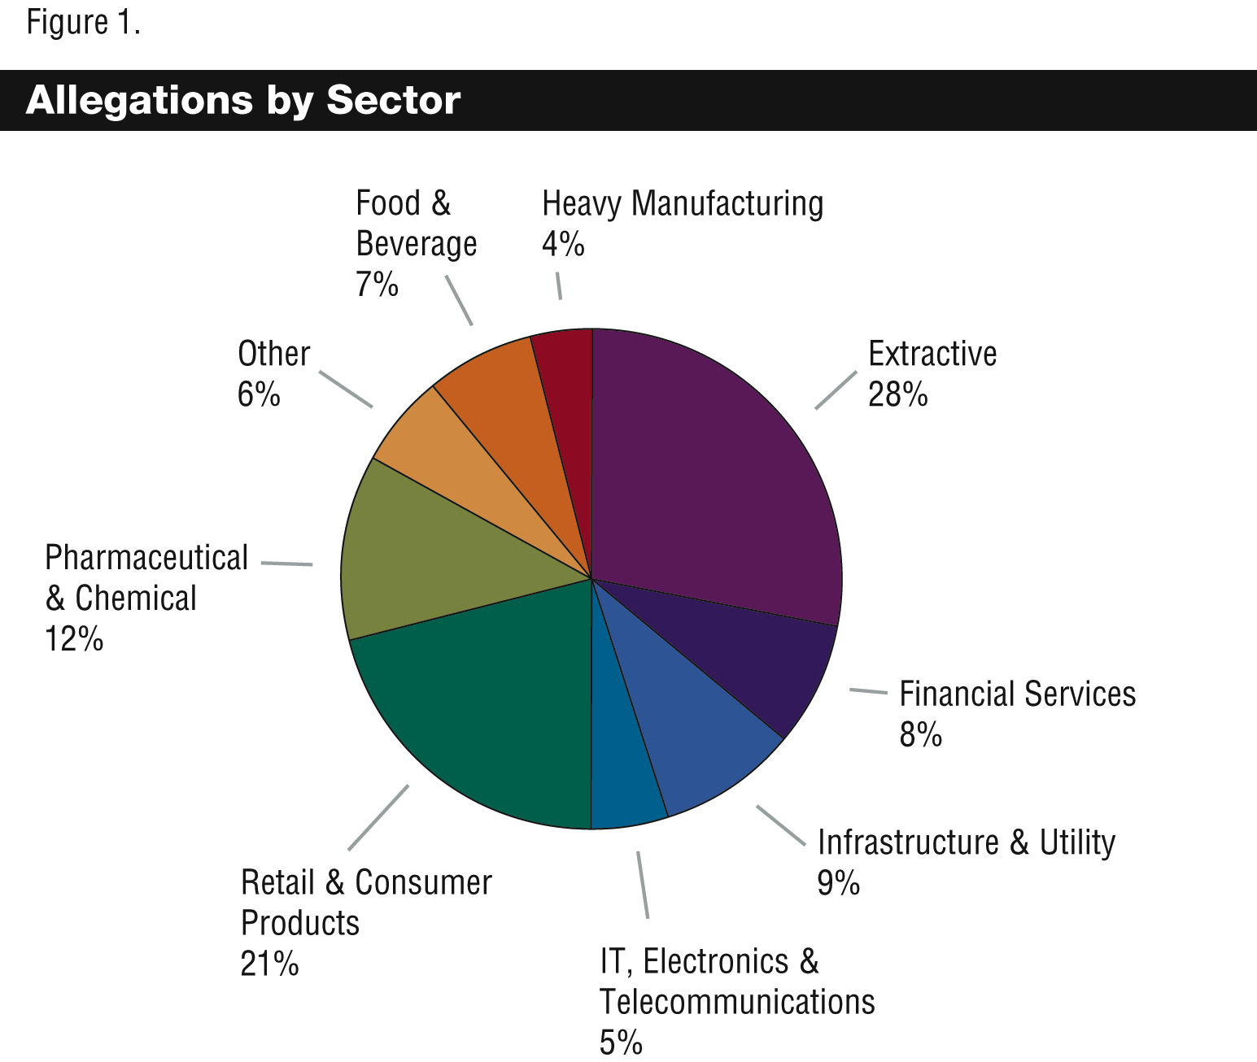
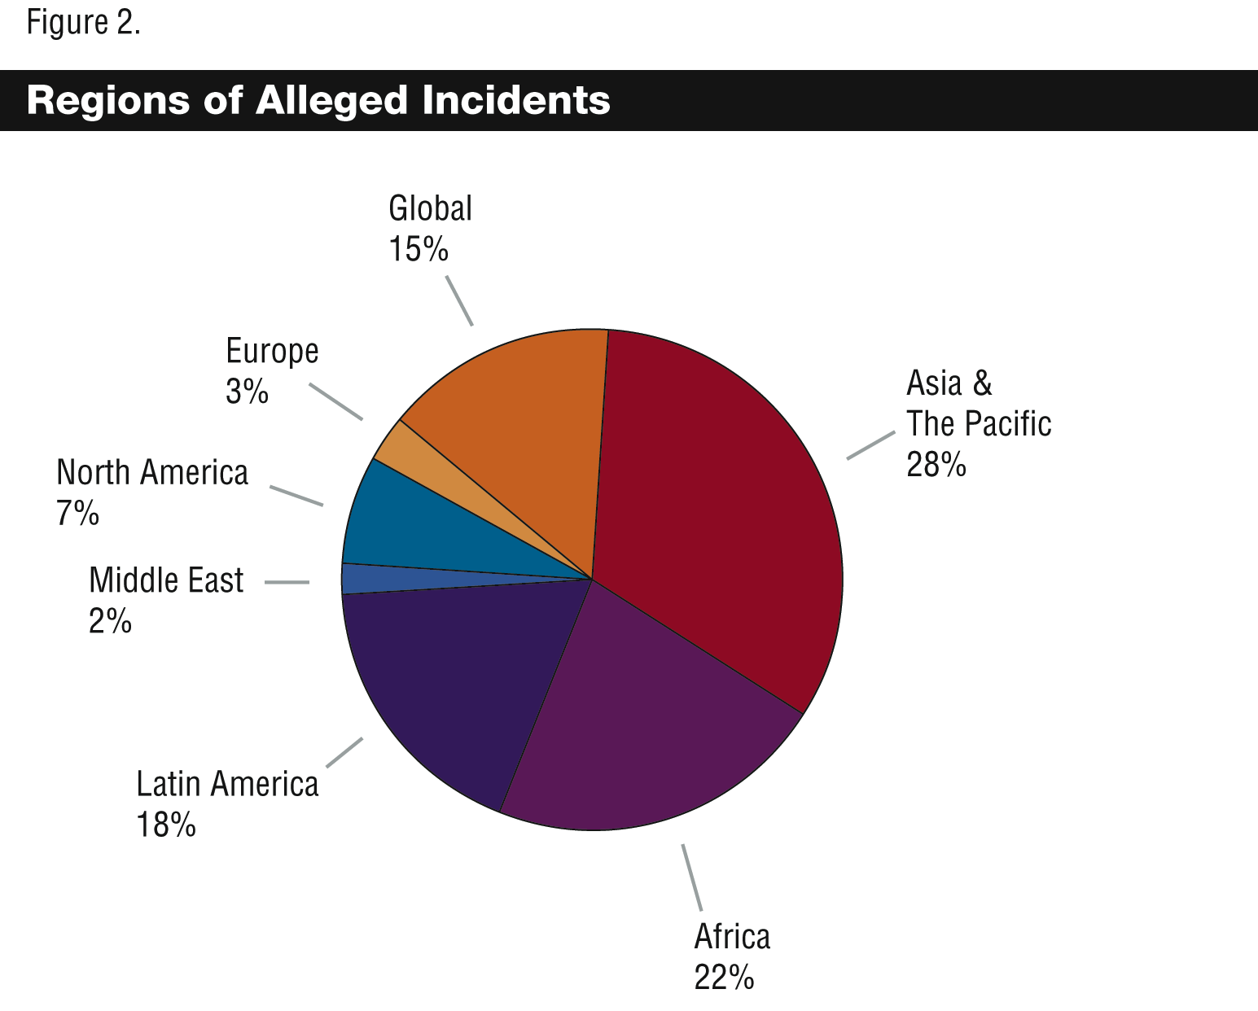
9. A number of factors contribute to which sectors, regions, and rights are the focus of allegations at any given time and those criteria may shift over time. Given this, caution should be exercised when drawing inferences about the concentration of allegations in a particular region or sector. However, the appearance of all regions and all sectors in the allegations is clear, and thereby the importance of all corporate actors considering human rights, wherever they operate.

Methodology
10. Each allegation was reviewed for the human right or rights to which it pertained, either expressly or implicitly. For purposes of this study, only alleged abuses were recorded and translated - the study did not attempt to predict what other concerns may have also existed in each case. In cases where the allegation stated that a specific right was violated, it was only necessary to record the alleged abuse of that right. Where an entry did not mention abuse of a specific right but provided a description of the abuse, that description was translated into human rights language. For example, where work-related injuries were described and it was alleged that the company contributed to or failed to prevent those injuries, it was translated into impact on the right to a safe work environment. Depending on the description, impacts on the right to health and the right to life might also be coded, e.g., where chronic injuries were sustained or work-related deaths were reported. Therefore, within the report, reference to alleged abuses or alleged impacts on human rights can mean those that were expressly alleged in rights language or those that contained descriptions of alleged abuses tantamount to impacts on human rights.
11. The universe of rights used for coding purposes are those expressed in the Universal Declaration of Human Rights (UDHR), the International Covenant on Civil and Political Rights (ICCPR), the International Covenant on Economic, Social and Cultural Rights (ICESCR), and International Labour Organization (ILO) core conventions. Environmental impacts with human rights implications were also recorded. And descriptions of corrupt corporate practices were noted, recognizing that such practices have the potential to impact the realization of all rights. Allegations that a company failed to take adequate steps in assessing and managing impacts on human rights were also noted.
12. Persons affected by the alleged abuse were also categorized. For each case, it was noted whether workers, communities, or end-users were affected. In some cases, more than one group of persons was affected and it was necessary to record the primary party affected followed by other affected parties. The number of persons affected was also captured - each case was coded using the groupings 1-50, 50-100, or more than 100 (>100) persons affected.
13. The dominant form of company involvement in the alleged abuse was coded. This included recording a brief description of the company actions alleged to cause the abuse and a categorization of the manner in which the company was involved - broadly classified as direct or indirect involvement. For direct cases, the company’s own actions or omissions were alleged to cause the abuse. Here, there was either no degree or a very minimal degree of separation between company actions and alleged abuses. In indirect cases, the company was perceived to contribute to or benefit from the violations of third parties, including suppliers, States or arms of a State, and other business. Some of these cases included specific allegations of corporate complicity in the abuse, e.g., State clearing of land for corporate use that violates indigenous rights in the process, or corporate finance of projects with records of abuse. Supply chain cases included allegations that were aimed at a buyer for abuses committed by its supplier.
14. This report is divided into two parts. Chapter I presents an overview of findings from the study, providing a view into what human rights companies are alleged to impact, the persons affected, and the dominant form of company involvement in the alleged abuses. First, labour and non-labour human rights impacts are discussed. This section also incorporates environmental harms and corruption as they were alleged to generate impacts on human rights. Next, data is presented on the persons affected by the alleged abuses, including workers, communities, and end-users. This section closes with data on the type of company involvement in the alleged abuses, broadly categorized as direct and indirect.
15. Chapter II contextualizes the findings, providing a view into how the human rights impacts presented in chapter I occurred. The contexts for alleged impacts on the rights of workers, communities, and end-users are presented. Each discussion includes a presentation of both direct and indirect cases of alleged impact on the rights of each group, highlighting the relevant sectors, regions, and corporate actions leading to allegations of abuse.

I. OVERVIEW OF FINDINGS
16. The allegations of abuse reviewed for this study reveal that corporations are seen to impact a wide range of human rights - including civil and political rights; economic, social and cultural rights; and labour rights. This section first discusses alleged labour rights impacts and then non-labour rights impacts, incorporating consideration of environmental harms and corruption where alleged. Data on the persons affected by the alleged abuses is also presented, showing an equal number of allegations of impact on workers and communities. This section closes with a discussion of direct and indirect cases of company involvement in the alleged abuse.

A. Human rights impacted by business

Labour-rights impacts
17. Most cases raised multiple allegations in relation to labour contexts, translating a single case into alleged impacts on a number of labour-related rights. In addition, labour rights abuses were often not discrete. A single allegation of abuse was often claimed to generate impacts on other labour and even non-labour rights. For example, where a firm was reported to use child labour, the circumstances of the case might also give rise to alleged impacts on the right to education, freedom from torture or cruel, inhuman or degrading treatment, the right to health, and even the right to life.
18. Figure 3 illustrates the range of alleged impacts on labour-related rights in the sample.
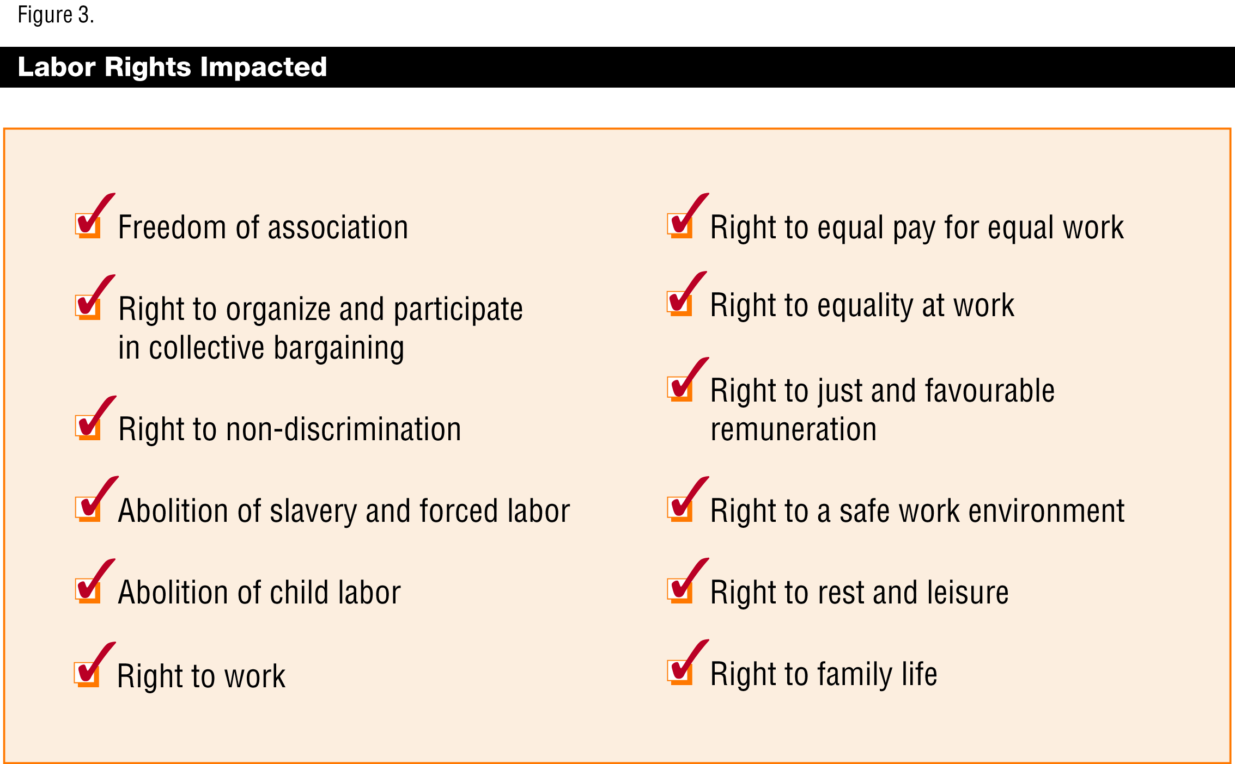
19. Labour rights impacts showed up frequently, with some labour abuses alleged at almost double the rates of others. Labour rights most commonly claimed to have been impacted include, e.g., the right to work (34 per cent), right to just and favourable remuneration (30 per cent), the right to a safe work environment (31 per cent), and the right to rest and leisure (25 per cent).
20. Corruption was also an issue raised in the labour context (17 of 86 cases of alleged corruption), most often connected to alleged corporate acts to cover up impacts on labour rights. A number of supplier level firms were alleged to have falsified or destroyed records prior to inspections and factory audits. They were also accused of coaching and forcing employees to lie during inspections.
21. Since many States have labour regulations in place for business that include formal adjudication channels for abuses, labour-related abuses might be underrepresented in the sample. This is because those cases may be more likely to have been taken to a formal mechanism for resolution and therefore would not have been captured in the sample (see discussion of the study sample, paragraphs 5-8 above). It was also apparent that some cases did not raise all available labour issues and instead chose to focus on key issues of concern, e.g., a media report that highlights only one or two labour issues in a factory - only issues presented were recorded - no inferences were made about what other concerns may have also existed in each case.

Non-labour rights impacts
22. Alleged impacts on non-labour rights were raised as frequently, and in some cases more frequently, than impacts on labour-related rights. Moreover, while some have viewed non-labour rights as a concern for only a few sectors, with the extractive sector being the most frequently used example, the cases reviewed for this study reveal that alleged impacts on non-labour rights occurred in relation to all sectors.
23. Figure 4 below shows the range of rights alleged to have been impacted negatively.
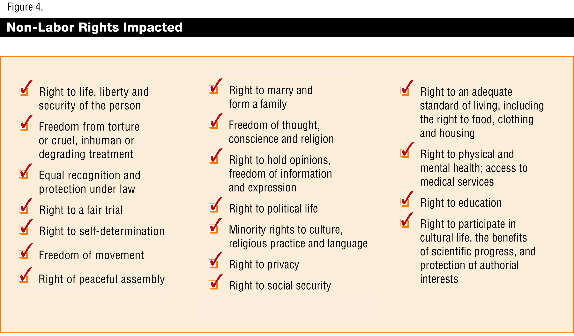
24. While the allegations indicated that corporations could impact a broad range of non-labour rights, certain non-labour rights were mentioned more than others in allegations. For instance, the right to physical and mental health appeared as an alleged impact in nearly 75 per cent of all cases. Impacts on this right occurred in a variety of contexts, e.g., where firms allegedly exposed individuals or communities to toxins, failed to provide medical treatment or medical insurance, or engaged in physical or mental abuse of individuals or communities (directly or indirectly). Additionally, alleged impacts on the right to physical and mental health often brought into question impacts on the right to life, liberty and security of the person and freedom from torture or cruel, inhuman or degrading treatment, appearing in 44 and 57 per cent of cases, respectively.
25. Impacts on the right to an adequate standard of living, including the right to adequate food, clothing and housing were alleged in near 40 per cent of cases and in relation to almost every sector. The right to social security, self-determination, privacy, and education were also alleged as impacts in between 20-25 per cent of all cases reviewed.
26. The allegations indicated that no sector or region was immune from contexts that may impact human rights. For example, allegations involving the rights to adequate food, clothing and housing were as likely to appear in cases concerning the living conditions of workers residing at a manufacturing facility campus as they were to appear in relation to communities affected by extractive or infrastructure projects. Regarding the right to education, a heavy manufacturing firm was alleged to have contributed to infringement of the right because it sold equipment that was subsequently used to block access to local schools while a supplier firm was alleged to employ children full-time in its factory without regard to their schooling. Alleged impacts on the right to privacy occurred where company-affiliated security forces arbitrarily attacked private homes and also in cases where companies set up surveillance systems and methods to intercept e-mail communications.
27. In addition to allegations concerning the rights listed in figure 4 above, nearly a third of cases alleged environmental harms that had corresponding impacts on human rights. Environmental concerns were raised in relation to all sectors. In these cases, various forms of pollution, contamination, and degradation translated into alleged impacts on a number of rights, including on the right to health, the right to life, rights to adequate food and housing, minority rights to culture, and the right to benefit from scientific progress. A number of environmental issues also prompted allegations that a firm had either impeded access to clean water or polluted a clean water supply, an issue raised in 20 per cent of cases.
28. Corruption issues were regularly raised in relation to the realization of non-labour rights, with transparency emerging as the key issue of concern. Transparency was expected but allegedly not delivered in relation to a number of issues, ranging from project impact assessments to corporate political and trade association payments.

B. Persons affected (workers, communities, end-users)
29. The allegations were divided according to whether they impacted workers, communities, and/or end-users. Alleged impacts on workers and communities occurred at equal rates, both at 45 per cent. This finding departs from traditional notions that business mainly affects the rights of workers. In the cases examined for this study, every sector was alleged to impact the rights of communities as well as those of workers.
30. Only about 10 per cent of the cases in this study alleged impacts on end-users; the majority of cases targeted pharmaceutical firms for impeding access to essential medicines in developing countries. It is beyond the scope of this report to speculate why the number of end-user-related cases is lower than those for workers and communities, though it is reiterated that the study did not include complaints before formal complaints mechanisms (see above discussion of the study sample), which may account for the absence of some of these cases from the sample.
31. A small number of cases (roughly 7 per cent) alleged impacts on more than one category of persons concurrently - some combination of workers, communities, or end-users. A few cases also stated that there were additional effects on reporters, activists, and, in one case, an NGO employee, including threats, violations of privacy, and impeding the right to hold opinions, freedom of information and expression.
32. Figure 5 below depicts the primary group alleged to have been affected in the cases - workers, communities, or end-users.
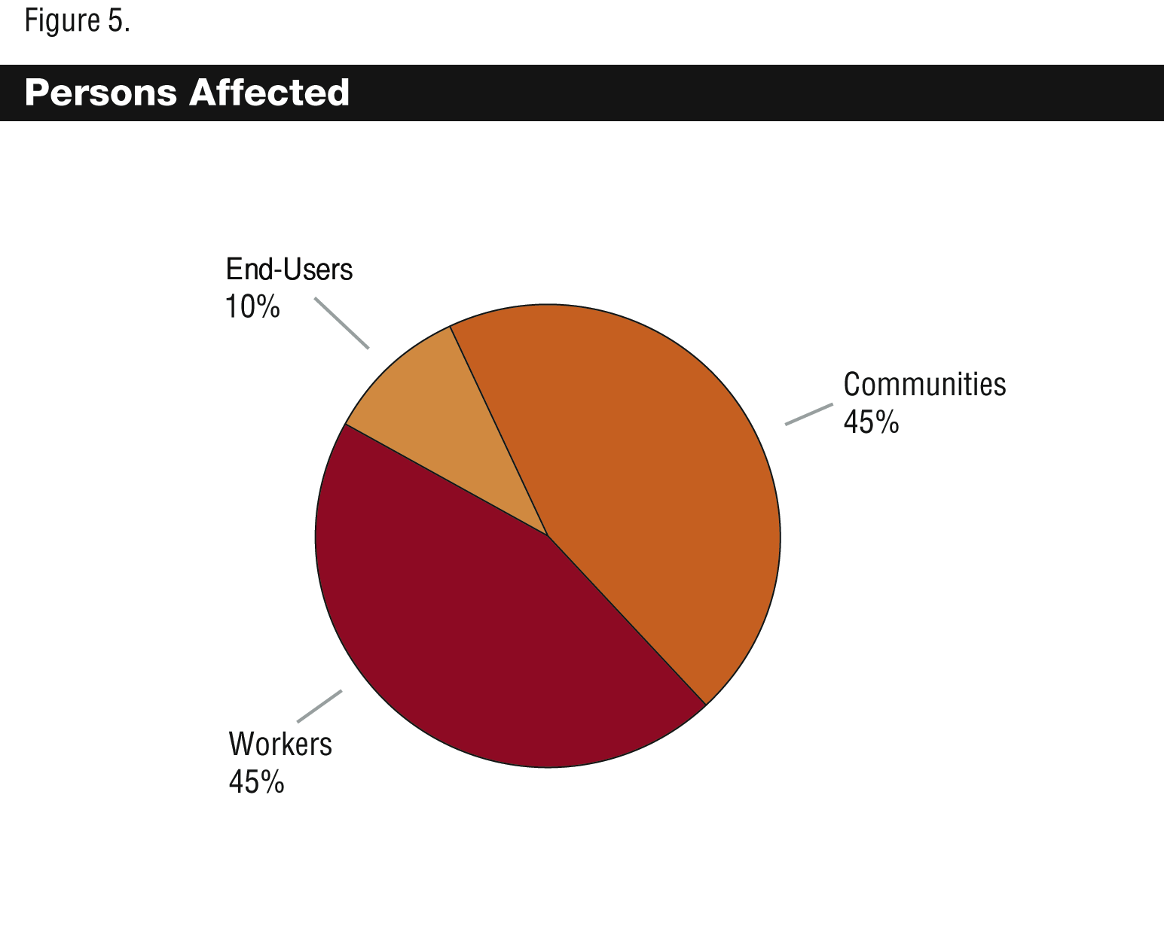
33. In some cases, a single instance of alleged abuse raised issues of impact on the rights of up to 60,000 persons. For those cases where a company action was seen to impact persons in more than one region, the numbers were even greater, for example, where a firm’s policy was alleged to generate impacts on persons in two or more of its areas of operation simultaneously.
34. While the reported magnitude of alleged impacts varied from case to case, almost all the cases involved impacts on more than 100 individuals. The allegations indicated that both unilateral and coordinated corporate actions have the potential to generate widespread impact on the human rights of various groups of persons.

C. Dominant form of company involvement in alleged abuses
35. The study categorized each case by the dominant form of company involvement in the alleged abuses. Broadly classified, company involvement in the abuse was recorded as either direct or indirect, with both types of involvement present in some cases. Nearly 60 per cent of cases featured more direct forms of company involvement in the alleged abuses (“direct cases”). For direct cases, the company, through its employees or agents, was generally alleged to have committed the abuse, with minimal or no separation between the company and the abuse.
36. Forty-one per cent of cases included indirect forms of company involvement in the alleged abuses (“indirect cases”). Here, firms were generally alleged to contribute to or benefit from the abuses of third parties. Supply chain cases were coded separately as a subset of indirect cases, making up 18 per cent of all cases in the sample. Other indirect cases, accounting for 23 per cent of all cases in the sample, connected a firm to other third-party abuses, including individuals, State or arms of a State, and other business enterprises.
37. Figure 6 below breaks down the allegations of abuse by the dominant form of company involvement.
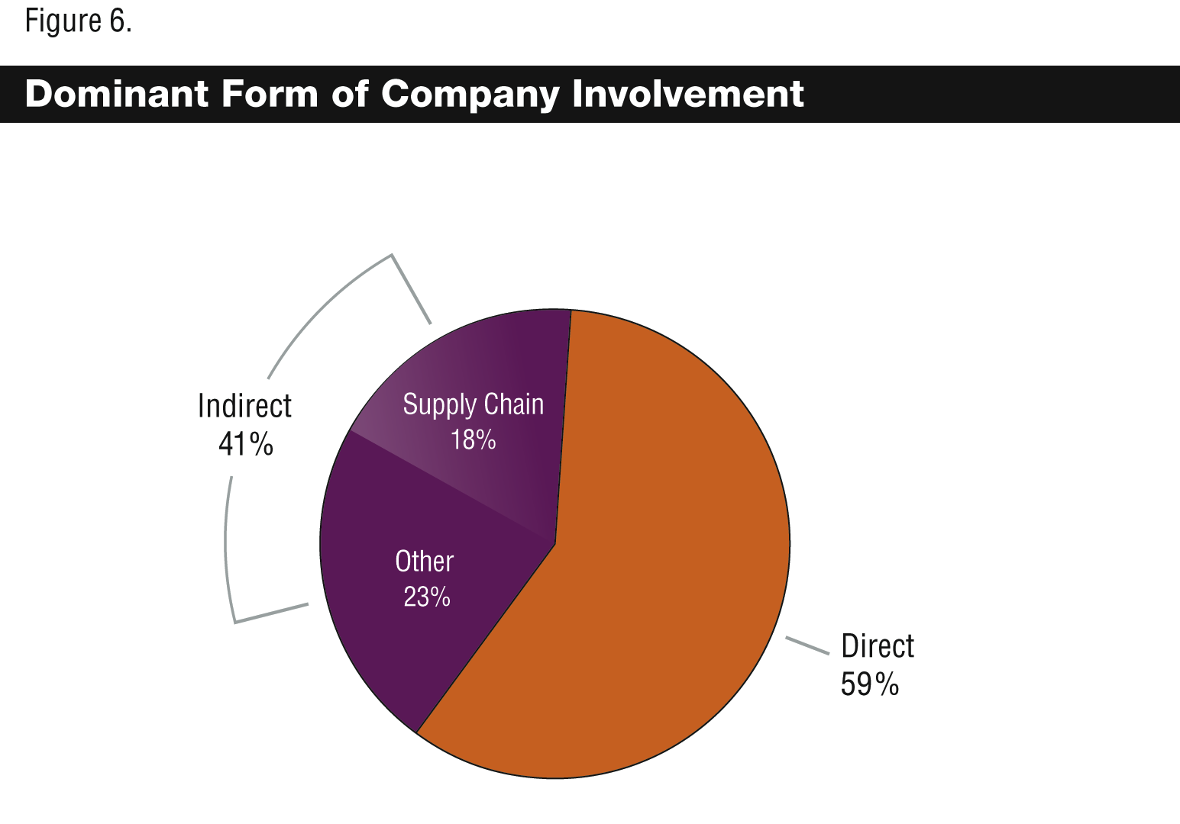

Direct cases
38. Direct company involvement in the alleged abuses was coded for all regions and in relation to all sectors. Moreover, direct cases contained allegations of abuse that impacted all groups of persons mentioned above - workers, communities, and end-users.
39. The dominant feature of direct cases was the claim that the company’s own actions or omissions had actually caused the alleged abuse. For example, a company refusing to hire persons because of their gender had an inherent and immediate impact on the right to non-discrimination; no intermediate circumstance or third-party actor was required to connect the firm to the abuse. Or, in another example, a company chemical spillage that increases the instance of certain diseases amongst workers and communities has a direct impact on their right to health, with few or no intervening circumstances or third-party actors to connect the company to impact on the right.

Indirect cases
40. Indirect company involvement in the alleged abuses occurred in relation to eight of nine sectors, only excluding the pharmaceutical and chemical sector; and in four regions, Africa, Asia and the Pacific, Latin America and the Middle East. While the sample revealed no indirect cases of abuse in Europe and only one in North America, the majority of indirect cases made allegations that Western (European and North American) firms were contributing to or benefiting from third-party abuses abroad. Indirect cases affected workers and communities. There were no end-user-related cases in this grouping; however, as stated previously, the sample contained lower numbers of cases alleging impacts on this group.
41. Supply chain cases stood out from other indirect cases because the companies’ connection to alleged abuses remained constant: firms, although a step removed, were viewed as responsible for human rights abuses in their supply chain. The allegations were primarily made against firms for the human rights abuses of first or second-tier suppliers.
42. Other indirect cases, connecting firms to the abuses of individuals, States or arms of a State, or other business enterprises, were more multidimensional; they set out descriptions of the activities of two or more actors - that of the third party or parties directly abusing rights and that of the firm perceived to contribute to or benefit from those abuses. Compared to supply chain cases, these indirect cases more frequently generated allegations of impact on the full range of rights, including both labour and non-labour rights. And alleged connections to abuse also varied, ranging from a firm’s mere presence in a region where abuses were occurring to a firm’s provision of loans to actors alleged to abuse human rights. Unlike direct and supply chain cases of abuse, these indirect cases frequently involved non-business actors, including States or arms of a State. The firm was viewed as contributing to or benefiting from the more direct violations of those State actors.

II. CONTEXTS OF ALLEGED CORPORATE
IMPACT ON HUMAN RIGHTS
43. This section gives further context to the findings from chapter I. Alleged corporate impacts on the human rights of workers, communities and end-users are discussed. For each group, both direct and indirect forms of impact are presented. The discussion highlights the relevant sectors, regions, and corporate actions alleged to generate abuse of human rights. Where explicitly included in the allegations, the section also discusses company failures with regard to processes thought to facilitate respect of human rights, e.g., impact assessments, community consultations. Finally, case examples from various sectors are presented in each section, providing the alleged corporate actions and corresponding impacts.

A. Alleged impacts on workers
44. Forty-five per cent of all cases alleged impacts on the rights of workers, making up 34 per cent of direct cases and 60 per cent of indirect cases (see figure 7 below). The following provides a discussion of direct and indirect cases affecting workers.
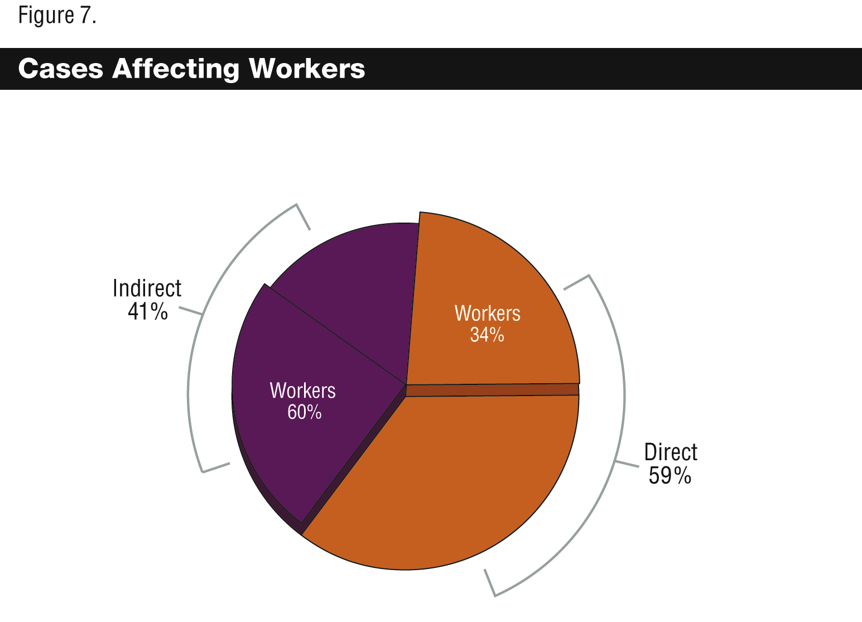

Direct cases affecting workers
45. Thirty-four per cent of direct cases of alleged abuse affected workers, covering 25 countries, from all regions. The number of reported abuses was high considering that worker-related cases might benefit from judicial or other forums in many regions, and thus, may not be fully captured in our sample. Thus, this segment of abuses is more likely to represent those cases that are either not benefiting from a forum, although one may exist, including where claims may not be legally cognizable.
46. All sectors are alleged to violate the full range of worker rights (see figure 3) as well as a number of non-labour rights, such as the right to life, health, adequate food and housing, and security of the person. Even extractive firms, often associated with large-scale community impacts, are alleged to violate workers rights as much as those sectors more commonly cited for labour-related abuses.
47. Three cases are presented here to show what corporate acts were alleged to cause direct impacts on the rights of workers.

1. Extractive sector
48. Several extractive companies operating in South Africa were alleged to have a policy that prohibits subcontractors from accessing on-site medical facilities (including access to HIV/AIDS medications). This was alleged as a form of discrimination and also a violation of the subcontractors’ right to a safe work environment and right to health. The companies were also alleged to discriminate against women in employment, reportedly failing to hire any women workers. It was stated that women then resorted to prostitution as a means to earn a living, generating impacts on the right to health of workers and the surrounding community because of the HIV/AIDS epidemic in the companies’ area of operation. Contribution to HIV/AIDS infection was also seen to impact the right to work because those falling ill or sick were unable to continue employment.
49. Workers were also reported to have settled in shacks with no access to sewage, electricity, or piped water, prompting allegations that the companies impacted the right to adequate housing and raising issues of access to water. Finally, dust generated by firm’s operations were alleged to cause a long-term respiratory disease that had impacted its workers and possibly even the surrounding community, raising issues of impact on the right to health and right to work.

2. Food and beverage sector
50. A group of food and beverage firms from various regions were cited for abuse of the rights of female employees hired to promote the companies’ alcoholic beverages (“beer promotion women”) in parts of Asia. In one Asian country, surveys found that beer promotion carries a strong social stigma. The common perception was that beer promotion was synonymous with sex work, putting beer promotion women at risk for abuse and harassment. It was alleged that up to 83 per cent of these women suffered harassment or abuse such as derogatory behaviour, unwanted sexual touching, physical and sexual abuse (including coerced sexual acts), and threats to personal safety. Several shootings were also reported where armed customers shot women workers, allegedly because they were not satisfied with the service.
51. The majority of beer promotion workers are employed on a commission-only basis, needing to meet quotas for sale of beverages to earn a wage. In order to earn enough to live, workers state that they need to sell enough to meet their targets, despite the risks to their safety. It is also alleged that quotas force women into prostitution with bar clientele to meet their sales targets, creating higher rates of exposure to and contraction of HIV/AIDS infections.
52. The allegations raised concerns over the workers’ right to a safe work environment, right to life and security of the person as well as freedom from torture, cruel, and inhuman treatment. In addition, these allegations generated impacts on the right to health of workers and in some cases the right to work. The alleged increase in HIV/AIDS infections also raised concern of impact on the health of surrounding communities. The report called for the companies to provide HIV education and contribute to the cost of health care for workers who are HIV-positive.

3. IT, electronics and telecommunications sector
53. An electronics firm was alleged to discriminate in hiring at its factory on the basis of gender, age, and marital status, violating the right to non-discrimination. The factory was also alleged to impact the prohibitions against forced and child labour. Regarding forced labour, the company allegedly took workers’ identity papers and made their return contingent upon worker performance. The factory also employed over 200 children under the age of 16, violating international prohibitions on child labour as well as local laws on the minimum age of employment. The latter also raised issues regarding freedom from torture or cruel, inhuman or degrading treatment and the right to education. The company was alleged to pay less than a minimum wage after assigning extensive fines to its workers, withholding pay, and failing to pay overtime. It was also said to impact the right to a safe work environment by failing to provide safety training or provide safety equipment, including masks to prevent exposure to toxic fumes. The factory was furthermore said to violate local and international laws on work hours, with 70-90 work hours per week as commonplace. Company failures to approve requests to terminate employment were also cited as impacting the right to work because the employee was denied the freedom to seek other employment.
54. Moreover, company dormitories were reported to house 8-12 workers in one small room and to have no electrical appliances or ready access to water, impacting the right to adequate housing. Workers were also separated from family and not permitted leave, impacting the right to family life. The company provided no pension or work-related injury insurance in violation of local law, additionally impacting the international right to social security and right to health. Corrupt practices included falsification of documents for inspections and coaching workers on what to say during inspection interviews.
55. The three cases above reinforce the traditional view that companies should respect the rights of workers in the workplace. However, they indicate an additional expectation that companies also look outside the workplace to ensure respect of worker rights. Two of the above cases cited the HIV/AIDS epidemic in the area of a company’s operation and alleged company policies that put workers at further risk; they cite inadequate wages, sales quotas, and discrimination as company acts that raise worker exposure to external epidemics. Still another case shows that, where a company provides housing, this housing is expected to meet human rights standards.

Indirect cases affecting workers
56. Around 60 per cent of indirect cases of alleged abuse affected workers, covering 16 countries and four regions, with only one case reported in North America and none in Europe. Nearly three quarters of these cases involved allegations of abuse by company suppliers. Supply chain cases came from five sectors: food and beverage; heavy manufacturing; IT, electronics and telecommunications; retail and consumer products; and a residual category “other”. Financial service firms were alleged to hold shares in or finance companies and projects known for labour abuse, accounting for 14 per cent of indirect cases affecting workers. The remaining cases were made against extractive-sector firms for connection to third-party abuse of workers.
57. Allegations of supply chain abuses were focused on incidents in the Asia and Pacific Region (40 of 57 cases), with a large number reported in China (17 cases) and Bangladesh (11 cases). Some reports of abuse in a company’s supply chain focused on only a few issues, for example, a report of child labour or forced labour, or a report on the overall health and safety conditions in a factory. Other cases provided more extensive reviews of the conditions within a factory, reporting on any abuse of worker rights - these cases often generated alleged impacts on the range of labour-related rights (see figure 3 above) as well as a number of non-labour rights (similar to the alleged impacts in direct cases).
58. Financial service firms were sometimes alleged as the primary financiers to companies linked with human rights abuse. One group of financial firms was alleged as the main investors in a company that used forced labour; another group was alleged to financially support a large retailer that is known for discrimination, forced and child labour, excessive work hours, unsafe work conditions, and frustrating employee efforts to organize.
59. Extractive firms were connected to alleged abuses of workers by contracted security forces that beat, killed, and tortured unauthorized workers. One country reportedly had over 100 such cases in a two-year period.
60. The following two examples illustrate allegations of abuse in a firm’s supply chain, allegations that made up the majority of indirect impacts on workers.

1. Retail and consumer products sector: supermarket retailers
61. A group of major supermarkets in the United Kingdom were alleged to benefit from sub-par working conditions and standards in their supply chains in Bangladesh, Costa Rica, and India. It was alleged that one of the supermarket’s suppliers obstructed employee attempts to organize, impacting the freedom of association and right to organize and participate in collective bargaining. The supplier was also alleged to discriminate in the employment of women, only hiring female workers for cheaper forms of labour. These allegations were accompanied by a report that a large number of contracted workers were abruptly fired and then rehired at a rate lower than the previously contracted rate. A number of workers were also shifted from permanent to temporary contracts. Both allegations generated impacts on the right to work. Wages were also reportedly under the minimum wage for hours worked, 12-15 hours a day, impacting the right to just and favourable remuneration and right to rest and leisure. In the light of these low wages, it was alleged that workers were unable to secure food, clothing and housing, impacting the right to all three. Finally, it was alleged that workers were routinely sprayed (aerial sprays) with chemicals and pesticides as they worked in the fields, impacting the right to a safe work environment and right to health.

2. Footwear manufacturers
62. The supplier to two major footwear retailers was alleged to require male employees to pay a fee for hire, resulting in discrimination against males in employment. This supplier’s workforce was reportedly 90 per cent female, alleged as both a result of affirmative discrimination and inability of men to pay the fee for hire. Workers were also paid per piece worked on, as opposed to hourly wages. The piece-rate wage was thought to lead to varying pay between work groups responsible for assembly of different pieces because the pace at which these pieces could be put together varied. Yet, it was alleged that the work was essentially the same. This generated impacts on the right to equal pay for equal work. The wage scheme also impacted the right to work because it was alleged that when less orders were made, the workers were not able to work. Additionally, receiving a rate per piece verses an hourly rate was said to lead to periods where workers made less than a minimum wage. The supplier was further alleged to offer no paid leave of any kind, including holiday, maternity, wedding, or bereavement leave - impacting the right to rest and leisure and the right to family life.
63. The safety and health of workers was also at issue. Workers were allegedly using toxic chemicals without receiving any training on how to handle such substances, impacting their right to a safe work environment and right to health. And the supplier was alleged not to provide insurance for work-related accidents, impacting the right to health and the right to social security. Managers also allegedly conducted intrusive body searches of employees and subjected them to routine harassment and intimidation, impacting rights to security of the person, freedom from degrading treatment, and right to privacy. Workers were also reported to live in overcrowded spaces with 10 workers per room and to share a bathroom with 100 workers on the floor, impacting the right to adequate housing. Management was reported to regularly come into living spaces without permission, also impacting the right to privacy.
64. In indirect cases affecting workers, firms were mainly connected to supplier and other business abuses. For supplier abuses, the cases indicate an expectation that buyer firms not benefit from such abuse. They also indicate that buyers should know the environment from which they are purchasing goods, at least with regard to principal suppliers, the primary subjects of these cases. For abuses committed by other business, the cases indicate an expectation that firms not contribute to or benefit from such third-party business abuse, for example, abuses of a client corporation, to which the firm has lent funds or provided other support, or abuses of a contracted service provider.

B. Alleged impacts on communities
65. Forty-five per cent of all cases alleged impacts on the rights of communities, making up 50 per cent of direct cases and 40 per cent of indirect cases in the sample (see figure 8 below). The subsequent paragraphs provide a discussion of direct and indirect cases affecting communities.
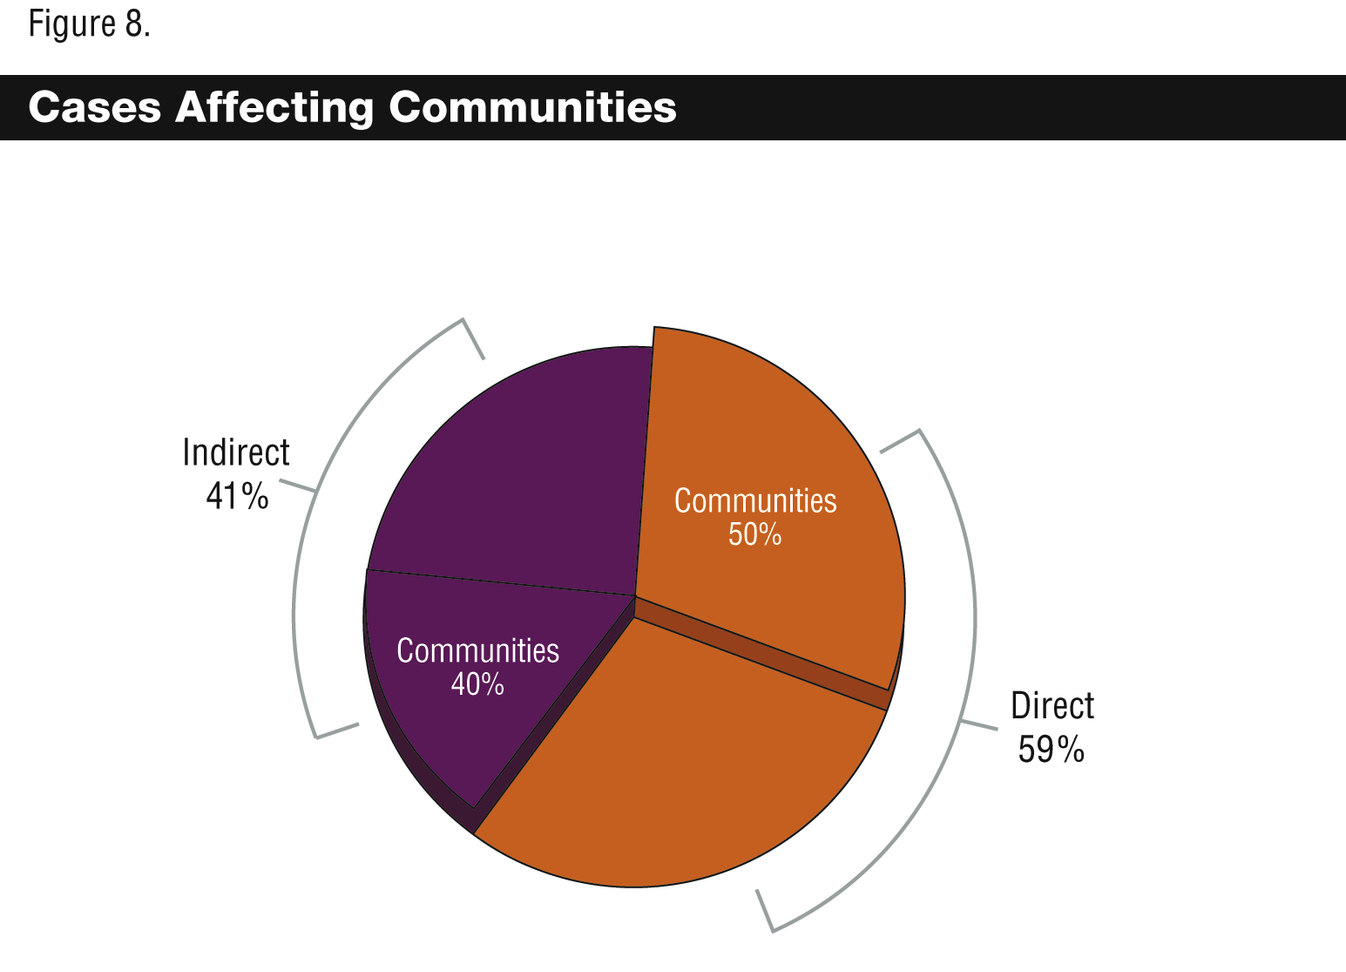

Direct cases affecting communities
66. Nearly 50 per cent of direct cases of alleged abuse affected communities, covering over 30 countries from all regions. The complaints were made in relation to eight of the nine sectors, only excluding the financial services sector, whose involvement in alleged abuses was generally indirect (see below, indirect cases affecting communities). For direct cases affecting communities, impacts were alleged on the full range of non-labour rights (see figure 4 above) and in relation to at least one labour-related right, the right to work. In nearly 15 per cent of cases, the right to work was alleged to be impacted where there were negative impacts on the health of communities, unfulfilled promises to provide jobs, and taking or contamination of community land that was previously used for cultivating and selling crops.
67. The majority of allegations in this category involved company environmental impacts that were alleged to negatively affect the health and livelihood of local populations. Corporate impacts on water supplies were raised in almost 40 per cent of direct cases of abuse impacting communities. Another portion of complaints were made regarding the rights of indigenous communities and primarily focused on extractive sector operations.
68. In relation to the environment, a number of companies were cited as the top corporate air polluters, both in their regions of operation, and in some instances, the globe. This included companies from the following sectors: pharmaceutical and chemical; food and beverage; retail and consumer products; heavy manufacturing; infrastructure and utility; extractive; and agricultural (other). These cases were most frequently alleged to generate impacts on the community’s right to health. In addition, several firms in this grouping were alleged to have exceeded permitted production rates for carbon dioxide (CO₂). Carbon pollution is cited as the primary cause of climate change, which has been argued to have numerous human rights implications, including impacts on the rights to life and health.
69. Other companies were alleged to release toxic chemicals into the environment surrounding their operations. This was alleged to poison local residents, grounds, and waters. The toxins were cited as the cause of cancers, reproductive diseases, and respiratory problems. In addition, the contamination of grounds and water supplies were alleged to kill both animals and aquatic life essential for sustenance in certain regions. These cases generated allegations of impact on the right to health, right to life, the right to food and the right to work, in cases where a farmer’s land was no longer cultivatable or locals suffered from toxin-related diseases that prevented them from working.
70. With regard to alleged impact on indigenous community rights (in this sample, these allegations were primarily made in relation to extractives), it was not always clear whether the dominant form of company involvement in the abuse was direct. Cases frequently coupled more direct forms of company involvement, for example, an alleged failure to obtain informed consent and environmental harms, with the abuses of third parties, whether private or public security forces or other arms of a State. Nevertheless, impacts on indigenous community rights are included here because in many of these cases the overriding form of company involvement was direct. Some cases even alleged that firms made an express request for third-party abuse of indigenous rights, for example, requesting security forces to carry out abusive acts such as the offensive use of force and intimidation - a potentially direct form of involvement on the part of the company.
71. Additionally, this set of cases also alleged that environmental impact assessments (EIA) and environmental and social impact assessments (ESIA) were poorly carried out. Various concerns surrounded environmental impact assessments, including allegations that appropriate equipment was not used to carry out tests, that EIA results were not disclosed, that EIAs were not conducted in a timely manner, and that communities were not consulted and that informed consent (first requiring full information on environmental and other impacts) was not gained before commencing projects. A smaller number of cases alleged that no EIA was conducted; one alleged that the EIA was fraudulently certified.
72. The following examples provide views into alleged corporate abuse of community rights, the first highlighting allegations of environmental harms and resulting impacts on the human rights of communities, and the other highlighting alleged abuse of indigenous community rights.

1. Infrastructure and utility sector (environmental harms)
73. An infrastructure and utility company was involved in a joint project with two other firms. The firms allegedly caused a gas explosion that killed 8 people and caused a mud volcano that displaced over 15,000 persons, destroyed 10,000 homes, and additionally destroyed farmland, roadways, rail systems and other infrastructure. Furthermore, it was stated that the disaster introduced toxins into the water supply, impacting fish and aquatic vegetation - a key source of income for area fisherman. This disaster was alleged to generate impacts on the rights to life, health, work, freedom of movement, adequate food and housing, and development-related rights. Company failure to compensate victims was viewed to sustain impacts on the above rights.

2. Extractive sector (indigenous communities)
74. An extractive firm was alleged to fail to consult indigenous groups or gain informed consent before pursuing its projects, viewed to impact the right to self-determination in a number of regions. In one case, the company allegedly entered land despite protests of landowners, impacting the right to privacy. It was also alleged to contribute to the forced removal of indigenous peoples from their homes, the arrest of those who refused to leave, and the shooting of an individual during the demolition process, impacting the right to life, liberty, and security of the person and freedom from torture or cruel, inhuman or degrading treatment.
75. Additionally, it was alleged that the company made no provision for the relocation and rehousing of indigenous peoples, impacting the right to adequate housing. The taking of land for company use was also alleged to impact the livelihood and culture of the indigenous group, depleting their ability to live off fisheries and pastures and impacting their right to culture. Pollution of fisheries, a primary food source, and ignoring requests to protect fisheries and pastures, was alleged to impact the right to food and self-determination.
76. Finally, it was alleged that the company failed to conduct an environmental impact assessment and failed to use appropriate equipment to detect toxins and other potentially harmful emissions, yet, used state of the art equipment to carry out its primary operations.
77. Impacts on local community rights such as those outlined above cover the range of civil and political, and economic, social and cultural rights. Key issues raised in relation to local indigenous communities are failure to seek informed consent, forced displacement, killings and violence, and environmental harms. These issues result in a range of impacts on the human rights of indigenous peoples, including rights to life, health, food, education, self-determination, privacy, freedom from torture, freedom of movement, minority rights to culture, and freedom of information. Allegations of abuse also occur in relation to other local communities surrounding company operations, for example, where a company releases chemicals and toxins into an area and causes visible deterioration of the health of inhabitants.
78. These allegations indicate an expectation that firms will incorporate community views in decision-making processes, gain informed consent, conduct impact assessments and otherwise respect community rights while carrying out projects.
79. Corporate actions are also connected to alleged impacts on the rights of the global community, poor records on pollution and other environmental harms are now being linked to impacts on the health of communities beyond those in the immediate area of a company’s operation - even where the effects are not immediately visible but the risk to health is imminent.

Indirect cases affecting communities
80. Around 40 per cent of indirect cases alleged impacts on communities, covering 16 countries and four regions, including Africa, Asia and the Pacific, Latin America, and the Middle East. Nearly all cases (almost 90 per cent) involved allegations that a company was contributing to or benefiting from State violations of human rights. These allegations came from four sectors: extractive; financial services; heavy manufacturing; and infrastructure and utility. The remaining cases concerned financial service firms’ provision of loans to company projects that were alleged to abuse human rights.
81. Similar to direct cases, impacts were alleged on the range of non-labour rights (see figure 4 above) as well as certain labour rights, such as the right to work.
82. The following paragraphs set out examples of contexts in which companies were alleged to contribute to or benefit from State abuse of human rights.

1. Heavy manufacturing sector
83. A heavy manufacturing firm, which provides equipment and services for energy projects, was alleged to benefit from State abuses carried out to make way for construction of a dam. The State was alleged to displace around 50,000 individuals to make way for the project, failing to provide adequate compensation and resettlement options, generating impacts on the rights to adequate food, housing, and social security. The Government was also alleged to obstruct local community representation in meetings and negotiations related to the project, impacting the right to self-determination and right to hold opinions. Other allegations cited the State’s use of force and arbitrary arrests and detentions to quell voices opposing the project, noting that police forces killed two protesters and the whereabouts of those detained was unknown. These actions allegedly impacted the rights to life, to freedom from torture and cruel, inhuman or degrading treatment, and the right to a fair trial. The company was viewed to benefit from those violations.
84. Additionally, it was alleged that environmental-impact assessments were inadequate and that no assessment of the project’s destruction of cultural sites was undertaken, generating impact on minority rights to culture and potential future impacts on health as a result of environmental harms. Regarding the EIA, it was alleged that State agency approval was bypassed and no disclosures of the assessment were made, raising corruption questions. Lastly, it was stated that, overall, the project served as a development setback, leaving the community with less resources than before.

2. Financial services sector
85. One large financial institution provided loans to the Government for a project that was allegedly ousting indigenous communities from cultivated farmland. It was alleged that the bank contributed to the indigenous loss of land, homes, and ultimately, food and income from the sale of crops. In addition, it was stated that no provision for relocation of the indigenous community was made. The alleged actions generated impacts on the rights to work, self-determination, food, adequate housing, privacy and to social security.
86. Another case involved a group of financial institutions. It was alleged that the firms’ provision of loans to a corrupt Government, one cited for extensive human rights violations, would frustrate efforts to make the Government more accountable. It was alleged that these firms would contribute to and fuel human rights violations and corruption.
87. The cases above suggest there is an expectation that business will not contribute to or benefit from violations of human rights, particularly by States, and that firms will not finance projects involving State or private actors known for abuse.
88. Business connection to State violations of human rights was alleged in various contexts, including where business provided the means for the State to commit the violation, whether physical means such as use of company products or property, or financial, by way of loans or revenues; and, where the State committed the violation in connection with the company’s project, violating rights in the course of making way for the project or during the project, in order eliminate or silence project opponents. This latter context gave rise to allegations that a company’s mere presence can fuel violations because some States were perceived to actively violate rights for gains from corporate investment.

C. Alleged impacts on end-users
89. Ten per cent of all cases alleged that there were impacts on the rights of end-users (both actual and potential). Alleged impacts on end-users were present in the direct cases only, making up 16 per cent of direct cases in the sample (see figure 9 below). These cases occurred primarily as a consequence of company actions related to its own products or services. The following provides a discussion of direct cases affecting end-users.
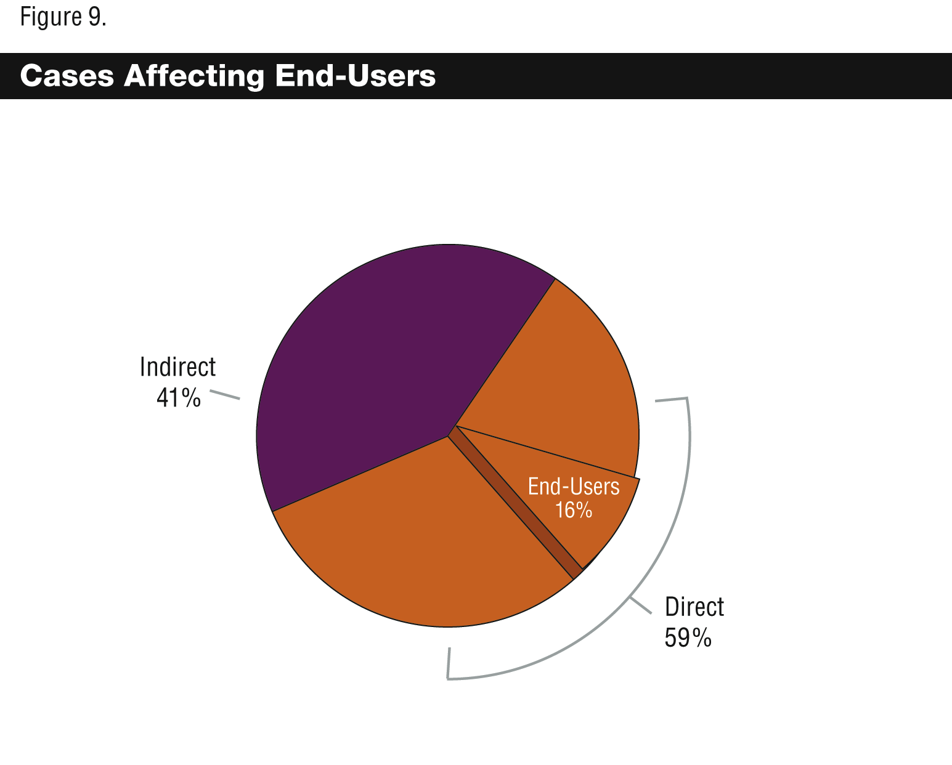

Direct cases affecting end-users
90. Around 16 per cent of direct cases alleged impacts on end-users, categorized primarily in the “global” region because the alleged impacts occurred in a number of States and regions simultaneously. As discussed in the overview section of this report, end-user-related abuses might be underrepresented in the sample for this study. With the exception of two allegations in this group, all were made against pharmaceutical firms for policies and practices alleged to affect the right to health of end-users globally - and thus, also occupying a substantial portion of the “global” designation in the region of alleged incident chart (see figure 2 above). The remaining two cases involved a financial institution, which was alleged to have closed a client account on the grounds that the client was transgendered, and an electronics firm, alleged to use toxic flame retardants in its products.
91. Allegations against pharmaceutical firms centred on issues of access to essential medicines and lack of research into diseases primarily affecting people in poorer regions. These issues were connected to alleged impacts on a number of human rights, including the right to life, right to health, right to benefit from scientific progress, right to work, right to education, and the right to social security. The following example from the pharmaceutical sector illustrates the range of allegations made against pharmaceutical firms and resulting impacts on end-users.

Pharmaceutical sector (access to medicine)
92. An NGO report evaluated pharmaceutical firms’ responses to health crises in emerging markets, reviewing 15 of the largest firms for their approaches to research, paediatric needs, drug accessibility, reporting, philanthropy, and political engagement. Firms were rated on access to essential medicine issues such as whether they conducted research on neglected diseases, formulated comparatively affordable and child friendly doses of medicines, sufficiently relaxed licensing and patents to permit introduction of generic medicines, and provided affordable pricing to low- and middle-income countries. In addition, companies were reviewed on the breadth of their reporting to shareholders, integration of philanthropic programmes into overall access-to-medicine programmes, and transparency of political contributions and trade association payments. Most firms received low ratings in one or more areas relating to access to essential medicine, impacting the right to life, right to health, and the right to benefit from scientific progress. Rights to education, work, and social security were also claimed as rights impacted by company restrictions on access to essential medicine or neglect in disease research.
93. With regard to HIV/AIDS, a number of firms received low scores on reports to shareholders; alleging that reports failed to make the business case for action, provide systematic reporting of goals and activities, or evidence of board level leadership. A lack of transparency of political contributions and trade payments was found for most firms, raising concerns over a firm’s public positions on public health issues as contrasted with their political and trade activity.
94. In regions facing health crises, the cases suggest that pharmaceutical companies producing vital drugs, such as HIV/AIDS medications, are at risk of allegations that they have prevented access to essential medicines. The allegations indicate that society expects global pharmaceutical firms to take additional steps in these circumstances, calling for positive steps such as research, relaxation of intellectual property restrictions, reduction of costs, or a thorough presentation of the business case for action to shareholders.

III. CONCLUSION
95. Firms from a broad range of sectors have been alleged to abuse or contribute to the abuse of one or more human rights - covering the full range of human rights, including civil and political; economic, social and cultural; and labour-related rights. The sample reviewed for this study also included allegations that company actions or policies had impacts on the rights of persons in two or more of its areas of operations, generating impacts on a range of rights in a number of different regions and contexts simultaneously. Even the traditional notion of the workplace as the primary environment of concern for companies does not appear to hold in this sample of cases. Based on the allegations made over the past two years, it seems just as common for corporations to face accusations of impact on the rights of communities as it is for them to face accusations of impact on the rights of workers.
96. The alleged abuses also appear to have domino effects and point to the dangers of business taking a narrow look into impacts. While some company conduct does indeed have an immediately identifiable and discrete impact on human rights, such as where a firm engages in a single act of discrimination, abusive conduct more frequently indicates - or even creates - an environment where abuses multiply. For example, where a firm is alleged to fail in providing protective gear or training for employees handling toxic substances, the conduct in the first instance impacts the right to a safe work environment. But this conduct also provides the enabling environment for a multitude of other impacts on human rights, for example, impact on the right to life, right to health, and the right to work in cases where employees are injured and unable to continue employment.
97. Company actions are also alleged to play into already existing social struggles, or worse, function to create new ones. In the cases, companies were urged to consider the consequences of actions and abuses in both the environments in which they occur and also in surrounding environments. For example, it was indicated that firms should consider the consequences of workplace policies on the rights of employees when they are outside of the workplace. This was apparent in cases where firms operated in environments facing high rates of HIV/AIDS infections, where some workplace policies were viewed to contribute to infection of workers, and ultimately, the community. The potential for magnification of impacts and abuse seemed particularly acute in already difficult operating environments. The cases show that taking actions without considering the full spectrum of potential impacts on rights may subject a firm to public scrutiny through campaigns and public reports of activities and related abuses.
98. Business may also face allegations for contributing to abuses carried out by other actors, whether suppliers, business partners or States. The allegations show that companies may face censure in the court of public opinion for contributing to or benefiting from such abuses and failing to take steps to stop it, even if actual courts might not necessarily find liability under current tests.
99. In addition, a large number of environmental harms are now linked to alleged abuse of human rights. Given current global scale environmental concerns, corporations with poor environmental records are alleged to contribute to impacts on a range of rights in the communities surrounding their operations and, in some cases, the global community. Business is also scrutinized for its management of environmental impact assessment processes, viewed as a means to prevent impacts on both the environment and human rights.
100. Finally, based on this sample, corporate failure to respond to allegations of human rights impacts may result in further backlash and recurrence of complaints. A number of complaints that went without company response were resubmitted. At a minimum, this indicates that it is in a corporation’s interest to respond to these allegations without delay. Even though impacts can be complex and easily multiply, it is equally simple. Managing respect for human rights at the outset of company activities can eliminate or mitigate the unintended succession of abuses and accompanying risks.
-----

* 迟交。
** 本报告的内容提要以所有正式语文分发。报告载于本文件的附件，仅以提交语文分发。
Later that year, the International Council on Mining and Metals made its second submission to the Special Representative, in part, analysing the allegations made in a set of 38 complaints involving mining firms.
See A/HRC/4/35/Add.4, “Business recognition of human rights: global patterns, regional and sectoral variations”.
Human Rights Council, fourth session, 12-30 March 2007, Oral Intervention, Amnesty International, ESCR-Net, Human Rights Watch, International Commission of Jurists, International Federation for Human Rights, available at http://www.reports-and-materials.org/NGO-joint-statement-to-UN-re-Ruggie-report-29-Mar-2007.pdf (accessed 15 March 2008).
See “Corporate responsibility to respect human rights”, summary report of the consultation in Geneva, held on 4-5 December 2007, at http://www.reports-and-materials.org/ Ruggie-Geneva-4-5-Dec-2007.pdf (accessed 19 May 2008). The report is also contained in A/HRC/8/5/Add.1.
At the time of writing (February 2008), two other such reviews were nearing completion, one from Human Rights Watch (final report launched in February 2008, see http://hrw.org/reports/2008/bhr0208/) and another from ESCR-Net. Human Rights Watch drew from 10 years of its research to describe a wide variety of business-related abuses and obstacles to justice sought by victims of these abuses. ESCR-Net collected and reviewed a set of emblematic cases, some solicited and some located in public space, and is due to publish a report of findings this year.
Business & Human Rights Resource Centre, “Companies we invited to respond to concerns in our Updates”, document No. 1, see http://www.business-humanrights.org/ Documents/Update-Charts. The Resource Centre was used as source material for the study but the Resource Centre itself was not involved in designing or producing the study. The Resource Centre also posts reports of positive steps by companies.
For this study, end-users mean those persons who use or are intended to use products, goods, or services.
Note that some cases made direct allegations against supplier firms. In these cases, the abuse was recorded as a direct form of involvement on the part of the supplier.
In the overall sample, 40 per cent of cases affecting workers were supply chain cases.
Several cases alleged that a buyer firm had actual knowledge of the conditions in its supply chain yet failed to act in any way; one such assertion was made where a supplier factory collapsed killing 64 workers and injuring a number of others, stating that the firm gained knowledge through its inspections of the potential for the building to collapse. One case indicated that when there is knowledge of abuse, remediation is the preferred first course of action - in this case, the buyer knew of the abuse and chose to terminate the relationship with a supplier, it was alleged to fail to remediate, and also to contribute to the loss of employment of 800 workers.
Cases often alleged company failure to obtain informed consent, a direct company action (or omission) that frequently led to alleged abuse of the right to self-determination as well as other rights. Sometimes in the same case a public security force was alleged to carry out killings and use intimidation to remove people from their land, a direct act of the security force and, where the removal related to a company project, an indirect form of involvement for the company.

