

BADIL Resource Center for Palestinian Residency and Refugee Rights

NGO Progress Report
Follow-Up to the Concluding Observations (Israel)

(Israel – CCPR/C/ISR/CO/3)

Twelve Months On

Reporting Period:
August 1, 2010 to July 31, 2011

Submitted to:
United Nations Human Rights Committee

This Report is submitted on behalf of BADIL Resource Center for Palestinian Residency and Refugee Rights, an independent, community-based non-profit organization mandated to defend and promote the rights of Palestinian refugees and IDPs founded in 1998, with consultative status with the UN ECOSOC, and a framework partnership with UNHCR.

Contacts:
Badil Resource Center
PO Box 728, Bethlehem, Palestine
Tel/fax 972-2-274-7346
E-mail: info@badil.org
Website: www.badil.org

Rania Madi,
BADIL Representative, Geneva
Tel: 0041-79-605390

Noura Erakat
BADIL Legal Advocacy Consultant
legal@badil.org

TABLE OF CONTENTS

1. Introduction…………………………………………………………………………………... 2

2. Summary of Actions taken by the State party since July 2010………………………………..4

3. Issues relating to recommendations contained in paragraph 8……………………………….. 4

3. Recommendation: Lift the Military Blockade of Gaza…………………………………4
3.2-3.5 Imports and Exports of Essential Humanitarian Supplies Severely Restricted......6
3.6 Access to Medical Care Restricted…………………………………………………....6
3.7 Crippling and Staggering Unemployment…………………………………………….7
3.8 Access to Education Denied…………………………………………………………..7
3.9-3.10 Crippled Infrastructure………………………………………………………….7
3.11 Recommendation: Invite Impartial, Independent, International Investigation into
2010 Flotilla Deaths………………………………………………………………8
3.13 Inadequate and Biased Internal Israeli Investigation……………………………….8
3.14-3.16 Independent U.N. Investigation Found Grave Violations of International
Law………………………………………………………………………………..8
3.17-3.18 Recent 2011 Flotillas Threatened With Force and Sabotaged………………...9

4. Issues relating to recommendations contained in paragraph 24……………………………….9

4. Recommendation: Respect the Bedouin population’s right to their ancestral land
and their traditional livelihood based on agriculture…………………………….9
4.6-4.11 Israel’s systematic destruction of Palestinian Bedouin villages……………….11
4.12-4.15 Destruction of agricultural livelihood by forced population transfer and
urbanization……………………………………………………………………...12
4.16-4.21 Evading Accountability: Outsourcing discriminatory practices to the Jewish
National Fund……………………………………………………………………12
4.22 The State Party has not guaranteed the Bedouin population’s access to health
structures, education, water and electricity, irrespective of their whereabouts on
the territory of the State party……………………………………………………14
4.25-4.26 Health Services………………………………………………………………..14
4.27 Education…………………………………………………………………………...15
4.28 Water………………………………………………………………………………..15

5. Concluding remarks and recommendations…………………………………………………. 15

6. Annex 1……………………………………………………………………………………… 16

7. Annex 2 ………………………………………………………………………………………22

- Introduction

  - On July 29, 2010, the Human Rights Committee published its report “Concluding Observations after reviewing Israel’s third Periodic Report in Geneva.” As part of the report, paragraph 26 of the Concluding Observations provides, “The State party should provide, within one year, relevant information on its implementation of the recommendations in paragraphs 8, 11, 22 and 24.” To assist the Committee in assessing any material Israel provides in response to this request, Badil wishes to update the Committee on issues relating to recommendations in paragraph 8 and 24 of the Concluding Observations.

Paragraph 8 reads: The Committee notes with concern the State party’s military blockade of the Gaza Strip, in force since June 2007. While recognizing the State party’s recent easing of the blockade with regard to the entry of civilian goods by land, the Committee is nevertheless concerned at the effects of the blockade on the civilian population in the Gaza Strip, including restrictions to their freedom of movement, some of which have led to deaths of patients in need of urgent medical care, and restrictions on the access to sufficient drinking water and adequate sanitation. The Committee also notes with concern the use of force when boarding vessels carrying humanitarian aid for the Gaza Strip, which resulted in the death of nine individuals and the wounding of several others. While noting the preliminary findings of the State party’s investigation into the incident, the Committee is concerned at the lack of independence of the commission of inquiry and the fact that it is prohibited from questioning the officials of the State party’s armed forces involved in the incident (arts. 1, 6 and 12).

The State party should lift its military blockade of the Gaza Strip, insofar as it adversely affects the civilian population. The State party should invite an independent, international fact-finding mission to establish the circumstances of the boarding of the flotilla, including its compatibility with the Covenant.

Paragraph 24 reads: The Committee notes that school enrollment rates have increased and that infant mortality has declined among the Bedouin population. Nevertheless, the Committee is concerned at allegations of forced evictions of the Bedouin population on the basis of the Public Land Law (Expulsion of Invaders) of 1981 as amended in 2005, and of inadequate consideration of traditional needs of the population in the State party’s planning efforts for the development of the Negev, in particular the fact that agriculture is part of the livelihood and tradition of the Bedouin population. The Committee is further concerned at difficulties of access to health structures, education, water and electricity for the Bedouin population living in towns which the State party has not recognized (arts. 26 and 27).

In its planning efforts in the Negev area, the State party should respect the Bedouin population’s right to their ancestral land and their traditional livelihood based on agriculture. The State party should also guarantee the Bedouin population’s access to health structures, education, water and electricity, irrespective of their whereabouts on the territory of the State party.

  - To assist the committee in monitoring Israel’s compliance with the recommendations, Badil has set herein the actions taken by the state parties since July 2010 in two parts: first, the actions taken in regards to recommendations in paragraph 8, and second, the actions taken in regards to recommendations in paragraph 24.

- Summary of Actions

  - Since the Committee’s Report on Israel one year ago, Israel has not implemented any significant changes or behavior to comply with the Report’s recommendations contained in paragraph 8.

- Israel has not lifted the blockade of Gaza, and thus has not eased any of the humanitarian conditions on the ground for the millions of civilians living in Gaza
- Gaza overall still suffers tremendously from the blockade in its denial of basic needs, goods, food, medicines, infrastructure materials, and access to education
- There has been no change or easing of the suffering of the Gaza civilians, despite Israeli claims to the contrary
- Furthermore, Israel has refused to cooperate with international efforts for an impartial, international, independent investigation into the murder of nine civilians on board one of the humanitarian flotillas attempting to bring humanitarian aid to Gaza one year ago.

  - The indigenous Bedouin population has been subject to multiple population transfer. Their displacement is discriminatory in both its intent and impact. Israel seeks to develop their lands for the exclusive benefit of its Jewish citizens. To accomplish this purpose, the State has limited basic services and socio-economic provisions to the Bedouin populations in the intent that they will be compelled to relocate to urban townships. Since the Human Rights Committee’s comments in July 2010, the conditions have deteriorated.

- Housing demolitions have increased since the Committee’s Observations in July 2010
- The village of Al-Araqib has been destroyed 24 times between July 25th 2010 and July 25th 2011
- The Israeli Land Authority has sued the residents of Al-Araqib sued for demolition and eviction costs in the amount of $500,000 (July 2011)
- No efforts have been made to preserve Bedouin Agricultural livelihoods
- Israeli authorities have sprayed Bedouin agricultural lands with herbicides and ploughed over them in order to compel their forcible transfer (October 2010)
- The State continues to outsource its discriminatory planning and development policies to organizations like the Jewish National Fund in order to evade scrutiny and accountability.
- Socio-economic indicators in health, water, and education are all still poor or worse

- Recommendation: lift the military blockade of the Gaza Strip insofar as it adversely affects the civilian population.

One year after this recommendation, there has still been no change, and the military blockade has not been lifted, despite Israeli assertions to the contrary. Israel asserts that “luxury” goods are transferred regularly to Gaza, such as hot tubs, LCD televisions, luxury cars, frost-free refrigerators, and claims that “The goods are ordered in advance by Palestinian Authority officials, who have yet to maximize the crossing’s truckload capacity.” Israel also asserts that imports of goods into Gaza have steadily increased over the past year, claiming “The amount and variety of goods to enter Gaza every day has increased (truck volume in June increased by 12%). Work is being done to increase the capacity of the existing land crossings and, if necessary, additional crossings will be built. . . . Efforts are being made to streamline the process of approving the entry and exit of people for medical and other reasons and the passage of employees of recognized international organizations.”

  - However, facts on the ground demonstrate a starkly different and bleak picture from what Israel portrays. Gaza overall still suffers tremendously from the blockade in its denial of basic needs, goods, food, medicines, infrastructure materials, and access to education. According to a December 2010 Palestinian Center for Human Rights report, “Palestinian civilians are illegally denied access to their basic needs, including food, medicine, fuel, electricity and other necessary commodities. As a rule Palestinians are not allowed to travel in and out of Gaza, with few exceptions mainly for humanitarian reasons (mostly patients needing life saving medical treatments). Students are not allowed to attend university programs abroad, or in the West Bank; families are divided and unable to visit each other even within the Palestinian territory; traders and businessmen are prevented from doing their business. Only a small, tightly regulated, number of internationals are allowed into Gaza under a strict system of permits. For the past three and half years the import of goods into Gaza has been prohibited by the Israeli authorities, with only limited quantities of basic goods, mainly food, allowed entry for ‘humanitarian’ reasons. Israel has also imposed a total ban on the exports of the Gaza Strip’s products, destroying the economic sector and generating dependency. Only limited quantities of two goods, flowers and strawberries, were allowed to be sporadically exported thanks to specific international mediation.”

Imports and Exports of Essential Humanitarian Supplies Severely Restricted

  - The imports of raw materials and exports are still severely restricted, such as importing cooking gas, or exporting Palestinian made goods, crippling Gaza’s economy. According to a June 2011 Palestinian Center for Human Rights report assessing the conditions in Gaza one year after the Committee’s report and recommendations, main crossings have been completely closed, causing the complete closure of economic and commercial establishments in Gaza. “The total closure of al-Mentar 'Karni' crossing on 02 March 2011 has created a bitter situation that has seriously affected the Gaza Strip. Following this closure, all the economic and commercial establishments in Gaza Commercial Zone were shut off. It should be noted that al-Mentar crossing is the biggest crossing in the Gaza Strip in terms of its operational capacity to absorb the flow of imports and exports.”

  - As of June 2011, the Israeli Army "continued to impose total ban on the delivery of raw materials to the Gaza Strip, except for very limited items and quantities. The limited quantities of raw materials allowed into Gaza do not meet the minimal needs of the civilian population in the Gaza Strip."

  - The January 2010 total and continued closure of the Nahal Oz crossing has led to the current cooking gas crisis, since the “Nahal Oz crossing. . . used to be dedicated for the delivery of fuel and cooking gas supplies to Gaza, and shifted fuel and cooking gas supplies to Karm Abu Salem crossing which is not technically equipped to receive Gaza's needs of fuel. Karm Abu Salem crossing, with its maximum absorptive capacity, can receive only 200 tons of cooking gas per day."

  - The continued total Israeli ban on exportation of Gaza’s products further exacerbates an already desperate economy and humanitarian situation. As of June 2011, the "IOF have continued to impose a total ban on the exportation of Gaza's products, especially industrial products, leading to undermining any real chances to rerun economic establishments."

Access to Medical Care Restricted

  - Access to medical care also remains severely restricted. Israel continues to restrict access to medical care outside Gaza while also restricting importing medical equipment and medicines into Gaza, compounding the humanitarian crisis and endangering the health and lives of the people of Gaza, "IOF have also continued to adopt a policy aimed at reducing the number of Palestinian patients allowed to move via Beit Hanoun crossing to receive medical treatment in hospitals in Israel or in the West Bank and Jerusalem. IOF denied new categories of Gazan patient permission to have access to hospitals via the crossing."

Crippling and Staggering Unemployment

  - Unemployment remains staggeringly high, leading to intense poverty, a crushing economy and overall poor quality of life. "At 45.2 percent, the broad unemployment rate in Gaza remained among the highest in the world in H2 2010 [2nd half of 2010]. The combination of persistently high unemployment and the continuing deterioration of the real wages of working people underlie significant levels of poverty."

Access to Education Denied

  - Education remains severely restricted, denying Palestinian youth the right to an education by restricting importing educational materials into Gaza. “The economic blockade, imposed by Israel after the Islamist resistance movement Hamas took control of Gaza in June 2007, has obstructed the import of books, science laboratory and other educational equipment to Gaza, according to the UN Educational, Scientific and Cultural Organization (UNESCO). Israel allows in limited humanitarian supplies. The lack of facilities, new information and experiences has caused a marked deterioration of Gaza’s whole educational system. Noor, an English education student at al-Azhar University, ranked second in Gaza, said she lacked essential books for her coursework and even chairs were missing from lecture halls.”

Crippled Infrastructure

3.9 Infrastructure continues to suffer due to the blockade and the restrictions on importing basic building materials, as well as a resulting loss in jobs in the construction industry. “The ongoing blockade on Gaza has had a devastating impact on the construction sector. Prior to the blockade, more than 50 per cent of the truckloads which entered Gaza each week contained construction materials. Today, less than 20 per cent of the truckloads entering Gaza contain construction materials. Essential items such as cement and gravel are permitted entry only for specifically approved construction projects. As a result, many construction workers, contractors and engineers have lost their jobs, and those who remain in Gaza are frequently out of work.”

3.10 Furthermore, a November 2010 UN estimate puts the needs of construction and infrastructure materials much higher than was currently being allowed to enter Gaza. "The UN estimates that Gaza needs 670,000 truckloads of construction materials for housing alone, but the report says on average, just 715 truckloads of construction materials have entered Gaza since the announcement in June."

3.11 Recommendation: Israel should invite an independent, international fact-finding mission to establish circumstances of the boarding of the flotilla, including its compatibility with the Covenant.

3.12 One year after the Committee’s recommendations, there has also been no change or compliance with this recommendation, as Israel has not only not invited an independent, international fact-finding mission regarding the flotilla, but also has openly defied such demands from the U.N. With no Israeli cooperation or invitation to an independent international fact-finding mission, justice delayed has become justice denied for the people of Gaza.

Inadequate and Biased Internal Israeli Investigation

3.13 With no invitation or cooperation with an independent, international fact finding mission, Israel instead conducted an internal investigation known as the Turkel Committee Report which concluded with Israel clearing itself of any liability, and in fact blaming the civilians on board for the violence.

Independent U.N. Investigation Found Grave Violations of International Law

3.14 However, the U.N. Human Rights Committee launched an independent investigation, which Israel refused to cooperate with, and concluded in finding Israel completely responsible and in violation of several international principles.

“265. The Mission considers that several violations and offences have been committed. It is not satisfied that, in the time available, it has been able to compile a comprehensive list of all offences. However, there is clear evidence to support prosecutions of the following crimes within the terms of article 147 of the Fourth Geneva Convention: Wilful killing; Torture or inhuman treatment; Wilfully causing great suffering or serious injury to body or health. The Mission also considers that a series of violations of Israel’s obligations under international human rights law have taken place, including: Right to life (art. 6, International Covenant on Civil and Political Rights); Torture and other cruel, inhuman or degrading treatment or punishment (art. 7, International Covenant; Convention against Torture); Right to liberty and security of the person and freedom from arbitrary arrest or detention (art. 9, International Covenant); Right of detainees to be treated with humanity and respect for the inherent dignity of the human person (art. 10, International Covenant); Freedom of expression (art. 19, International Covenant).”

3.15 Israel has not only refused to cooperate with the U.N. independent fact-finding mission, Israel has also refused to even issue an apology for the deaths of the nine civilians on board the flotilla by the Israeli Defense Forces.

3.16 Although still confidential, the Turkish independent investigation into the flotilla incident roundly blamed Israel for the “full-fledged and premeditated attack.”

Recent 2011 Flotillas Threatened With Force and Sabotaged

3.17 Compounding the fact that Israel refused to cooperate with any independent, international investigation into the 2010 flotilla incident, Israel threatened the 2011 flotillas with force if they continued on their planned path to Gaza. The 2011 flotillas were eventually stopped from departing through diplomatic pressure placed upon Greece (the country of departure), likely pressure from Israel.

3.18 Huwaida Arraf, Chairperson of the Gaza Freedom Movement Coalition and a member of the 2011 flotilla, discussed Israel’s diplomatic pressure exerted upon Greece to stop the flotillas from departing, as well as likely Israeli participation in the sabotage of the ships,

“In addition to the administrative delays, the Greek government issued an order banning all ships from leaving Greek ports to head to Gaza. This is devastating, not because of the practical implications (as we don’t have to declare Gaza as the destination of our ships), but rather because it codified Greece’s recognition of an illegal policy and therefore its complicity in an international crime. Then governmental obstacles became noticeable – inspectors going through our ships with a fine toothcomb, port authorities not giving us answers, procedural delays, unreasonable demands being made on us. For the Free Gaza Movement, this was our tenth sailing; and so we knew the drill and we knew that we were being purposely obstructed. . . . Finally, it’s worth noting that Israeli military sources did not deny the accusations of sabotage against our vessels last year, notably against the Challenger I, Challenger II both of which malfunctioned at the same time and in the same way. On the contrary, as an article in the Independent revealed: ‘A senior IDF officer hinted to the Knesset’s [Israeli Parliament] Foreign Affairs Committee that some of the vessels – though not the Mavi Marmara – had been tampered with to halt them far from the Gaza or Israeli coast.’ So, while we may never be able to prove it, we are pretty confident that Israel sabotaged our boats.”

4. Recommendation: Respect the Bedouin population’s right to their ancestral land and their traditional livelihood based on agriculture.

4.1 Within Israel today, the indigenous Palestinian community constitutes only 20% of the State’s population and is subject to institutionalized racism and discrimination with the aim of forcibly displacing them from their ancestral lands and homes.

4.2 The case of Palestinian Bedouins within the Negev is particularly telling. The 180,000 Bedouins today are pastoral nomads who are the descendants of 19 tribes whose population was reduced to 11,000 in the aftermath of Israel’s establishment. In 1953, 11 of the 19 tribes were forcibly removed from their homes and transferred to a reservation in the northeast of the Negev known as the “Enclosed Zone” or the Sayig. As a result of the Absentee Property Law, the pre-1948 Bedouins lost 90% of their lands and property.

4.3 Having forcibly settling the Bedouins in the Sayig and confiscating their ancestral lands, the Israeli government settled them sparsely throughout the Sayig in order to make room for Jewish settlements and army bases. The National Planning and Building Law (1965) excluded Bedouins from official recognition despite their existence prior to the establishment of Israel in 1948. In 1966 the State released a Master Plan that did not recognize dozens of the Bedouin villages rendering them invisible to the government and denied them basic services like electricity, water, sewage systems, and health care otherwise provided by the State.

4.4 In contrast, the Master Plan sought to Judaize the Negev and supported the expansion of Jewish settlements. Jewish towns are considered “development towns” and therefore enjoy funding allocated in the building plans. The development towns also enjoy expansion by draconian means, confiscating land of nearby Bedouin townships. In the case of Omer, the Local Planning Commission permitted the annexation of 7,000 dunums of neighboring unrecognized village of Tarabin al-Sana’. The 5,000 affected Bedouins petitioned for permission to reside in Tarabin al-Sana’ and in response the Omer authorities forced them into special created townships and issued 75 home demolition orders for their remaining homes.

4.5 The State seeks to forcibly remove the population of 75-90,000 Bedouins living in 40 unrecognized villages from their ancestral homes and their agricultural livelihoods and into overcrowded townships characterized by urbanization. Its tactics have included denial of basic services to the Bedouins and in many cases it has involved the violent and repeated destruction of their homes, villages, and agricultural lands.

Israel’s systematic destruction of Palestinian Bedouin villages

4.6 According to Adalah, Israel has destroyed at least 3,084 Palestinians homes within Israel Proper between 2000 and 2007, the majority of which have been in the Naqab. Among the villages that has been fully and repeatedly destroyed is Al-Araqib.

4.7 Between 25 July 2010 and 25 July 2011, Israeli authorities razed Al-Araqib twenty-four times. During its first attack on the village, Israeli authorities demolished 46 homes. As a result of their displacement, residents of Al Araqib have been forced to sleep in nearby towns including Rahat. The demolitions have also included the destruction and uprooting of thousands of their fruit trees.

4.8 Rather than comply with the Human Rights Committee recommendation to respect Bedouin rights to their ancestral lands and traditional ways of life, the Israeli government has treated the Bedouin populations with increased hostility.

4.9 Ortal Tzabar, the spokesperson for the Israeli Land Authority, describes the indigenous population struggling to maintain its lands as criminals. In an interview with IRIN News Service, Tzabar comments, "This case is not about demolitions; these people are criminals. This land has been deserted since 1950, when it was taken by Israel. We had even leased the land to other Bedouins for agricultural use and they chased them away.”

4.10 Al-Araqib’s residents have defiantly rebuilt their homes and villages at least 21 times. In response, the Israeli Land Authority has filed a civil suit against the villagers for 1 million NIS or $500,000 to compensate them for the cost of repeated demolitions and evictions.

4.11 The Negev Coexistence Forum for Civil Equality (Coexistence Forum) has monitored such destruction throughout the Negev since 2001. Attached are the two Annexes that include those demolitions in 2010 and the most recent figures in 2011 until July 25, 2011. The figures demonstrate Israel’s failure to comply with the Committee’s recommendations and its escalation of such violations.

Destruction of agricultural livelihood by forced population transfer and urbanization

4.12 In addition to systematic home demolitions, Israeli authorities have also targeted Bedouin agricultural livelihoods, with the intent of forcibly removing Bedouin communities into urban townships.

4.13 In its fight against Bedouin populations for land ownership, the Israel Land Administration dusted Bedouin crops with herbicide. In Salim Abu Mdigam v. the Israel Land Administration, the Israeli High Court held that that the dusting was intended to drive Bedouins off of their lands and into townships and was therefore illegal for contravening the Convention on Economic Cultural and Social Rights.

4.14 Although the High Court forbade the practice, the state began to destroy newly-sprouted Bedouin fields by ploughing over them. Israeli Authorities ploughed over and destroyed 7,400 dunams of fields in the Negev in 2010.

4.15 The destruction of Bedouin crops fits within a broader project of forced urbanization of Bedouin communities. Israeli authorities built urban townships that do not account for the agricultural livelihood or the particular cultural needs of the Bedouin population. According to the Coexistence Forum, “the towns have disrupted the social fabric and hierarchies of Bedouin communities.” Dismal and disproportionately low allocation of government funds for the development of said townships has subject them to severe socio-economic disadvantage relative to their Israeli counterparts.

Evading Accountability: Outsourcing discriminatory practices to the Jewish National Fund

4.16 Rather than comport with the Committee’s recommendations, a year since the publication of its Recommendations, Israel has outsourced its discriminatory planning and development practices in the Negev to a quasi-state organization to evade scrutiny and accountability.

4.17 Amendment to the Land Acquisition Law in 2010 coupled with passage of the Israel Lands Authority (2009) will facilitate the transfer of 50-60,000 dunums of land in the Galilee and the Negev to the Jewish National Fund for development and exclusive benefit by Israel’s Jewish citizens to the detriment of its indigenous Palestinian population.

4.18 At its fifth national congress in 1901, the World Zionist Organization established the Jewish National Fund (JNF) “as a landholding instrument geared towards the permanent acquisition of territory for Jewish use and settlement.” The JNF sought both title of land and expulsion of its non-Jewish inhabitants. Consider the statement by Menachem Ussishkin, head of the JNF directorate for most of the interwar period, when he expresses JNF policy towards the purchased land: “If there are other inhabitants there they must be transferred to some other place. We must take over the land. We have a greater and nobler ideal than preserving several hundred thousands of fellahin.”

4.19 Up until 1948, the JNF owned approximately 600,000 dunums of land. After the Israel’s establishment, and as a result of the transfer of huge amounts of particularly agricultural land, JNF land holdings rose to 2.5 million dunums or 13% of land within Israel’s pre-1967 borders. This means that at least 70% of JNF is land confiscated from Palestinian refugees and citizens (IDPs and/or so-called present absentees). In the early sixties, Israel formalized its land regime through passage of the Basic Law: Israel Lands, the Israel Land Law, and the Israel Lands Administration Law. Accordingly the Israel Land Authority (ILA) administers JNF owned lands.

4.20 Under Israeli law, ILA is a public institution—it controls approximately 93% of all land (state land 80% and JNF land 13%). However the JNF enjoys non-governmental organizational status exempting it from human rights norms and treaties applicable to State parties. In effect, the JNF is able to engage in discriminatory planning and development policies on behalf of the State without accountability.

4.21 Consider that during the seventh demolition of Al-Araqib in December 2010, the Jewish National Fund erected signs displaying the name of the forest to be planted in place of the Bedouin village. The JNF’s forestation project, funded by private donors, atop Palestinian lands has a long legacy. According to Ben Gurion Professor, Neve Gordon:

The practice of planting forests in an attempt to Judaize more territory is by no means new. Right after Israel’s establishment in 1948, the JNF planted millions of trees to cover up the remains of Palestinian villages that had been destroyed during or after the war. The objective was to help ensure that the 750,000 Palestinian residents who either fled or were expelled during the war would never return to their villages and to suppress the fact that they had been the rightful owners of the land before the State of Israel was created. Scores of Palestinian villages disappeared from the landscape in this way, and the grounds were converted into picnic parks, thus helping engender a national amnesia regarding the Palestinian Nakba.

  - The State Party has not guaranteed the Bedouin population’s access to health structures, education, water and electricity, irrespective of their whereabouts on the territory of the State party.

4.23 Unrecognized villages within Israel suffer from severe socio-economic conditions because they have not been integrated into the State’s general planning and therefore do not benefit from the State’s planning and development budget. According to Adalah’s 2011 The Inequality Report: The Palestinian Arab Minority in Israel,

Of the eight local councils and municipalities ranked within cluster 1 (the poorest of the ten-point scale) seven are Arab Bedouin villages in the Naqab. The unrecognized villages, where levels of poverty and social deprivation are significantly higher, are not even included in the state's statistical calculations and publications.

4.24 Inequitable planning, coupled with the State’s desire to forcibly remove the Bedouin populations, has resulted in ongoing deprivation of basic services to the Bedouin populations.

Health Services

4.25 The lack of accessible health centers and provision to Bedouin populations has resulted in a disproportionate infant mortality rate between Bedouins and the rest of the national average. Consider the following statistics from Israel’s Central Bureau of Statistics for 2010:

Jewish Communities | Muslim Communities (including Bedouin communities) | Unrecognized Bedouin Villages
2.7/1,000 births | 11.2/1,000 births | 12.2/1,000 births

4.26 Physicians for Human Rights-Israel’s recent report suggests that dismal infant mortality rates among Bedouin communities may be worsening.

Year | Muslim Communities in the South (including Bedouin communities) | Jewish Communties in the South
2007-2009 | 10.5/1,000 births | 2/1,000 births
2010 | 13.6/1,000 births | 4.1/1,000 births

Education

4.27 According to a recent article by IRIN, a news and analysis service of the Office of the Humanitarian Coordination Affairds (OCHA), education in the unrecognized villages remains inadequate and is particularly detrimental among girls. IRIN reports that 65% of girls are not in school because of the lack of schools. Whereas, “75 percent of the Bedouin students [largely from recognized Negev towns] in university are women. But in the unrecognized villages the situation is very different - 65 percent of girls are out of school because there are no schools."

Water

4.28 The Coexistence Forum reports that more than 30 percent of the Bedouin population in the Negev does not have access to running water. Although alternative water sources, like “water centers” would provide temporary relief to 90 percent of the Bedouin population, the State has not provided them as a means to forcibly displace and concentrate the Bedouin populations in its townships.

- Concluding remarks and recommendations: BADIL notes that Israel has not only failed to comply with the Human Rights Committee’s recommendations, submitted in July 2010, but that one year later those conditions meriting the attention of the Committee have worsened.

The military blockade of Gaza is still in place with no relief, further exacerbating an already existing humanitarian crisis. Israel has also stood in open defiance of U.N. requests for cooperation with an impartial, independent investigation into the Israeli Army’s murder of nine civilians aboard the flotilla last year.

Furthermore, in pursuit of its desire empty the land of its indigenous Bedouin population in the Negev to develop it for exclusive Jewish benefit, Israel has intensified its campaign of home demolitions, has increased its hostility towards the Bedouin populations, has outsourced its discriminatory practices to quasi-state entities to avoid accountability, and has limited the provision of basic resources like water, healthcare, and education.

Badil calls upon Israel to immediately comply with the Human Rights Committee’s recommendations from 2010.

It encourages the Committee to reiterate its recommendations to Israel to:

- Immediately lift the unlawful Gaza blockade and all the restrictions on imports and exports, access to medical care, humanitarian aid, access to education, and infrastructure materials.

- Invite an unhindered, independent, international fact-finding mission to investigate the 2010 flotilla incident resulting in the deaths of nine civilians at the hands of the Israeli Army.

- Cease its discriminatory planning and development policies in the Negev, deployed by the State or by its quasi-state organizational partners, namely the Jewish National Fund.

- Respect the land rights of its indigenous Palestinian Bedouin population, including its traditional means of agricultural livelihoods.

Annex 1

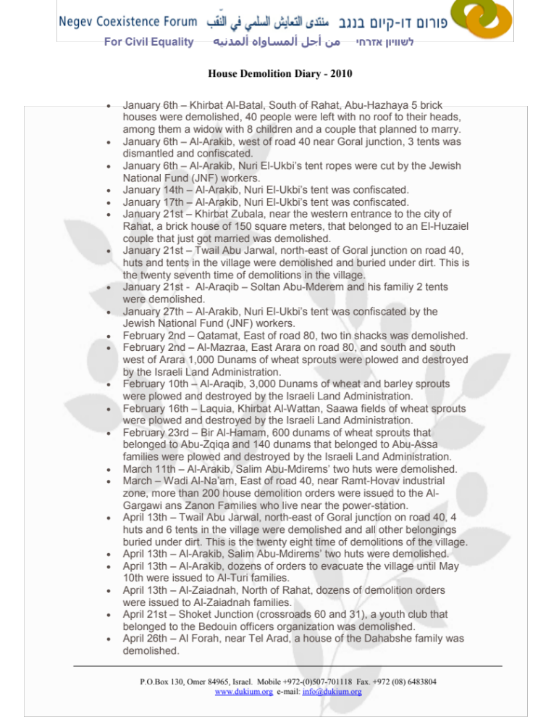
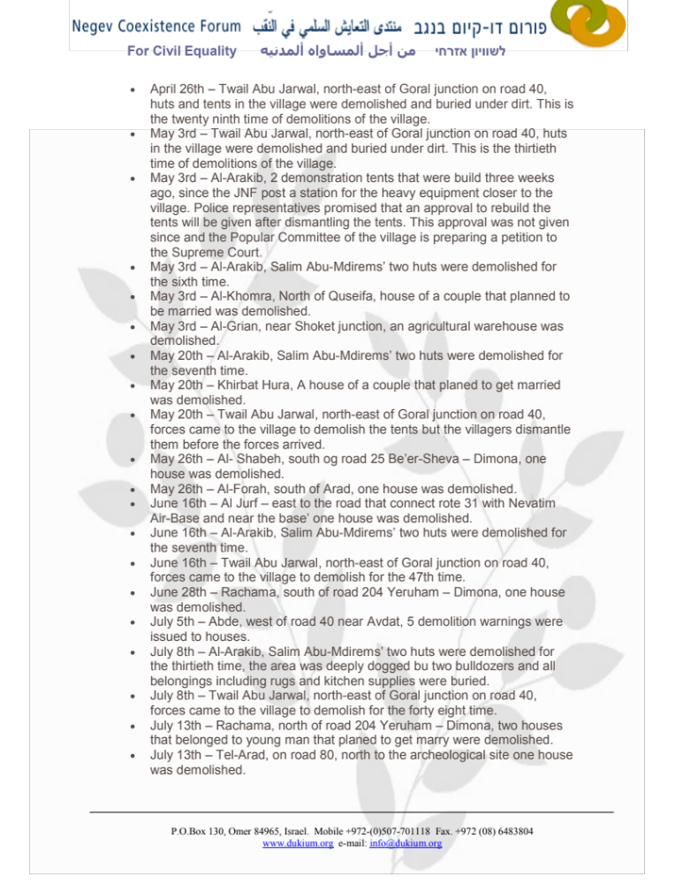

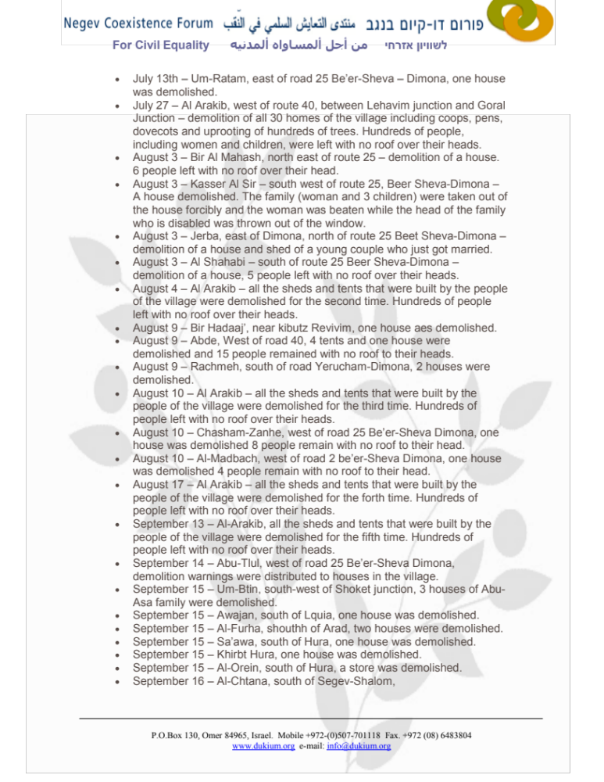

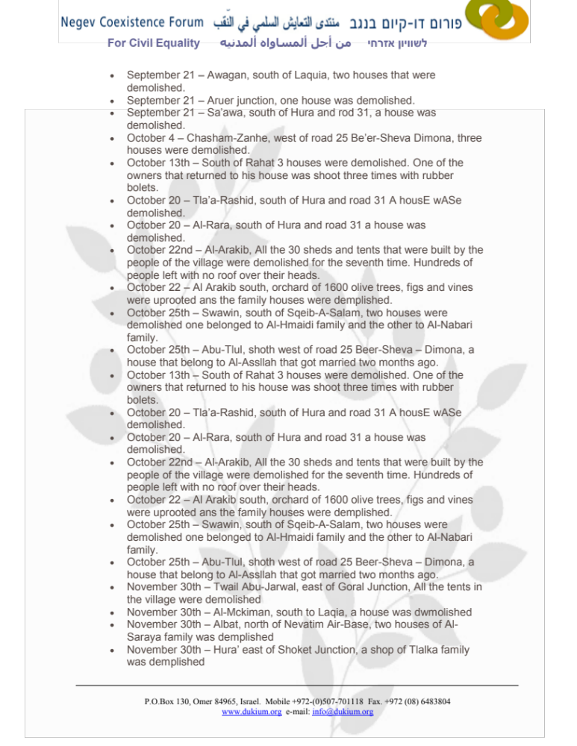

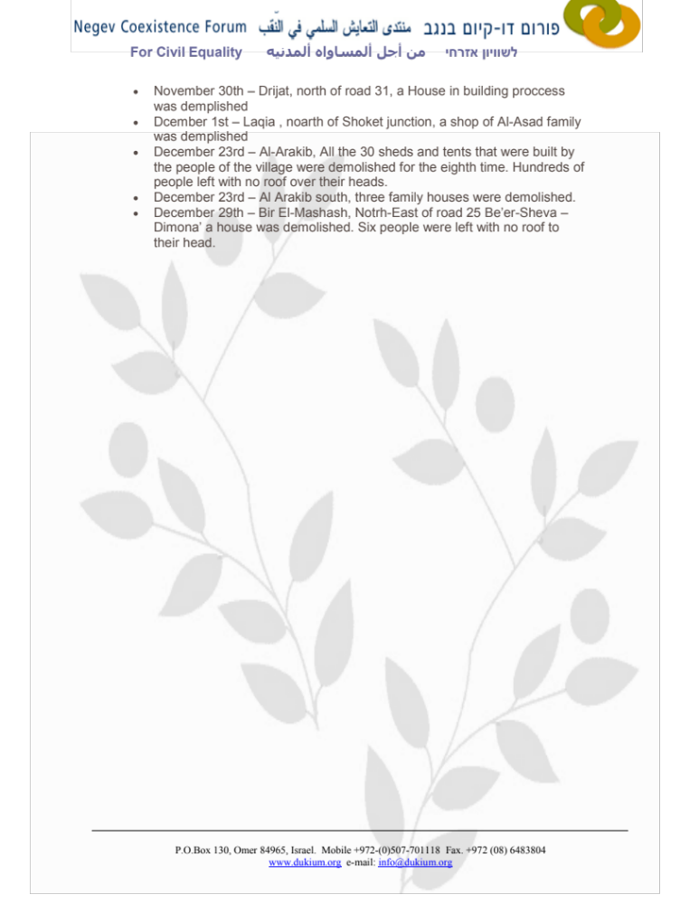

Annex 2

Record of House Demolitions and Crop Spraying during 2011
Negev Coexistence Forum for Civil Equality-http://www.dukium.org/eng/?page_id=885
July 25 – Following a weekend of building by activists and residents to mark the 12-month anniversary of the first mass demolition of the village, the police returned to Al Arakib to demolish all the new structures for the 24th time.
July 12 – Half a dozen shacks outside of the cemetery in Al Arakib were destroyed for the 23rd time.
June 21 – In Al-Grein, south west of Hura and south-west of Road 31, two houses were demolished even though this is a newly recognized town.
June 21 – Near Chasam Zaneh, east of Shqeb A-Salam (Segev-Shalom), three houses were demolished.
June 21 – In Sawawin, east of Shqeb A-Salam (Segev-Shalom), three houses were demolished.
June 21 – In Al Arakib, west of Road 40 between Lehavim and Goral junctions, all the shacks in village were demolished for the 22nd time.
May 31 – In Shqeb-A-Salam, south of Road 25 Be’er-Sheva – Dimona, a warehouse was demolished in the industrial zone.
May 31 – In Al Arakib, west of Road 40 between Lehavim and Goral Junction, two shacks were demolished by “Green Patrol” workers.
May 31 – In Wadi Al-Na’am, near Ramat-Hovav and east of Road 40, three houses were demolished.
May 25 – In Al Forah south of Arad, a large double-storey house where three families lived was demolished. The owners had recently appealed to the Supreme Court for an injunction and this demolition is believed to be illegal. Al Forah was recognized many years ago and is currently subject to a planning process.
May 11 – In Al-Arakib, west of Road 40 between Lehavim and Goral Junctions, all the shacks were demolished for the 21st time.
May 11 – In Al-Bcheira, south of Kuseifa, a sheep pen was demolished
May 11 – In Al-Zarnog, south of Road 25 Be’er-Sheva – Dimona, two houses were demolished.
May 11 – In Al-Rara, south of Hura, a house was demolished.
May 11 – In Umm-Ratam, east of Road 25 Be’er-Sheva – Dimona, a shack was demolished and the police wounded three people and one was arrested.
May 11 – In Al-Qrain, near Shoket Junction, a wall was demolished.
April 17 – In Rachama, north of Road 204 Yeruham – Dimona, a shack was demolished.
April 11 – In Kuseifa, south of Road 31, a stone house was demolished.
April 11 – In Sawa, east of Hura, one house was demolished.
April 6 – The village of Al Arakib, west of Road 40 between Lehavim and Goral Junctions, was demolished for the 20th time.
April 5 – Between Bir Al-Chamam and Um-Batin 1,500 dunams of crops were deep plowed.
March 14 – In Al Forah, south-west of Arad, three structures were demolished.
March 7 – The village of Al Arakib, west of Road 40 between Lehavim and Goral Junctions, was demolished for the 19th time.
March 7 – In Sawawin, south of Sqib A-Salam, an agricultural shade was demolished.
March 7 – In Bir-Hadaj, near Kibbutz Revivim, two houses were demolished.
February 27 – In Al Bcheirah, south of Kuseifa and Road 31, one house was demolished and 10 people remain homeless.
February 27 – In Al Forah, south east of Arad, an agricultural shade was demolished.
February 20 – In Bir-Hadaj, near Kibbutz Revivim, two houses were demolished.
February 17 – The village of Al Arakib, west of Road 40 between Lehavim and Goral Junctions, was demolished for the eighteenth time. The women, men and children who had come from Rahat to support the villagers were fired upon by the police with rubber- and sponge-tipped bullets. Several people were injured, one person was arrested, and five were detained but later released in the evening.
February 16 – The village of Al Arakib, west of Road 40 between Lehavim and Goral Junctions, was demolished for the 17th time. Police fired rubber and sponge-tipped bullets at the residents, and two residents were taken to the hospital. JNF bulldozers continued to prepare the grounds of the village for planting trees.
February 10 – The village of Al Arakib, west of Road 40 between Lehavim and Goral Junctions, was demolished for the 16th time. Activists and residents refused to leave their temporary structures, and women and children were shot by the police. The police then prevented ambulances from arriving to take the wounded (including two women and two children) to the hospital. Additional victims were treated at the village. Three residents, including one minor, and three activists were arrested.
February 9 – The village of Al Arakib, west of Road 40 between Lehavim and Goral Junctions, was demolished for the 15th time. The bulldozers that destroyed the temporary structures belonged to the JNF.
February 8 – The village of Al Arakib, west of Road 40 between Lehavim and Goral Junctions, was demolished for the 14th time.
February 7 – The village of Al Arakib, west of Road 40 between Lehavim and Goral Junctions, was demolished for the 13th time.
February 1 – In Al Arakib, west of Road 40 between Lehavim and Goral Junctions, all the temporary structures and tents were demolished for the 12th time. People were left with no roof over their heads.
January 31 – In Al Arakib, west of Road 40 between Lehavim and Goral Junctions, all 30 temporary structures and tents were demolished for the 11th time. People were left with no roof over their heads. Trucks removed all the materials from the demolitions to the “Dudaim Dump”. Further, the JNF began to develop the ground within the village for planting.
January 26 – In Shqeb-A-Salam, south of Road 25 Be’er-Sheva – Dimona, one structure was demolished.
January 26 – In Al-Sar, near Ohalim Junction, one structure was demolished.
January 17 – In Al Arakib, west of Road 40 between Lehavim and Goral Junctions, all the 30 temporary structures and tents were demolished for the 10th time again leaving all residents without shelter. Approximately 15 trucks removed all the debris of the demolished structures from village. Policemen from a special unit (known as Matpah in Hebrew) carried out this operation. The police left the village, however, later returned shooting rubber- and sponge-tipped bullets at the men, women, and children who had built tents so as to stay there for the night. Nine people were arrested, among them four villagers and some activists from NCF and other NGOs.
January 16 – In Al Arakib, west of Road 40 between Lehavim and Goral Junctions, all 30 temporary structures and tents were demolished for the 9th time. People were left with no roof over their heads and many were wounded from rubber and sponge-tipped bullets, as well as tear gas and pepper spray. Five people, including two teenagers, were taken to Soroka Hospital and three people were arrested.
January 11 – In Quseifa, south of Road 31, a house and three shops were demolished.
January 11 – In Rachama, north of Road 204 Yeruham – Dimona, two houses were demolished leaving 12 people homeless.

Israeli Defense Forces, Video: A Sample of Items Transferred into Gaza from Israel on a Daily Basis, available at http://idfspokesperson.com/2011/06/30/video-a-sample-of-items-transferred-into-gaza-from-israel-on-a-daily-basis/; See also Gaza in Lap of Luxury: Israeli Aid Includes Daily Shipment of Mercedes, HDTVs and Jacuzzis, available at http://www.theblaze.com/stories/gaza-in-lap-of-luxury-israeli-aid-includes-daily-shipment-of-mercedes-hdtvs-and-jacuzzis/.
Ministry of Foreign Affairs, New Government Policy Brings More Goods to Gaza, available at http://www.mfa.gov.il/MFA/HumanitarianAid/Palestinians/New_government_policy_brings_more_goods_to_Gaza_June_2010.htm; See also Ministry of Foreign Affairs, Implementation of Policy Towards the Gaza Strip – Update July 2011, available at http://www.mfa.gov.il/MFA/HumanitarianAid/Palestinians/Implementation_policy_Gaza_Strip-July_2011.htm.
Palestinian Center for Human Rights, The Illegal Closure of the Gaza Strip: Collective Punishment of the Civilian Population, (December 2010), available at http://www.pchrgaza.org/files/2010/Illegal%20Closur.pdf.
Palestinian Center for Human Rights, Weekly Report of Israeli Human Rights Violations in the Occupied Palestinian Territories (June 2-8 2011), available at http://www.pchrgaza.org/portal/en/index.php?option=com_content&view=article&id=7495:weekly-report-on-israeli-human-rights-violations-in-the-occupied-palestinian-territory-02-08-june-2011&catid=84:weekly-2009&Itemid=183.
Id.
Id.
Id.
Id.
United Nations Relief and Works Agency for Palestine Refugees (UNRWA), Labour Market Briefing: Gaza Strip Second Half 2010, available at http://www.unrwa.org/userfiles/201106083557.pdf.
Electronic Intifada, Blockade Denying Gaza Youth Education, Employment, (March 17, 2011), available at http://electronicintifada.net/content/blockade-denying-gaza-youth-education-employment/9270.
UNRWA, Rebuilding Gaza in Haiti, (March 2011), available at http://www.unrwa.org/etemplate.php?id=927.
Aljazeera, Aid Groups Decry Blockade on Gaza, (November 30, 2010), available at http://english.aljazeera.net/news/middleeast/2010/11/20101129153620490258.html.
The Public Commission to Examine the Maritime Incident of 31 May 2010, available at http://www.turkel-committee.gov.il/content-107.html.
Human Rights Council, Report of the International Fact-Finding Mission to Investigate Violations of International Law, Including International Humanitarian and Human Rights Law, Resulting from the Israeli Attacks on the Flotilla of Ships Carrying Humanitarian Assistance, A/HRC/15/21 (September 27, 2010), http://www2.ohchr.org/english/bodies/hrcouncil/docs/15session/A.HRC.15.21_en.pdf.
Maan News Agency, Israel’s Lieberman Rules Out Flotilla Apology, (August 11, 2011), available at http://www.maannews.net/eng/ViewDetails.aspx?ID=412361.
United Press International, Turkey: Israel Attacked Flotilla, (January 25, 2011), available at http://www.upi.com/Top_News/World-News/2011/01/25/Turkey-Israel-attacked-flotilla/UPI-81581295989911/.
Gulf Times, Israel approves plan to halt new Gaza aid flotilla, (June 28, 2011), available at http://www.gulf-times.com/site/topics/article.asp?cu_no=2&item_no=443533&version=1&template_id=37&parent_id=17; See also The Jewish Chronicle Online, Israeli navy on alert as second Gaza flotilla looms, (June 30, 2011), available at http://www.thejc.com/news/israel-news/50997/israeli-navy-alert-second-gaza-flotilla-looms.
The New York Times, Stuck In Dock, Flotilla Activists See the Hand of Israel, (July 1, 2011), available at http://www.nytimes.com/2011/07/02/world/middleeast/02flotilla.html?pagewanted=all.
Jadaliyya, “Breaking the Siege and the Diplomatic Impasse: An Interview with Huwaida Arraf” (July 28, 2011), http://www.jadaliyya.com/pages/index/2244/breaking-the-siege-and-the-diplomatic-impasse_an-i.
Jamjoum, Hazem, Al-Naqab: The Ongoing Displacement of Palestine’s Southern Bedouin, Al-Majdal, (Autumn 2008-Winter 2009) available at http://www.badil.org/en/al-majdal/item/6-al-naqab-the-ongoing-displacement-of-palestine%5C's-southern-bedouin.
Adalah, The Inequality Report: The Palestinian Arab Minority in Israel, (2010). [Hereinafter, “The Inequality Report”]
Tarazi, Monica, “Planning Apartheid in the Naqab,” MERIP, (Winter 2009).
The Inequality Report supra note 21at 36.
See The Negev Coexistence Forum for Civil Equality available at http://www.dukium.org/eng/
Kelper, Tania, Al-Araqib Destroyed for 21st Time, JNF Chnages Facts on the Ground, Alternative Information Center, available at http://www.alternativenews.org/english/index.php/topics/news/3384-el-araqib-destroyed-for-21st-time-jnf-changing-facts-on-ground.
Id.
Israel: Opportunity Gulf between Bedouin in the Negev, IRIN (14 August 2011) available at http://www.irinnews.org/report.aspx?reportid=93389. [Hereinafter “IRIN”]
Knell, Yolande, Israel sues Bedouin for $500,000 in Eviction Costs, BBC, available at http://www.bbc.co.uk/news/world-middle-east-14314883.
See Annex I & II.
See Salim Abu Mdigam vs. the Israel Land Administration, 2887/04.
Israel Land Administration website, “Press release: Clearing of invaded lands in the Negev completed”, accessed October 4 2010: http://www.mmi.gov.il/HodaotmmiInt/show_h.asp?key=916&CodeMaarecet=1 as quoted in Negev Coexistence Forum for Civil Equality, Shadow Report to the Committee on Economic, Social, and Cultural Rights, (October 2010) [Hereinafter “Coexistence Submission CESCR 2010”]
Coexistence Submission CESCR 2010.
Id.
Mahajneh, Alaa, Situating the JNF in Israel’s Land Laws, Al-Majdal Issue No. 43 (Winter – Spring 2010). [Hereinafter “Mahajneh”]
Freeman-Maloy, Dan, Metropolitan Aspects of the World Zionist Organization, Al-Majdal Issue No. 43 (Winter – Spring 2010).
Id.
See Mahajneh supra note 34.
Gordon, Neve, Uprooting the Bedouins of Israel, The Nation, (2 December 2010) available at http://www.thenation.com/article/156822/uprooting-bedouins-israel.
Inequality Report supra note 21 at 21.
As documented by Physicians for Human Rights-Israel see Dan Even, Israeli Bedouin women lack access to prenatal care, Ha’aretz (24 April 2011) available at http://www.phr.org.il/default.asp?PageID=134&ItemID=973.
Id.
IRIN supra note 27.
Coexistence Submission CESCR 2010 supra note 31.
Water centers consist of laying a main water pipe through the center of the village to which the residents connect at certain points a measuring device and private pipe.
Id. at 27.

