 | United Nations | HRI/CORE/CHN/2010
 | International Human Rights  Instruments |  | Distr.: General  10 March 2011  English  Original: Chinese
Core document forming part of the reports of States parties
China
Core document accompanying the second report of the People’s Republic of China on its implementation of the International Covenant on Economic, Social and Cultural Rights
[30 June 2010]
Contents
Page
I. General information 1
A. Geographic, economic, social and cultural characteristics of the State 4
1. Geography and history 4
2. Population 4
3. Economy 6
4. Society and culture 8
B. Constitutional, political systems and judicial framework 10
1. Constitution 10
2. Basic political systems 10
3. Organs of the State 11
4. Judicial framework 14
II. General legal framework within which human rights are protected 18
A. Acceptance of international human rights norms 18
1. Ratification of or accession to major international human-rights
instruments 18
2. Ratification of or accession to other international instruments
related to human rights 24
B. Legal framework for the protection of human rights at the national level 25
1. Legal safeguards for citizens’ rights and political rights 26
2. Legal safeguards for economic, social and cultural rights 28
3. Legal safeguards for the rights of women, children, the disabled,
minority nationalities, and other special groups 29
C. Framework within which human rights are promoted at the national level 30
1. The National Action Plan on Human Rights 30
2. Other major organs for protecting and promoting human rights 31
3. Participation by non-governmental organizations, academic
institutions and the media in safeguarding human rights 32
4. Development of human rights education 33
5. International cooperation in protecting and promoting human rights 34
D. Reporting process at the national level 35
III. Non-discrimination and equality 36
A. Legislation safeguarding the principles of non-discrimination and equality 36
B. Measures to prohibit and eliminate all forms of discrimination 36
1. Measures for non-discrimination and equality in the protection of
women’s rights 36
2. Measures for non-discrimination and equality in the protection
of the rights of the disabled 39
3. Measures for non-discrimination and equality in the protection
of the rights of minority nationalities 41
C. Measures to reduce imbalances in economic and social development
between urban and rural areas and between regions 44
1. Measures to reduce development imbalances between the eastern
and western regions 44
2. Measures to reduce development imbalances between urban
and rural areas 45
Annex 1: Membership of the inter-departmental working group preparing the report on the implementation of the Covenant 47
Annex 2: Non-governmental organizations and academic institutions consulted
during the preparation of the present report 48
Appendix: Figs. 1–32 49
I. General information
A. Geographic, economic, social and cultural characteristics of the State
1. Geography and history
China is located on the Pacific coast of East Asia. Occupying a total land area of 9.6 million square kilometres, it is the third largest country in the world, and the world’s largest developing country. Administratively, it comprises 4 province-level municipalities, 23 provinces, 5 autonomous regions, and 2 special administrative regions; Beijing is the capital city.
China has one of the longest histories in the world. After invasion by foreign powers in 1840, it was gradually reduced to a semi-colonial, semi-feudal status. With the founding of the People’s Republic of China in 1949, however, the Chinese people achieved national independence and liberation and became the true masters of the country, setting up a basic socio-political system to promote and protect human rights. The Chinese Government recovered sovereignty over Hong Kong and Macao in 1997 and 1999 respectively, and constituted them as the Hong Kong and Macao Special Administrative Regions of the People’s Republic of China.
2. Population
(a) Total population, gender structure and urban/rural distribution
China is the world’s most populous country. As of the end of 2009, the population of mainland China stood at 1.33474 billion, which was roughly 21 per cent of the overall population of the world and 33 per cent of the population of Asia. Population density was 139 persons per square kilometre. Males numbered 686.52 million, or 51.4 per cent, of the total population, while females numbered 648.22 million, or 48.6 per cent. A total of 46.6 per cent of the population of mainland China, or 621.86 million people, lived in cities, while 53.4 per cent, or 712.88 million people, lived in rural areas. With the development of China’s economy and society as well as its relentless urbanization, the proportion of urban residents in the overall population continues to rise, growing more than 1.5-fold from 17.92 per cent in 1978 to 46.6 per cent in 2009 (see Fig. 1).
(b) Birth and death rates and the natural rate of growth
In the thirty-odd years since the inauguration of the policy of reform and opening up, China’s population growth pattern has completed the transition from the traditional “high birth-rate, low death-rate, high-growth” model to a modern “low birth-rate, low death-rate, low-growth” model, a process that developed countries usually require a century or more to complete.
China’s birth rate stood at 12.13 per thousand in 2009, a drop of 6.12 per thousand from the 1978 figure of 18.25 per thousand. Its death rate is currently 7.08 per thousand, and has stayed around 7 per thousand for the past thirty years. The natural growth rate is 5.05 per thousand, a decrease of 7 per thousand from the 1978 figure of 12.00 per thousand. The overall year-end population figure rose from 962.59 million in 1978 to 1.33474 billion in 2009, for an average annual growth rate of 10.6 per thousand; this represents a drop of 9.7 per thousand from the 20.3 per thousand average annual growth rate of the pre-reform period (1949–1977). China’s population has entered an era of stable growth (see Fig. 2).
(c) Life expectancy, age structure, and dependency ratio
Since the inauguration of the policy of reform and opening up, rising living standards and progress in public sanitation have contributed to an enormous improvement in the overall health of the Chinese population. Average life expectancy has risen sharply from the 1981 figure of 67.8 years to the 2005 figure of 73.0 years, a gain of 5.2 years; this figure also surpasses the 2005 figure for world life expectancy overall (67 years) and that for average life expectancy in developing countries and regions (65 years). Average life expectancy for males rose from 66.3 years in 1981 to 70.8 years in 2005, while that for females rose from 69.3 to 75.3 years (see Fig. 3).
Accompanying the dramatic decreases in birth and fertility rates, the proportion of children in the general population has also declined, while that of the elderly has risen; the age structure of China’s population is changing from a youth-dominated to an aging model. The proportion of China’s population aged 0–14 years dropped from 33.6 per cent in 1982 to 18.5 per cent; that aged 15–64 years rose from 61.5 per cent in 1982 to 73.0 per cent in 2009, and that aged over 65 years rose from 4.9 per cent in 1982 to 8.5 per cent in 2009.
The proportion of dependent minors fell from 54.6 per cent in 1982 to 25.3 per cent in 2009, while that of the dependent elderly rose from 8.0 per cent in 1982 to 11.6 per cent in 2009; the overall dependency ratio fell from 62.6 per cent in 1982 to 36.9 per cent in 2009. The dependency ratio has stayed below 40 per cent since 2005 (see Fig. 4).
(d) Nationalities, spoken and written languages, religion
In addition to the majority Han nationality, there are 55 other minority nationalities in China. According to statistics from the fifth national census, there were 1.1594 billion Han people in China in 2000, or 91.59 per cent of the total population, and 106.43 million members of minority nationalities, or 8.41 per cent of the total. The Han population had increased by 116.92 million, or 11.22 per cent, from the time of the fourth national census in 1990, while the population of minority nationalities had increased by 15.23 million, or 16.70 per cent, during the same period.
Living standards for minority nationalities have improved greatly since the founding of the People’s Republic of China. With the increasingly broad availability of medical and health care systems, their populations have grown and prospered. Over the period from 1991 to 2000, average yearly growth rates for the populations of 45 minority nationalities, including Mongols, Tibetans, and Uyghurs, have exceeded the overall population’s average yearly growth rate of 10 per thousand; for some minority nationalities, average yearly growth rates have been as high as 44.8 per thousand (the Gaoshan nationality). Minority nationality growth rates are gradually accelerating; the proportion of the overall population they represent has grown from 5.8 per cent in 1964, to 8.0 per cent in 1990, and then to 8.4 per cent in 2000.
Of China’s 55 minority nationalities, only the Manchu and the Hui use the Chinese language (Hanyu). The other 53 minority nationalities have their own languages, and some have sub-branches that use different languages as well, resulting in an overall total of more than 80 languages in the Sino-Tibetan, Altai, Austro-Asiatic, Austronesian and Indo-European language families. Surveys indicate that of the more than 100 million members of minority nationalities in China, over 60 per cent, or 64 million, are able to speak their native languages from childhood. Since the founding of New China, in an effort to promote the development of cultural education among minority nationalities, the relevant departments of the national Government have also assisted the Tai, Li, Miao and Hani nationalities to improve, or in some cases create, their own writing systems. China now has 22 minority nationalities using a total of 28 different types of writing systems; nationwide, roughly 30 million citizens of minority-nationality heritage are using the writing systems of their particular nationality.
China is also a country of many religions, with currently more than 100 million adherents of various religions; major faiths include Buddhism, Daoism, Islam, Catholicism and Protestantism. Since the inauguration of the policy of reform and opening up, adherents of these religions have been steadily increasing in number. For example, Catholicism has been gaining an average of 50,000 adherents per year on average, and currently numbers some 5.5 million adherents; Protestantism is restoring or building nearly 600 churches a year, and now numbers some 16 million adherents (more than 20 times as many as there were in the early years of New China); and the number of Muslims has grown to 21 million from the 1997 figure of 18 million.
3. Economy
(a) Gross domestic product and growth rate, gross national income, consumer price index
In the 60 years since the founding of New China, and especially since the inauguration of the policy of reform and opening up, the overall Chinese economy has manifested historic increases in strength and size. China’s gross domestic product (GDP) stood at 33.5353 trillion yuan renminbi in 2009, an increase of 8.7 per cent over the previous year and third highest in the world after the United States and Japan, and constituted 6.4 per cent of the aggregate volume of the world economy. After adjusting for inflation, 2009 GDP was 86.5 times greater than in 1952, for a yearly average increase of 8.2 per cent; per capita GDP had grown from 119 yuan renminbi to 25,188 yuan renminbi over the same period. After adjusting for inflation, per capita GDP was 36.4 times greater than in 1952, for a yearly increase of 6.6 per cent (see Figs. 5 and 6).
Gross national income (GNI) had increased from 364.52 billion yuan renminbi in 1978 to 33.7313 trillion yuan renminbi in 2009. Per capita GNI stood at US$ 3,700 in 2009. According to World Bank classification, China has surpassed its long-standing status as a low-income country, and has now entered the ranks of lower-middle income countries (see Fig. 7).
China’s consumer price index stood at 99.3 in 2009 (based on the previous year as 100). See Figure 8 for China’s consumer price index over the thirty years since the inauguration of the policy of reform and opening up.
(b) Per capita income, Engel coefficient, consumption structure, proportion of people in poverty
Since the inauguration of the policy of reform and opening up, and with the development of the economy, Chinese citizens’ income has rapidly increased in both urban and rural areas. Annual urban per-capita disposable income rose from 343.4 yuan renminbi in 1978 to 17,175 yuan renminbi in 2009, and annual rural per-capita net income rose from 133.6 yuan renminbi to 5,153 yuan renminbi in 2009 (see Fig. 9).
As incomes have risen, the Engel coefficient for urban and rural households has undergone a noticeable decline. That figure had already fallen below 60 per cent by 1991, indicating that extreme poverty had been largely eliminated and people’s basic needs for food and clothing were being met. By 2009, the figure had declined a further 21 percentage points to 36.5 per cent from the 1978 figure of 57.5 per cent for urban households; for rural households it had declined 26.7 percentage points to 41 per cent from 67.7 per cent over the same period. The living standards of both urban and rural households are now more than adequate to meet their basic food and clothing needs, and they are making strides towards becoming moderately well-off (see Fig. 10); medical care, education and entertainment services have developed, and the proportion of recreational consumption has markedly increased (see Figs. 11 and 12).
The rise in the people’s living standards also demonstrates that the number and proportion of poor people in the overall population have greatly declined. Since the inauguration of the policy of reform and opening up, China has carried out a strategy of poverty alleviation and development, and has succeeded in realizing a large-scale reduction in poverty by means of economic development, specialized poverty-alleviation programmes, general urban and rural planning, social participation and other measures. There were 250 million people in absolute poverty in 1978; that figure had been reduced to 14.79 million by 2007; the 1978 poverty rate of 30.7 per cent had fallen to 1.6 per cent over the same period. China was the first country in the world to achieve the United Nations Millennium Development Goal on poverty reduction. China revised its poverty standard in 2008 to include the low-income population among the overall numbers of the poor, thereby broadening the scope of those covered under poverty-assistance programmes. Recent figures indicate that the rural poor numbered 35.97 million in 2009, and the incidence of poverty stood at 3.8 per cent (see Fig. 13).
(c) Labour and employment
China has a large population and labour force, and implements a policy whereby workers find employment on their own initiative, the market regulates the demand for employment, and the government promotes employment. The Government has adopted an active employment policy; as it strives to create employment opportunities for workers and continuously expand the scope of employment, the overall labour structure is gradually optimized and unemployment is effectively controlled.
(i) The working population
The working population of China was 779.95 million in 2009, a 94 per cent increase over the 1978 figure of 401.52 million. Urban employment grew even faster, having increased 2.27 times the 1978 figure to 311.2 million in 2009 (see Figs. 14 and 15).
(ii) Employment conditions in various sectors of the national economy
With the changes in China’s industrial structure, employment in secondary industries and the service sector has grown rapidly while employment in primary industries has declined, resulting in the optimization of the overall employment structure. There were 297.08 million people employed in the primary sector in 2009, for 38.1 per cent of overall employment; 27.8 per cent, or 216.84 million, were employed in the secondary sector; and 34.1 per cent, or 266.03 million were employed in the service sector. Compared to the 1952 figures, primary-sector employment had decreased by 45.4 per cent, while secondary and service-sector employment had risen by 20.4 and 25.0 per cent respectively (see Fig. 16).
(iii) Unemployment rates
The Chinese Government has implemented a series of positive employment policies, including reduced or waived taxes and fees, guaranteed small loans, social security benefits and subsidies, occupational subsidies, training subsidies, employment services and employment assistance, in an effort to resolve the problem of finding employment for the large number of workers laid off as a result of changes in the structure of the economy. In the context of the international financial crisis, the Government has also drafted a series of policies to assist the large numbers of rural workers returning home from the cities, as well as graduating college students, to find work, and to reduce the negative impact of the financial crisis to the greatest extent possible. The registered urban unemployment rate stood at 4.3 per cent at the end of 2009, still a relatively low figure (see Fig. 17).
(iv) Proportion of workers participating in trade unions
Workers in China enjoy the right to join trade unions. The overall proportion of labourers in trade unions has been trending upwards, and has been above 90 per cent since 1990. In 2008, 94.35 per cent, or 212 million, workers and staff were participating in trade unions (see Fig. 18).
4. Society and culture
(a) Health and medicine
(i) Major communicable diseases and the ten leading causes of death
In the sixty years since the founding of New China, and particularly since the inauguration of the policy of reform and opening up, China has established relatively comprehensive systems for disease prevention and control, and also for medical and health services, at the national, provincial, metropolitan and county levels. Historically, contagious diseases posed a serious threat to the health, lives and safety of the Chinese people; during the 1950s, contagious and parasitic diseases were the leading cause of death throughout the country. After years of effort, the incidence of and mortality rate associated with contagious diseases had fallen precipitously by 2008, declining to the lowest rank of the ten leading causes of death among the Chinese population (see Figs. 19 and 20).
China is also the first developing country to eradicate major infectious diseases like smallpox and poliomyelitis. The Chinese Government conscientiously took account of the lessons learned from its experience in combating the 2003 SARS epidemic, and successfully controlling the spread of avian influenza and influenza type A (H1N1) in 2004 and 2009 respectively. Nor was there a major epidemic following the disastrous earthquake in Sichuan province in 2008.
China is strengthening systems to prevent, control and treat serious infectious diseases like HIV/AIDS, tuberculosis, schistosomiasis and hepatitis B. It provides treatment free of charge for those suffering from HIV/AIDS, tuberculosis and schistosomiasis, and has set up a working committee on HIV/AIDS prevention and treatment under the State Council; the budget for prevention and treatment is being increased yearly.
(ii) Mortality rates for infants and women in pregnancy and childbirth
Advances in China’s medical care and sanitation have brought positive progress in maternal and child health; mortality rates for infants and women in pregnancy and childbirth have undergone a clear and sustained decline. Data indicate that infant mortality had fallen from 200 per thousand in the early years of the People’s Republic to 50.2 per thousand by 1991, and declined further to 13.8 per thousand by 2009. Mortality among new-borns declined from 33.1 per thousand in 1991 to 9.0 per thousand in 2009; mortality rates for women in pregnancy and childbirth had fallen from 1,500 per hundred thousand in the early years after Liberation to 80 per hundred thousand by 1991, and declined further to 31.9 per hundred thousand by 2009 (see Fig. 21).
(b) Culture and education
(i) Rates of literacy, school admissions and advancement to higher grades
The Chinese Government implements a strategy of revitalizing the country through science and education, and consistently prioritizes the development of education. In the 60 years since the foundation of New China, the universalization of basic education has been steadily gaining ground. Nine-year compulsory education was essentially established throughout China as early as the end of 2000, wiping out youth illiteracy and achieving the United Nations Millennium Development Goal of universal primary education ahead of schedule. Overall rates of illiteracy dropped from 33.58 per cent in 1964 to 6.6 per cent in 2008. By the end of 2008, free compulsory education had become a reality in both urban and rural areas. By 2009, a net 99.4 per cent of school-age children were entering elementary school, essentially universalizing elementary education. In 1990, 74.6 per cent of primary-school students went on to higher grades; by 2009 that proportion had increased to 99.1 per cent; for junior middle-school students, that percentage was 40.6 per cent in 1990, increasing to 85.6 per cent by 2009; and for senior middle school students it was 27.3 per cent in 1990, increasing to 77.6 per cent by 2008 (see Fig. 22).
(ii) Student-teacher ratios
After years of investment in education, the ratio of students to teachers has attained reasonable levels at schools at all levels throughout China. In 2009, the student-teacher ratio for primary schools was 17.9, for junior middle schools it was 15.5, for regular senior middle schools it was 16.3, and for regular colleges and universities it was 17.3 (see Fig. 23).
(c) Social security
For many years, the Chinese Government has been working to build a comprehensive social security system that keeps pace with the level of economic development. Since the inauguration of the policy of reform and opening up, and especially since the 1990s, social security in China has been developing rapidly, and a social security system comprising social insurance, social assistance and social welfare has basically taken shape.
A social security system comprising urban retirement insurance, unemployment insurance, occupational injury insurance, maternity insurance, medical insurance for urban workers, and basic medical insurance for urban residents has been set up and is developing rapidly. A total of 234.98 million people were covered under urban retirement insurance by the end of 2009, nearly 4,1 times the coverage figure for 1989 (see Fig. 24). 2009 coverage figures for unemployment insurance (127.15 million people), occupational injury insurance (148.61 million people), maternity insurance (108.60 million people), and basic medical insurance for urban workers (219.61 million people) were respectively 1.60, 8.16, 11.86 and 54.9 times their 1994 levels (see Fig. 25). A social and retirement insurance system for residents of rural areas is currently under active exploration, and pilot projects to test new types of rural medical care reforms are being introduced at an accelerated rate. By the end of 2009, the New Rural Cooperative Medical System had been launched in 2,716 counties (including rural municipalities and districts), covering 830 million people for a participation rate of 94.0 per cent (see Fig. 26).
Additionally, the Chinese Government has set up a number of social assistance systems, such as minimum cost of living subsidies, providing security for the lives of low-income residents. A total of 2.35 million people were receiving unemployment insurance payments in late 2009, and as of the end of 2009, a total of 234.56 million urban residents and 476 million rural residents were receiving minimum cost of living subsidies from the Government.
B. Constitution, political systems and judicial framework
1. The Constitution
The Constitution is the fundamental law of the People’s Republic of China. The current Constitution of the People’s Republic of China was adopted at the fifth session of the Fifth National People’s Congress on 4 December 1982 and promulgated by the Congress on the same day. Amendments to the Constitution were adopted at the first session of the Seventh National People’s Congress on 12 April 1988, the first session of the Eighth National People’s Congress on 29 March 1993, the second session of the Ninth National People’s Congress on 15 March 1999, and the second session of the Tenth National People’s Congress on 14 March 2004.
The Constitution provides that the People’s Republic of China is a socialist State under the democratic dictatorship of the people, based on the alliance of the workers and peasants and led by the working class. The socialist system is the fundamental system of the People’s Republic of China. All power in the People’s Republic of China belongs to the people. The organs of State apply the principle of democratic centralism.
Incorporating the spirit of the Universal Declaration of Human Rights, the Constitution clearly provides that the State respects and preserves human rights. The “Fundamental Rights and Duties of Citizens”, in Chapter 2 of the Constitution, include the equality of all citizens before the law, the right to vote and stand for election, and the civic and political rights of freedom of speech, of the press, of assembly, of association, of procession, of demonstration, of religious belief, of correspondence, and of the person, as well as the economic, social and cultural rights to work, to leisure, to education, to social security, and to engage in cultural pursuits. The Constitution also specifically provides for the protection of the rights of women, the elderly, minors, the disabled, minority nationalities, foreigners and other special groups.
2. Basic political systems
The system of people’s congresses, the system of multi-party cooperation and political consultation under the leadership of the Communist Party of China (CPC), and the system of regional national (ethnic) autonomy are the three major basic political systems of the People’s Republic of China.
(a) The system of people’s congresses
The system of people’s congresses is a basic political system in China. All power in the People’s Republic of China belongs to the people, who exercise State power through the National People’s Congress and local people’s congresses at all levels, formulating laws and regulations and resolving important issues at the State and local levels. The administrative, judicial and supervisory organs of the State are created by the people’s congresses, and are responsible to and supervised by them. The people’s congresses are in turn created by the people through democratic elections, in which all citizens 18 years of age and above have the right to vote and to stand for election. People’s congresses at the county and township levels are directly elected by the people. Voter turnout rates have consistently exceeded 90 per cent for many years.
(b) The system of multi-party cooperation and political consultation
The system of multi-party cooperation and political consultation under the leadership of the CPC is the political party system of the People’s Republic of China. In addition to the CPC, a total of eight democratic parties (the Revolutionary Committee of the Chinese Guomindang, the China Democratic League, the China Democratic National Construction Association, the China Association for Promoting Democracy, the Chinese Peasants’ and Workers’ Democratic Party, the China Party for Public Interest, the Jiusan Society, and the Taiwan Democratic Self-Government League) participate with the ruling party in managing the affairs of State and in drafting and implementing laws and regulations. The Chinese People’s Political Consultative Conference is the main forum for multi-party cooperation and political consultation under the leadership of the CPC.
(c) The system of regional national (ethnic) autonomy
China adheres to the principle that all nationalities are equal, and implements a system of regional national (ethnic) autonomy whereby regions whose population primarily comprises minority nationalities exercise autonomy, establish autonomous official organs, and exercise autonomous rights, including the right to enact their own legislation and manage their own affairs in the areas of economics, education, science, culture and health.
3. Organs of the State
The State organs of the People’s Republic of China include the National People’s Congress, the President of the People’s Republic of China, the State Council of the People’s Republic of China, the Central Military Commission of the People’s Republic of China, local People’s Congresses and People’s Governments at all levels, the organs of self-government of the national autonomous areas, the People’s Courts and the People’s Procuratorates.
(a) The National People’s Congress
The National People’s Congress of the People’s Republic of China is the highest organ of State power; each of its sessions lasts for five years, and it meets once yearly. Its permanent subsidiary organ is the Standing Committee of the National People’s Congress. The Congress and its Standing Committee exercise the legislative power of the State.
The functions and powers and powers of the Congress include amending the Constitution; supervising the enforcement of the Constitution; drafting and amending legislation; electing or removing the President and Vice-President of the People’s Republic of China as well as the Chairman of the Central Military Commission, the President of the Supreme People’s Court and the Procurator-General of the Supreme People’s Procuratorate; and appointing or removing the Premier, Vice-Premiers, State Councillors, Ministers in charge of Ministries or Commissions, and the Auditor-General and the Secretary-General of the State Council.
The powers exercised in accordance with the Constitution by the Standing Committee when the Congress is not in session include: interpreting the Constitution and supervising its enforcement; drafting and amending legislation other than that falling under the purview of the Congress itself; and supervising the work of the State Council, the Central Military Commission, the Supreme People’s Court and the Supreme People’s Procuratorate.
(b) The President of the People’s Republic of China
The President of the People’s Republic of China is the head of State, and is elected by the National People’s Congress for a term coinciding with that of the Congress itself; the President may serve for no more than two terms in succession. Pursuant to the decisions of the National People’s Congress and its Standing Committee, the State President promulgates statutes; appoints and removes the Premier, Vice-Premiers, State Councillors, Ministers in charge of Ministries or Commissions, and the Auditor-General and the Secretary-General of the State Council; confers State medals and titles of honour; issues orders of special pardons; proclaims martial law; proclaims states of war; and issues mobilization orders. The president represents the People’s Republic of China in carrying out the affairs of State and receiving foreign diplomatic representatives, and pursuant to decisions of the Standing Committee of the National People’s Congress, appoints and recalls plenipotentiary representatives abroad, and ratifies and abrogates treaties and important agreements concluded with foreign States.
(c) State Council of the People’s Republic of China
The State Council, that is, the Central People’s Government of the People’s Republic of China, is the executive body of the highest organ of State power, and is the highest organ of State administration. It is composed of the Premier, Vice-Premiers, State Councillors, Ministers in charge of Ministries or Commissions, the Auditor-General and the Secretary-General. The Premier has overall responsibility for the State Council. The Ministers have overall responsibility for the respective ministries or commissions under their charge. The term of office of the State Council is the same as that of the National People’s Congress. The Premier, Vice-Premiers and State Councillors shall serve no more than two consecutive terms.
Among its other functions, the State Council adopts administrative measures, enacts administrative rules and regulations and issues decisions and orders in accordance with the Constitution and the statutes; submits proposals to the National People’s Congress or its Standing Committee; lays down the tasks and responsibilities of the ministries and commissions of the State Council, exercising unified leadership over the work of the ministries and commissions and directing all other administrative work of a national character that does not fall within the jurisdiction of the ministries and commissions; exercises unified leadership over the work of local organs of State administration at various levels throughout the country, laying down the detailed division of functions and powers between the Central Government and the organs of State administration of provinces, autonomous regions and province-level municipalities; draws up and implements the plan for national economic and social development and the State budget; and decides on the enforcement of martial law in parts of provinces, autonomous regions and province-level municipalities.
The State Council is responsible, and reports on its work, to the National People’s Congress or, when the National People’s Congress is not in session, to its Standing Committee.
(d) The Central Military Commission
The Central Military Commission of the People’s Republic of China directs the armed forces of the country, and is composed of the Chairman, the Vice-Chairmen, and Members. The Chairman of the Central Military Commission has overall responsibility for the Commission. The term of office of the Central Military Commission is the same as that of the National People’s Congress. The Chairman of the Central Military Commission is responsible to the National People’s Congress and its Standing Committee.
(e) Local people’s congresses and local people’s governments at various levels
People’s congresses and people’s governments are established in provinces, province-level municipalities, counties, cities, municipal districts, townships, nationality townships and towns. The local people’s congresses at various levels are local organs of State power, and they serve five-year terms of office. Local people’s congresses at and above the county level establish standing committees. Local people’s congresses at various levels ensure the observance and implementation of the Constitution and the statutes and the administrative rules and regulations in their respective administrative areas. Within the limits of their authority as prescribed by law, they adopt and issue resolutions and examine and decide on plans for local economic and cultural development and for development of public services.
Local people’s governments at various levels are local organs for the administration of State power, and their terms of office are the same as those for the local people’s congress at the corresponding level. Local people’s governments at various levels are responsible, and report on their work, to the local people’s congress at the corresponding level and to the State administrative organs at the next higher level. Local people’s governments at various levels throughout the country are State administrative organs under the unified leadership of the State Council and are subordinate to it.
(f) The organs of self-government of national autonomous areas
The organs of self-government of national autonomous areas are the people’s congresses and people’s governments of autonomous regions, autonomous prefectures and autonomous counties. The chairmanship and vice-chairmanships of the standing committee of the people’s congress of an autonomous region, prefecture or county shall include a citizen or citizens of the nationality or nationalities exercising regional autonomy in the area concerned. The administrative head of an autonomous region, prefecture or county shall be a citizen of the nationality, or of one of the nationalities, exercising regional autonomy in the region concerned. The organs of self-government of autonomous regions, prefectures and counties exercise the functions and powers of local organs of State as specified in the Constitution. At the same time, they exercise the right of autonomy within the limits of their authority as prescribed by the Constitution, the law of regional national autonomy and other laws, and implement the laws and policies of the State in the light of the existing local situation.
(g) The people’s courts
The people’s courts in the People’s Republic of China are the judicial organs of the State. The People’s Republic of China establishes the Supreme People’s Court as well as the local people’s courts at various levels, military courts and other special people’s courts. The people’s courts exercise judicial power independently, in accordance with the law, and are not subject to interference by administrative organs, public organizations or individuals. The term of office of the President of the Supreme People’s Court is the same as that of the National People’s Congress; he or she serves no more than two consecutive terms. The Supreme People’s Court supervises the administration of justice by the local people’s courts at various levels and by the special people’s courts; people’s courts at higher levels supervise the administration of justice by those at lower levels. The Supreme People’s Court is responsible to the National People’s Congress and its Standing Committee. Local people’s courts at various levels are responsible to the organs of State power which created them.
(h) The people’s procuratorates
The people’s procuratorates of the People’s Republic of China are State organs for legal supervision. The People’s Republic of China establishes the Supreme People’s Procuratorate, the local people’s procuratorates at various levels, military procuratorates, and other special people’s procuratorates. People’s procuratorates exercise procuratorial power independently, in accordance with the law, and are not subject to interference by administrative organs, public organizations or individuals. The Supreme People’s Procuratorate is the highest procuratorial organ. The term of office of the Procurator-General of the Supreme People’s Procuratorate is the same as that of the National People’s Congress; he or she serves no more than two consecutive terms. The Supreme People’s Procuratorate directs the work of the local people’s procuratorates at various levels and of the special people’s procuratorates; people’s procuratorates at higher levels direct the work of those at lower levels. The Supreme People’s Procuratorate is responsible to the National People’s Congress and its Standing Committee. Local people’s procuratorates at various levels are responsible to the organs of State power at the corresponding levels which created them and to the people’s procuratorates at the higher level.
4. Judicial framework
(a) Judicial organs
The courts and procuratorates are the judicial organs of China. Additionally, although the organs of public and State security and of judicial administration are administrative in function, they also have a partially judicial function.
The people’s courts include the Supreme People’s Court, local people’s courts at various levels, and specialized people’s courts. Local people’s courts are divided into basic, intermediate and superior people’s courts. The duties of the local people’s courts at various levels are primarily (1) to try criminal cases, punish offenders and maintain social order; (2) to try civil cases, resolve civil disputes, and protect the legitimate rights of those involved; (3) to try administrative litigation cases, protect the legitimate rights of individual citizens, corporations and other organizations, and ensure and see to it that administrative organs discharge their functions in accordance with the law; and (4) to carry out judicial judgments and rulings that have come into effect.
The people’s procuratorates include the Supreme People’s Procuratorate, local people’s procuratorates at various levels, and specialized people’s procuratorates. Local people’s procuratorates at various levels are divided into people’s procuratorates of provinces, autonomous regions and province-level municipalities; intermediate people’s procuratorates of provinces, autonomous regions and province-level municipalities; people’s procuratorates of autonomous prefectures and provincially-administered municipalities; and people’s procuratorates of counties, cities, autonomous counties and municipal districts. The duties of the local people’s procuratorates at various levels are primarily (1) to exercise procuratorial authority over major cases of treason, splitting the State and serious damage to the unified enforcement of State law; (2) directly accept, file and bring cases against, and investigate cases of offences committed by State employees; (3) review cases investigated by public and State security organs and determine whether to approve arrest, prosecute or to exempt from prosecution, as well as exercise supervision over the investigatory activities of public and State security organs to determine whether those activities conform to the law, and additionally to investigate and follow up on cases of unlawful arrests, searches, investigations and evidence-gathering; (4) initiate public prosecutions of criminal cases and support such prosecution, and exercise supervision over the criminal and civil trials and administrative proceedings of people’s courts to determine whether they conform to the law; and (5) exercise supervision over the execution of judgments and organs in criminal cases and over the activities of prisons, detention houses and organs in charge of reform through labour to determine whether such executions and activities conform to the law.
The organs of public and State security and of judicial administration are constituent parts of the organs of State administration, and also have a partially judicial function, primarily as follows: (1) the organs of public security are responsible for the investigation of criminal cases, including investigation, detention, preliminary hearing, and executing arrests; (2) the organs of State security at various levels are responsible for investigating cases of espionage, and can carry out the investigation, detention, preliminary hearing, and arrest functions of the organs of public security under the Constitution, laws and regulations; and (3) the organs of judicial administration manage the work of prisons and the reform of criminals through labour, as well as providing leadership for and supervision of lawyers, notarial offices and people’s mediation committees.
(b) The legal system and just judicature
China consistently maintains that all persons are equal before the law, and is working to uphold judicial and social justice and guarantee citizens’ legitimate rights through the exercise of systems of open public trials, collegial judgment panels, people’s assessors, recusal of judges, limitation of second-instance trials, and court costs assistance.
(i) Open public trials. Trials in people’s courts are conducted in accordance with the principles of fairness, timeliness and openness. Article 125 of the Constitution provides that “All cases handled by the people’s courts, except for those involving special circumstances as specified by law, shall be heard in public”. Judgments in closed trials are uniformly pronounced in public as well. Prior notice is given for trials that are to be held in public, and citizens and reporters for the media are permitted to witness the proceedings. People’s courts also invite members of people’s congresses and people’s political consultative committees to witness that the presentation of evidence, cross-examination and the overall case proceedings are conducted openly, and provide effective information that each important segment of the process, from filing the case through the trial to the conclusory work, is carried out with a view to protecting the rights of the parties concerned.
(ii) Collegial judgment panels. Article 10 of the Organic Law of the People’s Courts of the People’s Republic of China provides that the people’s courts shall adopt the collegial system in the administration of justice. Cases of first instance in the people’s courts shall be tried by a collegial panel of judges or of judges and people’s assessors; simple civil cases, minor criminal cases and cases otherwise provided for by law may be tried by a single judge. Appealed or contested cases in the people’s courts are handled by a collegial panel of judges. The collegial panel must comprise an odd number of members.
(iii) People’s assessors. With the exception of summary procedural cases or cases falling under other provisions of the law, first-instance trials of civil, administrative or criminal procedural cases of relatively high social significance, as well as of cases in which the accused (in a criminal case), the plaintiff or the accused (in a civil case), or the plaintiff (in an administrative case) petitions for the participation of people’s assessors, are conducted with collegial judgment panels comprising people’s assessors as well as judges, in order to guarantee the people’s participation in the judicial process in accordance with the law, and promote fairness in the trial system. Although they are not permitted to serve as presiding judges, people’s assessors participating in collegial judgment panels under the law have the same rights and perform the same functions as other members of the panel, and exercise the same power to vote independently on the findings of the court and the application of the law.
(iv) Recusal of judges. If a party to a case feels that a judge has a conflict of interest in that case, or that the judge has some other connection with parties to the case that would affect his or her ability to render a fair and impartial judgment, that person has the right to request the recusal of the judge concerned. If the judge is himself or herself a party to the case, or a close relative of one of the legal representatives, or feels that he or she has a conflict of interest or other interest in the case, he or she must withdraw from the case.
(v) Second-instance limitation for trials. Article 12 of the Organic Law of the People’s Courts provides that “In the administration of justice, the people’s courts adopt the system whereby the second instance is the last instance”. If a party to the case does not accept a judgment or ruling of first instance of a local people’s court at a particular level, that party may bring an appeal to the people’s court at the next higher level within the time limit prescribed by law; and if the people’s procuratorate is of the view that a judgment or ruling of first instance is erroneous, may present a protest to the people’s court at the next higher level within the time limit prescribed by law. With the exception of death-penalty cases, which require review by the Supreme People’s Court, the superior people’s courts handle such appeals or protests as second-instance proceedings, and their judgments or rulings in such cases are considered final. Judgments and rulings of first instance of the Supreme People’s Court are also considered final.
(vi) Court costs assistance. For parties to a case who have authentic financial difficulties, the people’s courts defer, reduce or waive entirely the payment of costs associated with the case in order to preserve the legal right of such persons to bring civil or administrative proceedings in the people’s courts. The Supreme People’s Court and the relevant authorities have issued regulations on the provision of court costs assistance to parties with authentic financial difficulties, with a view to guaranteeing the right of access of such persons to the judicial process.
(c) Other information regarding the judicature
(i) Statistics on police, judges and procurators
As of 2009, there were 1.90 million police officers in China’s organs of public security. At the same time, there were 190,216 judges and 140,000 procurators in China. Proportionally, there were 14.6 police officers and 10.5 procurators per hundred thousand members of the overall population.
(ii) Criminality
See Fig. 27 for a table of the number and types of criminal cases filed by the public security organs in 2007 and 2008.
(iii) Pre-trial detention
Under the provisions of the Criminal Procedure Law of the People’s Republic of China, as amended in 1996, persons taken into custody by the organs of public security are to be questioned within 24 hours of being detained. Those discovered to have been wrongfully detained must be released immediately. If the public security organ finds it necessary to arrest a detainee before sufficient evidence has been gathered, the detainee may obtain a guarantor pending trial or be placed under residential surveillance (article 65). The period granted by a people’s court, people’s procuratorate or public security organ to a criminal suspect or defendant for awaiting trial after obtaining a guarantor shall not exceed twelve months; the period for residential surveillance shall not exceed six months (article 58).
If the public security organ deems it necessary to arrest a detainee, it shall, within three days after the detention, submit a request to the people’s procuratorate for examination and approval. Under special circumstances, the time limit for submitting a request for examination and approval may be extended by one to four days. As to the arrest of a major suspect involved in crimes committed in a series of locations, serial offences, or crimes committed by a gang, the time limit for submitting a request for examination and approval may be extended to 30 days. The people’s procuratorate shall decide either to approve or disapprove the arrest within seven days from the date of receiving the written request for approval of arrest submitted by a public security organ. If the people’s procuratorate disapproves the arrest, the public security organ shall, upon receiving notification, immediately release the detainee (article 69).
The time limit for holding a criminal suspect in custody during investigation after arrest shall not exceed two months. If the case is complex and cannot be concluded within the time limit, an extension of one month may be allowed with the approval of the People’s Procuratorate at the next higher level (article 124). If investigation cannot be concluded within the time limit, an extension of two months may be allowed upon approval or decision by the people’s procuratorate of a province, autonomous region or province-level municipality (article 126). If in the case of a criminal suspect liable for sentencing to fixed-term imprisonment of ten years or longer, investigation of the case can still not be concluded upon expiration of the extended time limit as provided in Article 126, another extension of two months may be allowed upon approval or decision by the people’s procuratorate of a province, autonomous region or province-level municipality (article 127). If, owing to special circumstances, it is not appropriate to hand over a particularly grave and complex case for trial even within a relatively longer period of time, the Supreme People’s Procuratorate shall submit a report to the Standing Committee of the National People’s Congress for approval of postponing the hearing of the case (article 125).
In cases that a public security organ has completed investigating and has transferred to it, a people’s procuratorate shall decide within one month whether or not to recommend bringing it to court; an extension of a half month may be allowed for major or complex cases (article 138).
Chinese judicial authorities make their decisions regarding the pre-trial detention of criminal suspects in strict accordance with the relevant provisions of the Criminal Procedure Law.
(iv) Death penalty system
China has not yet abolished the death penalty, but controls it strictly and applies it sparingly. It is applied only to a very few criminals who have committed the most serious crimes, and is not imposed on persons who had not reached the age of 18 at the time the crime was committed or to women who are pregnant at the time of trial. In order substantively to reduce the use of the death penalty, China has instituted a death-penalty reprieve system, whereby execution is postponed for two years in cases when not immediately required; if no further crimes are deliberately committed during the two-year reprieve period, the sentence is reduced to life imprisonment, or to 15 to 20 years’ fixed-term imprisonment for particularly meritorious behaviour.
From 1 July 2006 onward, all death-penalty trials of the second instance have been conducted publicly. From 1 January 2007 onward, all death-penalty review powers have uniformly reverted to the Supreme People’s Court. In principle, the review of a death penalty by the Supreme People’s Court entails the arraignment of the accused, and a visit to the scene of the crime when necessary. The Supreme People’s Court is currently in the process of improving the death-penalty review procedure, and unifying standards for the application of the death penalty, so as to ensure that such cases are reviewed with rigour, discretion and fairness.
(v) Legal aid
The new Criminal Procedure Law and the Law of the People’s Republic of China on Lawyers, adopted in 1996, both contain provisions on legal aid. If the defendant involved has not engaged anyone to advocate on his or her behalf owing to financial difficulties or other reasons, the People’s Court may designate a lawyer who has the duty to provide legal assistance by advocating on his or her behalf. If the defendant is blind, deaf or mute, or is a minor, and thus has not engaged anyone to advocate on his or her behalf, the People’s Court shall designate a lawyer who has the duty to provide legal assistance by advocating on his or her behalf. Where citizens require legal assistance with regard to support, industrial injury, criminal procedure, claims for State indemnity and claims for pension payments under the law, they may, if they cannot afford to pay the service fee, obtain legal aid in accordance with the provisions of State laws.
In 1997, China established a Legal Aid Centre in the Ministry of Justice, to provide unified leadership and consultation on legal assistance work nationwide. The China Legal Aid Foundation was established at the same time, with the primary function of collecting, administering and using funds for legal aid, as well as publicizing the national legal aid system and promoting a just judicature. Legal aid centres are also being established throughout the country at the provincial and prefectural-municipality levels, as well as in local counties and districts that meet the requirements, in order to organize and carry out legal aid work. In counties and districts that do not meet the requirements for setting up a legal aid organ, the substantive organization of legal aid work is carried out by the county or district justice bureau. Currently, a four-tiered organizational framework for legal aid in China has been put in place at the national, provincial, prefectural-municipality, and county or district levels; a total of 318,514 legal-aid cases of all types had been handled throughout the country as of 2006, and legal information services had been provided 3,193,801 times.
II. General legal framework within which human rights are protected
A. Acceptance of international human rights norms
1. Ratification of or accession to major international human-rights instruments
(a) Major international human-rights instruments ratified or acceded to
As of 2009, China had ratified or acceded to the following major international human-rights instruments:
(i) The International Covenant on Economic, Social and Cultural Rights;
(ii) The International Convention on the Elimination of All Forms of Racial Discrimination;
(iii) The Convention on the Elimination of All Forms of Discrimination against Women;
(iv) The Convention against Torture and Other Cruel, Inhuman or Degrading Treatment or Punishment;
(v) The Convention on the Rights of the Child;
(vi) The Optional Protocol to the Convention on the Rights of the Child on the involvement of children in armed conflict;
(vii) The Optional Protocol to the Convention on the Rights of the Child on the sale of children, child prostitution and child pornography; and
(viii) The Convention on the Rights of Persons with Disabilities.
China signed the International Covenant on Civil and Political Rights in 1998. The competent authorities are in the process of instituting legislative and judicial reforms with a view to reducing, to the greatest degree possible, conflicts between national legislation and policies and the provisions of the Covenant, and thereby creating the conditions for its early ratification. The ratification process will accelerate as China pursues the fundamental principle of the rule of law and thoroughgoing judicial reform.
(b) Reservations to and declarations regarding international instruments
The reservations to and declarations regarding the major human-rights instruments ratified or acceded to by the Chinese Government listed above, as well as the reasons for them, are as follows:
Name of instrument | Reservation/  Declaration | Content | Rationale
Int’l Covenant on Economic, Social and Cultural Rights | Declaration | The Government of the People’s Republic of China (PRC) will fulfil its obligations under the provisions of paragraph 1 (a) of article 8 of the Covenant in accordance with the relevant provisions of the Constitution of the PRC, the Trade Union Law of the PRC, and the Labour Law of the PRC. | Owing to differences in social systems as well as historical and cultural traditions, the structure and formation of Chinese labour unions differ from those of many other countries. A unified national trade union, the All-China Federation of Trade Unions, has been established under the provisions of the Constitution, the Trade Union Law and other relevant legislation. This is the historic choice of the Chinese workers’ movement over the course of its long development, and reflects the will and wishes of the broad labouring masses. China’s Declaration regarding paragraph 1 (a) of article 8 of the Covenant accords with current substantive conditions in China. For many years, Chinese trade unions at all levels have very effectively carried out their work, forcefully protecting the rights and interests of the broad labouring masses and earning their widespread trust and confidence.
Conv. on the Elimination of All Forms of Discrimination against Women | Declaration | The People’s Republic of China does not consider itself bound by the restrictions of article 29, paragraph 1 of the Convention. | Article 29 of the Convention provides that any dispute between two or more States Parties concerning the interpretation or application of the Convention which is not settled by negotiation shall, at the request of one of them, be submitted to arbitration. If within six months from the date of the request for arbitration the parties are unable to agree on the organization of the arbitration, any one of those parties may refer the dispute to the International Court of Justice by request in conformity with the Statute of the Court.  China has consistently advocated the peaceful resolution of international disputes through negotiation, and does not accept the jurisdiction of the International Court.
Int’l. Conv. on the Elimination of All Forms of Racial Discrimination | Declaration | 1. The signing and ratification of this Convention in the name of China by the authorities on Taiwan is unlawful and without validity.  2. The People’s Republic of China has reservations regarding article 22 of the Convention and is not bound by it. | Article 22 of the Convention provides that any dispute between two or more States Parties with respect to the interpretation or application of the Convention, which is not settled by negotiation or by the procedures expressly provided for in this Convention, shall, at the request of any of the parties to the dispute, be referred to the International Court of Justice for decision.  China has consistently advocated the peaceful resolution of international disputes through negotiation, and does not accept the jurisdiction of the International Court.
Conv. against Torture and Other Cruel, Inhuman or Degrading Treatment or Punishment | Reservation | Reservations regarding articles 20 and 30 paragraph 1 of the Convention | 1. Article 20 of the Convention is of an optional nature; under the provisions of article 28 of the Convention, each State may, at the time of signature or ratification of the Convention or accession thereto, declare that it does not recognize the competence of the Committee provided for in article 20.  2. Article 30 paragraph 1 of the Convention provides that any dispute between two or more States Parties concerning the interpretation or application of this Convention which cannot be settled through negotiation shall, at the request of one of them, be submitted to arbitration. If within six months from the date of the request for arbitration the Parties are unable to agree on the organization of the arbitration, any one of those Parties may refer the dispute to the International Court of Justice. States Parties to the Convention may declare reservations to this paragraph (see article 30 paragraph 2). China has consistently advocated the peaceful resolution of international disputes through negotiation, and does not accept the jurisdiction of the International Court.
Convention on the Rights of the Child | Declaration | The People’s Republic of China will fulfil its obligations under the provisions of article 6 of the Convention, on the condition that they accord with the provisions of article 25 of the Constitution regarding family planning, as well as those of article 2 of the Law of the PRC on the Protection of Minors. | Taking cognizance of domestic conditions in China, and in line with its basic national policies, the Government of the People’s Republic of China has issued a declaration regarding family planning in order better to fulfil its obligations under the Convention.
Optional Protocol to the Conv. on the Rights of the Child on the sale of children, child prostitution and child pornography | Declaration | In accordance with the provisions of the Basic Law of the Hong Kong Special Administrative Region (HKSAR), and on the basis of the views of the Government of the HKSAR, for this Protocol to be applied in the HKSAR of the People’s Republic of China, it must first be enacted as a law; this Protocol is therefore not applicable in the HKSAR until further notice from the People’s Republic of China. | In accordance with the “One Country, Two Systems” guidelines, and on the basis of paragraph 1 of article 153 of the Basic Law of the Hong Kong Special Administrative Region, the application to the Hong Kong Special Administrative Region of international agreements to which the People’s Republic of China is or becomes a party shall be decided by the Central People’s Government, in accordance with the circumstances and needs of the Region, and after seeking the views of the government of the Region.
Optional Protocol to the Conv. on the Rights of the Child on the involvement of children in armed conflict | Declaration | 1. The minimum age for voluntary enlistment in the armed forces of the People’s Republic of China is 17 years.  2. In order to implement the foregoing provision, the Government of the People’s Republic of China has instituted the following safeguards:  (i) The Military Service Law of the PRC provides that each year, male citizens who have reached 18 years of age by December 31 shall be enlisted for active service. To meet the needs of the armed forces and based on the principle of voluntary participation, male and female citizens who have not yet reached 18 years of age by December 31 of a certain year may be enlisted for active service. Citizens eligible for enlistment who have registered for military service according to the provisions of Article 13 of this Law but who have not been enlisted for active service shall serve in the soldiers reserve. The minimum age for persons serving in the soldiers reserve shall be 18 years. The Regulations on the Recruitment of Soldiers, drafted by the State Council and the Central Military Commission on the basis of the Military Service Law of the PRC, provides that in order to meet the needs of the armed forces and based on the principle of voluntary participation, male and female citizens who are 17 years of age but have not yet reached 18 years of age by December 31 of a certain year may be enlisted for active service.  (ii) The Criminal Law of the PRC provides that whoever engages in malpractice for selfish ends in enlistment, accepting or sending unqualified recruits, if the circumstances are serious, shall be sentenced to fixed-term imprisonment of not more than three years or criminal detention; if the consequences are especially serious, he shall be sentenced to fixed-term imprisonment of not less than three years but not more than seven years.  (iii) The Provisions on Integrity in Recruitment, approved by the State Council of the PRC and the Central Military Commission, provide that recruitment qualifications may not be loosened, nor may draft standards be lowered; a system of visits to the homes and work units of youth recruits be instituted; and that the true ages of youth recruits be investigated. | Article 3 of the Protocol provides that each State Party shall deposit a binding declaration upon ratification of or accession to the Protocol that sets forth the minimum age at which it will permit voluntary recruitment into its national armed forces and a description of the safeguards it has adopted. The Chinese Government issues this declaration on the basis of the provisions of its legislation and its actual recruitment practices.
(c) Derogations, restrictions or limitations
There are no derogations, restrictions or limitations with regard to the major human-rights instruments ratified or acceded to by the Chinese Government listed above.
2. Ratification of or accession to other international instruments related to human rights
(a) Ratification of or accession to other United Nations human-rights instruments
China has ratified or acceded to the following other United Nations human-rights instruments:
(i) The Convention on the Prevention and Punishment of the Crime of Genocide;
(ii) The Convention Relating to the Status of Refugees and its Protocol;
(iii) The United Nations Convention against Transnational Organized Crime; and
(iv) The Protocol to Prevent, Suppress and Punish Trafficking in Persons, Especially Women and Children, supplementing the United Nations Convention against Transnational Organized Crime.
(b) Ratification of or accession to instruments of the International Labour Organization
China has ratified or acceded to the following instruments of the International Labour Organization:
(i) The Convention concerning the Application of the Weekly Rest in Industrial Undertakings (No. C14);
(ii) The Convention concerning Equal Remuneration for Men and Women Workers for Work of Equal Value (No. C100);
(iii) The Convention concerning Discrimination in Respect of Employment and Occupation (No. C111);
(iv) The Convention concerning Employment Policy (No. C122);
(v) The Convention concerning Minimum Age for Admission to Employment (No. C138); and
(vi) The Convention concerning the Prohibition and Immediate Action for the Elimination of the Worst Forms of Child Labour (No. C182).
(c) Ratification of or accession to instruments of the Hague Conference on Private International Law
China has ratified or acceded to the following instruments of the Hague Conference on Private International Law:
(i) The Convention of 15 November 1965 on the Service Abroad of Judicial and Extrajudicial Documents in Civil or Commercial Matters;
(ii) The Convention of 18 March 1970 on the Taking of Evidence Abroad in Civil or Commercial Matters; and
(iii) The Convention of 29 May 1993 on Protection of Children and Co-operation in Respect of Intercountry Adoption.
(d) Ratification of or accession to the Geneva Conventions and other instruments of international humanitarian law
China has ratified or acceded to the following Geneva Conventions and other instruments of international humanitarian law:
(i) The Geneva Convention for the Amelioration of the Condition of the Wounded and Sick in Armed Forces in the Field;
(ii) The Geneva Convention for the Amelioration of the Condition of the Wounded, Sick and Shipwrecked Members of Armed Forces at Sea;
(iii) The Geneva Convention relative to the Treatment of Prisoners of War;
(iv) The Geneva Convention relative to the Protection of Civilian Persons in Time of War;
(v) The Protocol Additional to the Geneva Conventions of 12 August 1949 and Relating to the Protection of Victims of International Armed Conflicts;
(vi) The Protocol Additional to the Geneva Conventions of 12 August 1949, and Relating to the Protection of Victims of Non-International Armed Conflicts;
(vii) The 1954 Convention for the Protection of Cultural Property in the Event of Armed Conflict, and its First Protocol;
(viii) The 1976 Convention on the Prohibition of Military or Any Other Hostile Use of Environmental Modification Techniques;
(ix) The 1925 Protocol for the Prohibition of the Use of Asphyxiating, Poisonous or Other Gases, and of Bacteriological Methods of Warfare;
(x) The 1972 Convention on the Prohibition of the Development, Production and Stockpiling of Bacteriological (Biological) and Toxin Weapons and on Their Destruction;
(xi) The 1980 Convention on Prohibitions or Restrictions on the Use of Certain Conventional Weapons Which May Be Deemed to Be Excessively Injurious or to Have Indiscriminate Effects, Protocol I on Non-Detectable Fragments, Protocol II on Prohibitions or Restrictions on the Use of Mines, Booby-Traps and Other Devices, Protocol III on Prohibitions or Restrictions on the Use of Incendiary Weapons, Protocol IV on Blinding Laser Weapons, and Protocol V on Explosive Remnants of War; and
(xii) The 1993 Convention on the Prohibition of the Development, Production, Stockpiling and Use of Chemical Weapons and on their Destruction.
B. Legal framework for the protection of human rights at the national level
On the basis of its Constitution, China has drafted and refined a systematic series of laws to safeguard human rights. As of the end of 2009, the National People’s Congress and its Standing Committee had drafted 250 laws to protect human rights. At present, China has created a relatively complete corpus of legislation to safeguard human rights using the Constitution as the core document, and including the Legislation Law, the Criminal Law, the Criminal Procedure Law, the Administrative Procedure Law, the Administrative Review Law, the Judges Law, the Public Procurators Law, the People’s Police Law, the Lawyers Law, the State Compensation Law, the Regional National Autonomy Law, the Law on Protection of Women’s Rights, the Law on the Protection of Disabled Persons, the Law on the Protection of Minors, the Compulsory Education Law, the Property Rights Law, the Labour Law, and the Law on Safety in Production.
1. Legal safeguards for citizens’ rights and political rights
(a) Legal safeguards for the right to life
China’s Constitution and General Principles of the Civil Law contain basic provisions regarding safeguards for citizens’ right to life. The Criminal Law treats as crimes the taking of a person’s life by premeditated murder or as a result of negligence, as well as through explosions or other major-liability accidents that result in loss of life, and provides penalties for such actions under the law.
China strictly controls the death penalty and applies it sparingly. The Criminal Law provides that the death penalty shall only be applied to criminals who have committed extremely serious crimes, and shall not be imposed on persons who have not reached the age of 18 at the time the crime is committed or on women who are pregnant at the time of trial. The Criminal Law also provides for a system of two-year suspensions of execution, which fosters the strict control of the application of the death penalty and reduces the numbers of persons actually executed.
(b) Legal safeguards for the right to personal liberty
The Chinese Constitution provides that “the freedom of person in the People’s Republic of China is inviolable”. The Criminal Law establishes the crime of unlawful detention, and enforces criminal penalties for those who unlawfully deprive others of their personal liberty. Employees of State organs who use their official authority to commit such crimes are subject to heavier penalties under the law.
The Criminal Procedure Law provides that the arrest of a criminal suspect or accused person must be approved or decided upon by the people’s procuratorate, or by a people’s court, and carried out by the public security authorities. This mechanism of mutual constraints can effectively oversee and restrain the exercise of power.
Laws and regulations such as the Criminal Procedure Law and the Regulations of the People’s Republic of China Governing Detention Facilities provide clear conditions, procedures, time limitations and places of custody for criminal detention and arrests, and safeguard the right of detained persons to bring complaints and appeals. Under the State Compensation Law, citizens who have been unlawfully deprived of their personal liberty or falsely imprisoned or sentenced have the right to receive compensation from the State.
Over the past five years, the procuratorial, public-security and court authorities have set up working mechanisms for providing notification of detention time limits and reminders that detention time limits are about to expire, conducting periodic inspections and preparing reports on compliance with regulations concerning detention time limits, and lodging complaints about, monitoring and rectifying detentions that extend beyond the legally prescribed time limits, with the aim of putting an end to them.
(c) Legal safeguards against torture
The Criminal Law, the Criminal Procedure Law, the Judges Law, the Public Procurators Law, and the People’s Police Law clearly prohibit the coercion of confessions by torture as well as the unlawful gathering of evidence. The Criminal Law designates as crimes the coercion of confessions by torture, resorting to violence to obtain testimony, and the mistreatment of persons in custody; persons engaging in such acts are liable for criminal penalties under the law. Under the State Compensation Law, compensation may be claimed if a citizen suffers bodily injury or death as the result of an authority or its functionary, in exercising its administrative functions and powers, resorting to or instigating violence to coerce confession or testimony or unlawfully using weapons or police equipment. Specialized compensation committees have been set up in the Supreme People’s Court and in local superior and intermediate people’s courts to handle State compensation cases.
In recent years, a series of regulations, such as the Provisions of the Supreme People’s Procuratorate on Filing Standards for Cases of Dereliction of Duty, the Provisions on Procedures for Handling Criminal Cases by the Organs of Public Security, the Provisions on Procedures for Handling Administrative Cases by the Organs of Public Security, and the Six Injunctions for People’s Prison Police, have been issued to further refine the mechanism to prevent, monitor, and punish torture, as well as compensate its victims.
(d) Legal safeguards for the right to a fair trial
The Constitution, Criminal Procedure Law and Organic Law of the People’s Courts safeguard fair trials by establishing a systematic mechanism of open trials, defenders, recusal, and people’s assessors.
The relevant legislation provides that, with the exception of cases involving State secrets, individual privacy or persons not yet of age, all trials handled by people’s courts are to be open to the public. To ensure fairness and objectivity, parties to the case may submit a request for the recusal of a member of the court if they feel that a conflict of interest exists involving that person. In handling cases of the first instance having relatively major social significance, or those in which parties to the case have requested it, people’s courts form collegiate panels of judges and people’s assessors to conduct the trial. People’s assessors enjoy the same powers as judges to make findings and apply the law.
The Constitution and the Criminal Procedure Law also clearly stipulate that accused persons have the right to a defender. The Criminal Procedure Law provides that if the accused is blind, deaf, mute, or a minor and is facing a possible sentence of life imprisonment or death, but has not engaged a defender, the court shall designate a lawyer to defend that person. Those unable to pay the lawyer’s fee by reason of economic hardship, or who have been otherwise designated by the people’s court, may receive legal assistance free of charge. When the amended Law on Lawyers went into effect in June 2008, it further ensured the rights of lawyers during trial proceedings, including the right to meet with their clients, view case documentation, investigate evidence and mount a defence.
(e) Legal safeguards for the right to vote
As stipulated in the Constitution and other relevant legislation, unless they have been deprived of their political rights by law, all Chinese citizens 18 years of age or older have the right to vote and stand for election, regardless of nationality, race, sex, profession, family background, religious faith, level of education, level of wealth, or length of residence. Under the provisions of the Electoral Law and the Organic Law of the Local People’s Congresses and Local People’s Governments of the People’s Republic of China, voters or a joint group representing at least ten people may recommend candidates, who have the same legal status as the candidates of political parties and social groups; all representatives to local people’s congresses at various levels as well as leaders of the people’s government are without exception elected. An amended Electoral Law was adopted in March 2010 following deliberation in the National People’s Congress, and for the first time urban and rural areas were given equal electoral representation, thereby further safeguarding the equality of voting rights of every citizen.
(f) Legal safeguards for the right to freedom of religious faith
The Constitution clearly stipulates that citizens have the freedom to believe in, or not to believe in, any religion. No State organ, public organization or individual may compel citizens to believe in, or not to believe in, any religion; nor may they discriminate against citizens who believe in, or do not believe in, any religion. The Criminal Law stipulates that any State functionary who unlawfully deprives citizens of their legitimate freedom of religious belief and infringes upon the folkways and customs of minority nationalities, if the circumstances are serious, shall be sentenced to fixed-term imprisonment of not more than two years or criminal detention. In 2005, the State Council promulgated and brought into effect the Regulations on Religious Affairs, further safeguarding the rights and interests of the religious community, regulating the administrative actions of government organs, and preserving religious concord and social harmony.
(g) Legal safeguards for the rights to freedom of speech and of the press
It is clearly stipulated in the Constitution and elsewhere that citizens enjoy the right to freedom of speech and of publication, as well as the right to criticize and make suggestions to any organ of State or State functionary.
The Regulations of the People’s Republic of China on the Disclosure of Government Information formally took effect on 1 May 2008; they stipulate that citizens have the right to obtain Government information, and that the Government shall make public, in a timely manner, important information regarding emergencies and other situations affecting the people’s livelihood. Systems for issuing press releases and announcements by spokespersons have been set up by more than 160 Government departments, including the National People’s Congress, National People’s Political Consultative Conference, State Council, and Supreme People’s Courts and Procuratorates, as well as the governments of every province, autonomous region and province-level municipalities.
Under the provisions of the Regulations Concerning Letters of Petition, governments at all levels have established organs for dealing with letters of petition; these organs accept the views, advice or requests submitted to government organs by citizens, companies or other organizations, thereby receiving the oversight of the citizenry and safeguarding their rights to participate in, express opinions on, and oversee the activities of the Government.
2. Legal safeguards for economic, social and cultural rights
(a) Legal safeguards for workers
The Labour Law, the Labour Contract Law, the Law on Mediation and Arbitration of Labour Disputes, the Employment Promotion Law, the Regulations on Paid Annual Leave for Employees, and the Regulations on Labour Security Supervision regulate and promote employment, and provide a rational division of the rights and duties of the employing work unit and the worker and protect the lawful rights of the worker. The Regulations on Labour Injuries and Insurance, the Regulations on Unemployment Insurance, the Provisional Regulations on Collection and Payment of Social Insurance Premiums, and the Proposed Regulations on Maternity Insurance for Enterprise Employees ensure that workers are able to obtain the material assistance they need in retirement, unemployment, illness, industrial injury and childbirth. The Regulations on the Employment of the Disabled, the Regulations Concerning the Labour Protection of Female Staff and Workers, and the Provisions on the Prohibition of Child Labour provide special protection for the physical and mental health and lawful rights of various vulnerable groups. China has also successively promulgated the Law on Safety in Production and the Law on Safety in Mines, which protect the lives of workers by setting up safety-oversight mechanisms at the national, provincial, municipal and county levels, vertically administered mine-safety supervision systems and emergency rescue mechanisms for safety in production.
(b) Legal safeguards for educational and cultural rights
The right of citizens to receive an education is protected under the Constitution and other laws. Free compulsory education is explicitly stipulated under China’s Law on Compulsory Education, as amended in 2006. From 2006 to 2008, sundry school fees for students at the compulsory education level were waived in urban and rural areas, genuinely implementing free compulsory education and safeguarding the right of all school-age children and youth to receive compulsory education on an equal footing. The Constitution also stipulates that citizens have the freedom to engage in scientific research, literary and artistic creation and other cultural pursuits.
(c) Legal safeguards for other economic and social rights
The Constitution stipulates that the lawful private property of citizens shall not be infringed upon. The Property Law stipulates that the property rights of the State, collective groups, private individuals and other rights holders are protected under the law, and may not be infringed upon by any entity or individual.
The Regulations on Subsistence Security for Urban Residents and the Regulations for the Rural Five-Guarantees Subsistence Programme stipulate that basic subsistence is to be provided to impoverished urban residents and rural residents who are unable to work, have no source of income or other persons to rely on for support or maintenance.
3. Legal safeguards for the rights of women, children, the disabled, minority nationalities, and other special groups
(a) Legal safeguards for women’s rights
Promoting gender equality is a basic policy of China, which has already completed a legal system to safeguard women’s rights based on the Constitution, with the Law of the People’s Republic of China on the Protection of Rights and Interests of Women as the mainstay and over 100 other laws and regulations, such as the Marriage Law, the Employment Promotion Law, and the Law of the People’s Republic of China on Maternal and Infant Health Care. China was one of the first countries to accede to the Convention on the Elimination of All Forms of Discrimination against Women. The Fourth World Conference on Women was held in Beijing in 1995, and adopted the Beijing Declaration and Platform for Action; the Conference was a major influence on the promotion of gender equality and women’s development in China. The Chinese Government has also drafted programmes for the development of women in China for the periods 1995–2000 and 2001–2010, setting priorities and targets for women’s development and establishing organs for evaluating the implementation of the programmes.
(b) Legal safeguards for children’s rights
China has put in place a complete set of laws to protect children’s rights, including the Compulsory Education Law, the Law on the Protection of Minors, and the Law of the People’s Republic of China on the Prevention of Juvenile Delinquency. In 1992, China promulgated the Outline Programme on the Development of Children in China in the 1990s, its first national action plan on children’s development, based on the Convention on the Rights of the Child and the global goals proposed at the World Summit for Children. Currently, implementation of the concrete goals, strategies and measures in the areas of health, education, legal protections and the environment contained in the Programme for the Development of Children in China (2001–2010) is progressing smoothly.
(c) Legal safeguards for the rights of the disabled
China has put in place a set of laws and regulations protecting the rights of persons with disabilities, centred on the Law of the People’s Republic of China on the Protection of Disabled Persons and with over 60 other laws containing concrete provisions to protect the lawful rights of persons with disabilities; these laws safeguard the rights of the disabled in the areas of rehabilitation, education, employment, social security, and participation in State affairs and the life of society. China ratified the United Nations Convention on the Rights of Persons with Disabilities in 2008.
(d) Legal safeguards for the rights of minority nationalities
China has set up a comprehensive system of laws, including the Constitution and the Law of the People’s Republic of China on Regional National Autonomy, to protect the rights of minority nationalities. Under the provisions of the Constitution and the Law on Regional National Autonomy, regional autonomy is implemented in areas where people of minority nationalities live in concentrated communities. Each autonomous national-minority area implements the right of autonomy in accordance with the limits of authority provided for under the provisions of the Constitution and the Law on Regional National Autonomy, and carries out the laws and policies of the State in line with local conditions. The organs of self-government of national-minority autonomous areas enjoy broad autonomy in the areas of legislation, economy, education, culture and health, ensuring that all nationalities in the area have the freedom to use and develop their own languages and writing systems, and to maintain or reform their folkways and customs, as well as ensuring that citizens of all nationalities have freedom of religious faith. The chairmen and heads of districts and counties of national-minority area governments should be citizens of the minority nationality exercising autonomy in the area. When admitting new students, institutions of higher education and secondary specialized schools appropriately broaden their admissions standards and criteria for minority-nationality examination candidates, and give special consideration for examination candidates who are members of minority nationalities whose populations are especially small.
C. Framework within which human rights are promoted at the national level
1. The National Action Plan on Human Rights
The Chinese Government unswervingly promotes the cause of human rights in China, and, in response to the proposal by the United Nations to draft a national human rights action plan, and in line with the recommendation of the Vienna Declaration and Programme of Action, drafted the National Action Plan on Human Rights 2009–2010 and promulgated it in April 2009. This was the first time the Chinese Government had drafted a national plan focusing on human rights; the Plan covered the areas of civil, political, economic, social, and cultural rights, and set working goals and concrete measures for the promotion and protection of human rights by the Chinese Government for the period 2009–2010.
The Plan was drafted with the participation of all concerned departments of the Chinese Government as well as a broad cross-section of society at large, and is the result of full consultation with more than 50 legislative, judicial and administrative organs and the incorporation of the views of civil society. In December 2009, the Chinese Government conducted a mid-term evaluation of the implementation of the Plan, which found that the overall implementation was proceeding in good order and that the Plan’s work goals and missions were gradually being realized, with part of the work having been completed ahead of schedule.
2. Other major organs for protecting and promoting human rights
China has not yet set up a national human-rights institution as construed under the Paris Principles, but there are a number of Government departments that carry out functions similar to such an institution in promoting and protecting human rights.
(a) State Bureau of Letters and Calls
The State Bureau of Letters and Calls was established in 2000 and is the first national level administrative organ to be charged with handling letters, calls and visits to leading Government officials and organs. Its primary responsibilities include handling letters and visits from Chinese citizens and foreigners, and ensuring that communication channels are open for those purposes; transmitting the major suggestions, opinions and issues put forward in letters, calls and visits; comprehensively analyzing the comments, suggestions or complaints made in those letters, calls and visits, and conducting investigations and research on that information; and making suggestions on revising and improving the relevant policies, laws and regulations. Offices charged with handling such letters and calls exist in people’s congresses and Government agencies at all levels, receiving and handling letters, calls and visits from the public in accordance with the Regulations on Letters and Visits, investigating violations of human rights, supervising the administrative actions of Government agencies to ensure that these are lawful, and safeguarding citizens’ rights to participate in political activity, express themselves and oversee the administration of government.
(b) National Working Committee on Children and Women under the State Council
The National Working Committee on Children and Women under the State Council is the consultative inter-agency organ of the State Council concerned with women’s and children’s affairs. Chaired by the Premier or a State Councillor, it is charged with coordinating and promoting the efforts of relevant Government departments to implement legislation and policy measures concerning women and children and work for the overall cause of women and children. Its basic functions include coordinating and promoting the efforts of relevant Government departments effectively to protect the rights and interests of women and children; draft and implement development programmes concerning women and children; and provide the personnel, financial and physical resources necessary for work concerning women and children and working for their cause, as well as leading, supervising and monitoring the work of working committees on women and children in the people’s governments of each province, autonomous region and province-level municipality.
(c) State Council Working Committee on Persons with Disabilities
The State Council Working Committee on Persons with Disabilities is the consultative inter-agency organ of the State Council concerned with the affairs of the disabled. Chaired by the State Council Vice-Premier in charge of disabled persons’ affairs or a State Councillor, its primary responsibilities are the overall coordination of the drafting and implementation of guidelines, policies, legislation, programmes and planning with regard to the disabled, the coordination of responses to major issues arising in work concerning the disabled, and organizing and coordinating major United Nations activities in China in connection with the disabled.
(d) State Ethnic Affairs Commission of the People’s Republic of China
The State Ethnic Affairs Commission is a department of the State Council responsible for administering ethnic affairs at the national level. Established in 1949, it was one of the first national ministries and commissions of New China. Its primary functions are drafting State laws and regulations safeguarding the rights of minority nationalities; organizing and developing publicity and education about policies and laws relating to minority nationalities, and supervising their implementation; supervising the implementation and enhancement of self-government structures for minority-nationality regions; studying and drafting principles and procedures for cooperation among minority nationalities and promoting equality, solidarity, mutual assistance, and cooperation among minority nationalities; organizing investigative studies of the human-rights situation among minority nationalities; conducting research on special policies and measures for economic development in minority-nationality regions; conducting research on cultural and artistic issues unique to minority nationalities and proposing relevant suggestions; managing work on minority-nationality languages and writing systems; developing education for minority nationalities; and training minority-nationality political and administrative professionals.
(e) China National Committee on Ageing
The China National Committee on Ageing is the consultative inter-agency organ of the State Council concerned with the affairs of the elderly. Established in 1999, its primary functions are studying and drafting strategies and major policies regarding the development of the cause of the elderly, and coordinating and promoting the implementation of development plans for the elderly by the relevant departments of Government; coordinating and promoting the effective safeguarding of the rights and interests of the elderly by the relevant departments of Government; coordinating and promoting the strengthening of centralized guidance and integrated management of work in elderly affairs by the relevant departments of Government and promoting the launching of a variety of activities beneficial to the physical and mental health of the elderly; leading, supervising and monitoring elderly-affairs work in all provinces, autonomous regions and province-level municipalities; and organizing and coordinating the major activities of the United Nations and other international organizations in China regarding the affairs of the elderly.
3. Participation by non-governmental organizations, academic institutions and the media in safeguarding human rights
The Chinese Government encourages and supports the launching by civil society of activities to promote and protect human rights, and non-governmental organizations are rapidly developing in this area. As of the end of 2009, the number of non-governmental organizations legally registered in China had reached 431,000, an increase of 96 times that of the number in 1996. These organizations are active in such areas as poverty alleviation, health, education, the environment, and safeguarding legal rights, and have become an influential force in Chinese politics, economics, culture, and society.
Major domestic Chinese non-governmental organizations dedicated to promoting and protecting human rights include the All-China Women’s Federation, the China Disabled Persons’ Federation, and the All-China Federation of Trade Unions.
The All-China Women’s Federation is the largest women’s organization in China protecting women’s rights and interests and promoting women’s development. Its basic functions are to focus and mobilize women’s broad participation in economic production and social development; provide education and leadership to women in order broadly to strengthen their self-respect, self-confidence, independence and self-improvement, thereby comprehensively enhancing their quality and fostering the development of talented women; represent women in participating in the democratic management and democratic supervision of national and social affairs, and participate in the drafting of laws, regulations and codes regarding women and children, thereby protecting the lawful rights and interests of women and children and promoting gender equality; and serve women and children.
The China Disabled Persons’ Federation is a people’s organization, made up of disabled persons, their relatives and friends, and persons who work with the disabled. It is certified under national law and authorized by the State Council, and is the unified organization for persons with all types of disabilities. Its functions, in the categories of representation, service and management, include representing the common interests of the disabled and protecting their lawful rights and interests; initiating businesses and activities directly serving the disabled; and undertaking tasks requested by the Government to manage and develop disabled persons’ affairs.
The All-China Federation of Trade Unions is the leadership organ comprising trade union federations in all parts of China and in all industries. Its primary functions are to protect the lawful rights and interests of workers and staff as well as their democratic rights; mobilize and organize mass participation by workers and staff in construction and reform to complete the task of economic and social development; and take part in the democratic management of enterprises and bring about continuous improvement in the ideological and moral education and scientific, technical and cultural development of workers and staff through education.
Chinese non-governmental organizations also play an active role in human-rights activities in the international sphere. As of the end of 2008, 25 mainland Chinese non-governmental organizations, including the China NGO Network for International Exchanges, the United Nations Association, the All-China Women’s Federation, the China Disabled Persons’ Federation, and the China Society for Human Rights Studies, had obtained consultative status with the Economic and Social Council of the United Nations.
The Regulations on the Registration and Administration of Social Organizations, promulgated in 1998, are the primary legislation governing the registration and administration of non-governmental organizations. Under their provisions, in addition to requiring that the establishment of a civil organization be registered with the civil affairs department, approval documents must also be submitted by the administrative department primarily responsible. The term “administrative department primarily responsible” refers to the relevant organ of the people’s government (along with the authorizing department associated with it) at the county level and above. These organs conduct the necessary qualification administration and enterprise licensing, providing specialized advice to civil organizations as well as specific guidance and support as needed.
Chinese academic institutions of all kinds also actively participate in human-rights studies and the propagation of knowledge about human rights, and participate in the drafting of major human rights legislation. Additionally, through publishing books and articles, conducting lectures, and pursuing news stories, the media play a unique role in publicizing, popularizing and monitoring the promotion and protection of human rights.
4. Development of human-rights education
Beginning in 1986, China has conducted a series of four nationwide five-year campaigns for promoting knowledge about the legal system and comprehensively introducing the rights and duties of citizens. During the fifth five-year campaign for the promotion of legal knowledge (2006–2010), the Chinese Government consolidated promotional activities, relying on the existing systems of compulsory education, secondary education, higher education and vocational education, and the training institutions of organs of the national Government, as well as broadcast, television, print, and Internet media, to conduct a methodical and diversified programme of education on human rights, and popularize and disseminate knowledge of the laws and of human rights.
(i) Curriculum content concerning the law and human rights is gradually being increased at the elementary and secondary-school level. Since the early 1990s, education about the legal system and human rights has gradually been included in schooling, with classes on the legal system currently offered in most elementary and middle schools.
(ii) Colleges and universities are encouraged to conduct research and education on human-rights theory. Currently, 30 university law schools and departments are offering specialized courses in human-rights law, and human-rights research centres have been set up in 20 colleges and research institutions.
(iii) Human-rights education and training for civil servants is being emphasized, especially that aimed at public-security, procuratorate, court, prison, and administrative law-enforcement organs and personnel. Law-enforcement organs draft human-rights education and training programmes tailored to the specific types of work that they do, broadening the scope of education about and publicizing of laws and regulations in the area of protecting human rights and promoting the normalization, routinization and systematization of knowledge about and education in human rights. In June of 2009, the Ministry of Justice completed a mass training programme for 2,080 newly-appointed heads of local judicial bureaux and prison wardens, in which human-rights education was an important component of the training. In September, the Supreme People’s Court mobilized more than 3,500 chief justices of courts at the intermediate and basic levels for rotational training to strengthen the concept of and capacity for the fair application of judicial justice.
(iv) Organized activities are being undertaken to educate the public on human rights; knowledge of human rights is being popularized among the public through the mass media of radio, television, print and the Internet, strengthening human-rights awareness among the public as a whole. The China Society for Human Rights Studies organizes research and field surveys on human-rights theory throughout the country, as well as a variety of human-rights education and popularization activities including lectures and training courses. The rapid development of “Human Rights” magazine and unofficial websites such as www.humanrights.cn reflects the full utilization of the Internet and other new media to carry forward human-rights popularization and education.
(v) International exchanges and cooperation in the area of human-rights education are also being undertaken. The China Society for Human Rights Studies and the human-rights research organs of colleges, universities, and social-sciences research institutions are making full use of academic and scientific research platforms to pursue international exchanges and cooperation through a variety of channels, as well as assiduously fostering the formation of a group of highly-qualified specialists in the field of human rights who have an international outlook.
5. International cooperation in protecting and promoting human rights
China actively takes part in United Nations activities in the area of human rights. It played active and constructive roles in the work of the 1993 World Conference on Human Rights in Vienna, the 2001 World Conference against Racism in Durban, and the 2009 Durban Review Conference, as well as the United Nations Commission on Human Rights and the United Nations Human Rights Council.
China maintains good cooperative relations with the United Nations High Commissioner for Human Rights and with the Office of the High Commissioner, and has received the High Commissioner on eight visits to China. Since the signing in 2000 of a technical Memorandum of Understanding between China and the Office of the High Commissioner for Human Rights, the two sides have undertaken a series of human-rights exchange and cooperation programmes. China has a positive attitude with regard to cooperation on Special Procedures mechanisms. Since 1994, it has received the Special Rapporteur on freedom of religion or belief (in 1994), the Working Group on Arbitrary Detention (in 1996, 1997 and 2004), the Special Rapporteur on the right to education (in 2003), and the Special Rapporteur on Torture (in 2005). The Special Rapporteur on the right to food has also been invited to visit China.
China actively undertakes bilateral and regional exchanges and cooperation on human rights. Over the past decade, it has engaged in human rights dialogues and exchanges with nearly 20 countries and regions, including the United States, the European Union, Great Britain, Norway, the Netherlands, Germany, Switzerland, Sweden, Hungary, Japan, Russia, Cuba, Mexico, Peru, and Chile, and also participates broadly in Asia-Pacific regional, sub-regional and inter-regional human-rights activities, having hosted the 8th and 13th Annual Workshops of the Framework on Regional Cooperation for the Promotion and Protection of Human Rights, and has also hosted two informal Asia-Europe Meeting (ASEM) Seminars on Human Rights.
D. Reporting process at the national level
The Chinese Government consistently and conscientiously fulfils its commitments under international human-rights instruments. It takes the associated report-writing obligations seriously, and works to provide the relevant human-rights treaty committees with high-quality reports on the actions it undertakes to fulfil those commitments. The Ministry of Foreign Affairs is the consultative inter-agency organ for the writing of reports required under human-rights instruments. When such a report is required, the Ministry schedules the work six months to a year in advance, and takes the lead in assembling an inter-agency working group to prepare the report. The working group includes the competent legislative, judicial and administrative authorities substantively associated with the areas covered under the treaty in question. During the preparation of the report, the working group will meet as needed to discuss the report draft, inviting the participation of academic institutions and non-governmental organizations associated with the areas covered under the treaty in order to listen to their comments and suggestions and reflect those in the text of the report.
To complete the drafting of the present Core Document and Treaty-Specific Document, the Ministry of Foreign Affairs took the lead in setting up an inter-departmental working group in October 2009, whose membership included nearly 30 legislative, judicial and administrative agencies and departments (see Annex 1 for a full list). During the drafting process, the working group consulted nearly 20 national non-governmental organizations and academic institutions for their views (see Annex 2 for a full list). In preparing the materials on its particular area of responsibility, each agency and department also solicited the views of academic institutions and non-governmental organizations specializing in that area. The views of the public on the report were also broadly solicited via the Ministry website.
III. Non-discrimination and equality
A. Legislation safeguarding the principles of non-discrimination and equality
Although there is at present no unified legal definition of “discrimination” in Chinese domestic legislation, discrimination on the basis of nationality, religion, gender, age and disability are clearly prohibited under the Constitution, the Law on Regional National Autonomy, the Law on the Protection of Rights and Interests of Women, the Law on the Protection of Rights and Interests of the Aged, the Law on the Protection of Minors, the Law on the Protection of Disabled Persons, and the Law on the Promotion of Employment. China has ratified a large number of international instruments against discrimination, and on that basis has also drafted specific laws to prohibit possible discrimination and the problems associated with it. China’s legislative authorities are of the view that drafting a unified legal definition of “discrimination” is a very complicated task, while addressing the possible manifestations of discrimination and the problems associated with it by means of individual laws is more immediately pertinent and workable, and thus better suited to protecting the rights and interests of special groups and implementing the prohibition of discrimination in practice.
The Chinese Constitution establishes the principle that all citizens are equal before the law. Every citizen equally enjoys the rights provided under the Constitution and the laws, and also equally fulfils the obligations provided for under the Constitution and the laws. Article 34 of the Constitution provides that all citizens of the People’s Republic of China who have reached the age of 18 have the right to vote and stand for election, regardless of nationality, race, sex, occupation, family background, religious belief, education, property status, or length of residence. The Constitution and the Law on Regional National Autonomy provide that all nationalities are equal, and the State safeguards the lawful rights and interests of each minority nationality, prohibiting discrimination towards or oppression of any minority nationality. Every nationality has the freedom to use and develop its own language and writing system, as well as the freedom to preserve or reform its own folkways and customs. The Constitution and such laws as the Law on the Protection of Rights and Interests of Women provide that women enjoy equal rights with men in political, economic, cultural and social, and family life. The Constitution and such laws and regulations as the Law on the Protection of Disabled Persons ensure that disabled persons enjoy the same rights as the non-disabled in education, employment, social security, and participation in the administration of State affairs and in social life.
B. Measures to prohibit and eliminate all forms of discrimination
1. Measures for non-discrimination and equality in the protection of women’s rights
Promoting equality between men and women is a basic policy of the State. In recent years, the Chinese Government has come to view equality and justice, including gender equality, as an important element in constructing a harmonious socialist society, and has taken a variety of economic, legal, administrative and public-opinion measures in an effort to ensure that women enjoy equal rights with men in political, economic, cultural and social, and family life, while continuously promoting comprehensive development for women.
(a) Improving the institutional framework for promoting gender equality
China is continuously improving the legal system for protecting women’s rights and interests and promoting gender equality. Programmes for women’s development were drafted for the periods 1995–2000 and 2001–2010, setting priority development areas and targets, further improving the working structure of the State Council Working Group on Women and Children, giving full play to the All-China Women’s Federation and other non-governmental organizations connected with women’s development, increasing funding for women’s development programmes, and working to promote gender equality and women’s development.
(b) Employment equality for women
For China, the primary goal and priority area in promoting gender equality and women’s development is ensuring that women have the same employment opportunities as men, as well as an equal share of economic resources and the fruits of social development. A series of policies and measures have been drafted and implemented to ensure that women have an equal role in economic development, as well as equal access to economic resources and effective services, and to strengthen women’s self-development capacity and improve their social and economic status. Over the past few years, the relevant departments of the Chinese Government have actively cooperated with the United Nations Development Programme, the International Labour Organization and other international organizations, to promote social gender mainstreaming in the labour and employment sphere as well as women’s employment and capacity for entrepreneurship, and positive results have been achieved. The proportion of women among all employed people has risen from 7.5 per cent during the early years of the People’s Republic to 45 per cent today, exceeding the world average. There are a total of 86.526 million women workers and staff throughout the country, or 35.3 per cent of the overall total; women constitute 25 per cent of the business workforce. The proportion of women employed in primary and secondary industries is decreasing, while clearly increasing in technical and highly knowledge-intensive enterprises. Proportionately more women than men are employed in the social services, education, culture and arts, broadcast film and television, and health and fitness spheres.
(c) Eliminating poverty for women
China has drafted preferential policies fostering the elimination of poverty for women. At the Global Conference on Scaling Up Poverty Reduction, held in Shanghai in 2004, the Chinese Government called for policies to relieve and eliminate poverty, emphasizing that under the principle of equal priority, when active support is given for poor women’s participation in poverty-elimination programmes, no less than 40 per cent of participants in such programmes are women. From 2001–2004, some 13.52 billion yuan renminbi in State low-interest poverty-alleviation loans were issued to rural households in the form of microcredit loans, and more than half of the borrowers of these loans were women.
Non-governmental organizations are also actively helping women overcome poverty. Women’s Federation organizations at all levels, acting in accordance with local conditions, have launched “Women’s Actions to Help the Poor”. The China Population Welfare Foundation has launched the “Happiness Project”, aimed at providing assistance to poor mothers, gathering funds to help them take part in economic and social development and improve their health and educational levels.
(d) Equality of participation for women in decision-making and management
Participation by women at the managerial level in the affairs of the State and society is continually increasing, and their level of participation in political affairs is also gradually rising. In recent years, women have actively participated as candidates for election to people’s congresses at all levels as they exercise their democratic rights; the proportion of women candidates to local people’s congresses has risen as high as 73.4 per cent. The proportion of women delegates in the National People’s Congress remains above 20 per cent; women constituted 21.3 per cent of the delegates to the Eleventh National People’s Congress, as well as 17.7 per cent of the delegates to the National Committee of the Chinese People’s Political Consultative Conference. In 2008, there were eight women among the top leadership of the country, with 230 women leading State ministries and commissions; more than 40 per cent of the civil service nationwide are women. Women already constitute 48.2 per cent and 21.7 per cent of the membership of community neighbourhood committees and village committees respectively.
(e) Educational equality for women
In China, women enjoy the same educational rights and opportunities as men. The State takes realistic measures and actions to safeguard the right of girls to nine years’ compulsory education and increase opportunities for women to receive education at the middle- and high-school levels; with a focus on eliminating illiteracy among young women, there have been marked increases in women’s overall lifetime educational levels and average years of education received. When the People’s Republic was first established, more than 90 per cent of Chinese women were illiterate. By 2008, 99.54 per cent of primary-school-aged girls were in school nationwide; 49.86 per cent, 48.16 per cent and 34.70 per cent of all students in bachelor’s, master’s and doctoral degree programmes respectively were women, and the number of women professionals had exceeded 10 million. Women were enjoying greater opportunities to receive higher levels of education and to continue their educations. More and more women were relying on their own efforts to change their destinies through knowledge.
(f) Raising the status of women in marriage and the family
As far back as the 1950s, the Marriage Law of the People’s Republic of China was one of the first laws to be promulgated in New China, and contained clear provisions stipulating the equal status of women in marriage and the family. The amended Marriage Law promulgated in China in 2001 reiterated the basic principle of gender equality, emphasized the equal status of husband and wife as well as the equality of their rights and obligations in marriage and the family, and provided a focused enhancement of the articles focused on the protection of women’s rights, such as those prohibiting domestic violence, bigamy and the like. At present, women’s status in marriage and the family has undergone a historic transformation, with clear increases in the degree of women’s freedom of marriage and in their decision-making role within the family, and further safeguards for their personal and property rights.
(g) Combating domestic violence and safeguarding women’s rights
In China, the Constitution, the Criminal Procedure Law, the General Provisions of the Civil Law, the Marriage Law, the Law on the Protection of Rights and Interests of Women, the Law on the Protection of Rights and Interests of the Aged, the Law on the Protection of Minors, and the Law on the Protection of Disabled Persons all prohibit the use of violence of any kind against women by any person. In September of 2008, the All-China Women’s Federation, the Propaganda Department of the Central Committee of the Communist Party of China, the Supreme People’s Procuratorate, the Ministry of Public Security, the Ministry of Civil Affairs, the Ministry of Justice and the Ministry of Health jointly promulgated the “Opinions on Preventing and Stopping Domestic Violence”, clearly setting out the specific duties of each of the aforementioned Government departments and ministries in the area of preventing and halting domestic violence. In recent years, local laws and regulations against domestic violence have also been enacted in some regions; as of the end of 2009, a total of 27 provinces, autonomous regions and province-level municipalities had drafted regulations, legal opinions or measures of this kind. The Chinese Government is also actively cooperating with non-governmental organizations to implement intervention programmes, carry out major publicity campaigns and educational and training activities, set up police reporting centres, forensic medical examination centres and rescue shelters for women, and open up anti-domestic-violence hotlines, in order to provide consultation, protection, medical care and psychological assistance services to victimized women.
China is gradually beginning to build up socialized mechanisms to safeguard women’s rights and interests. An organ to protect the rights and interests of women and children, comprising 20 Government ministries and commissions, has been set up at the national level. As of 2009, similar organs had been established in 29 provinces, autonomous regions and province-level municipalities. Some courts have set up collegial judgement panels specifically to adjudicate civil cases involving the protection of women’s rights and interests, and also to allow female people’s assessors to play an effective role. Nearly 600 female cadres of the All-China Women’s Federation have served as people’s assessors. The State is actively carrying out gender-awareness training for law-enforcement and judicial personnel, to enhance their contributions in the area of safeguarding women’s rights. Moreover, the Chinese Government is supporting the efforts of non-governmental organizations to set up women’s rights hotlines and legal-consultation centres in order actively to provide legal assistance and service for women.
2. Measures for non-discrimination and equality in the protection of the rights of the disabled
(a) Educational equality for the disabled
The Chinese Government has taken practical measures to safeguard access to education for disabled people, further enhancing their quality of life and opportunities to participate in society. As of 2009, a total of 1,672 special-education schools had been set up for blind, deaf, and mentally-disabled young people and children, and supplementary special classes had been set up in 2,801 general compulsory-education schools, serving approximately 428,000 blind, deaf and mentally-disabled students. 104 special-education general high schools have been established, serving 6,339 students; of those, 84 are high schools for the deaf, serving 5,197 students, and 20 are high schools for the blind, serving 1,142 students. There are 84 intermediate vocational education institutions for the disabled, serving 11,448 students. In 2009, there were 6,586 disabled persons registered at general institutions of higher learning, and 1,196 disabled persons had entered special education universities to pursue their studies (see Fig. 28). At the same time, programmes to assist disabled persons to obtain education are being launched around the country; in 2008, some 35,510 poor disabled youth received financial assistance for compulsory education under a public-welfare fund sponsored by the China Disabled Persons Federation.
In 2009, there were 1,852 special vocational training institutions for the disabled at the provincial, municipal and county levels, while another 2,132 general vocational training institutions accepted disabled students for training; disabled persons received vocational education and training a total of 785,000 person-times, with certificates of vocational qualification awarded a total of 109,000 person-times.
(b) Equality in employment and social security for the disabled
The Chinese Government endeavours to safeguard the right of the disabled to equal access to employment, and works to promote employment of the disabled. In 2009, the number of disabled persons employed in China reached 22 million, of whom 4.434 million were urban residents and 17.57 million were rural residents.
The social security situation for the disabled has further improved. In 2009, a total of 28.76 million disabled urban staff and workers were covered under social insurance, of whom 1.903 million were covered under old-age insurance, and 1.298 million were covered under medical insurance; 2.836 million urban disabled persons were covered under basic medical insurance; 6.408 million urban and rural disabled persons had been brought into the scope of the basic cost-of-living allowance; a total of 105,000 and 949,000 persons were living in urban and rural welfare homes for the disabled respectively; and 2.673 million urban and rural disabled persons were receiving temporary assistance, while 1.433 million urban and rural disabled persons were being provided a regular allowance (see Fig. 29).
(c) Eliminating poverty for the disabled
Provinces, autonomous regions and province-level municipalities are bringing poverty assistance and development for the disabled into the scope of government functions and appraisal goals, and broadly mobilizing the energies of society in programmes to aid poor persons with disabilities. Notable progress has been made in poverty alleviation for the disabled, and poor persons with disabilities are having more productive lives.
As poverty-alleviation programmes developed from 1992 to 2009, over 10 million poor rural disabled persons were able to obtain adequate food and clothing through participation in productive labour. Some 430,000 rural dwellings have been reconstructed under programmes enacted since 2004 to reconstruct dilapidated housing for poor rural disabled persons, benefitting 603,000 persons with disabilities. Of the 1.923 million poor rural disabled persons receiving poverty assistance in 2009 alone, 1.085 million were able to cast off poverty, and reconstruction was completed on 102,000 dwellings, benefitting 140,000 poor rural disabled persons (see Fig. 30).
(d) Building accessible facilities
To bring more convenience to the lives of disabled persons, China is broadening the scope of construction of accessible facilities, and laws and standards for barrier-free construction are being improved. In 2009, regulations and government ordinances on accessible-facilities management were introduced in 6 provinces, 58 municipalities and 279 counties throughout the country, while leading and coordinating bodies for building accessible facilities were set up in 14 provinces, 136 municipalities and 677 counties. Accessible-facilities construction was being undertaken systematically in 542 cities, counties and districts, with 2,066 accessibility inspections carried out, accessibility training given 19,000 person-times, and 5,331 publicity notices about accessibility placed in the mass media and 2.229 million printed materials issued to publicize accessibility, thereby laying a good foundation for the accessibility provisions contained in the eleventh Five-Year plan. Large numbers of accessibility features, such as ramps, tactile paving surfaces, handrails, escalators, audible street signals and other such equipment, have been installed or upgraded on major urban thoroughfares, in public facilities such as markets, hospitals, schools, cinemas, museums, airports and bus stops, as well as in private residences. Accessibility equipment has also been installed in some vehicles. Many public-service agencies also make their services accessible in the form of audio, character-display, Braille, and sign language.
(e) Rehabilitation for the disabled
China places a high degree of importance on rehabilitation for the disabled. In 2009, through the enactment of a series of programmes emphasizing rehabilitation, the Chinese Government provided various levels of rehabilitation to 6.2 million disabled persons, handily accomplishing the goals of the public-welfare fund sponsored by the China Disabled Persons Federation for rehabilitation of the disabled, and benefiting 408,000 poor persons with disabilities.
In 2009, 1.043 million cataract surgeries were completed in China, of which 373,000 were performed on poor persons free of charge; visual aids were provided to 40,501 visually-impaired persons; 15,034 blind persons underwent mobility-orientation training; 19,830 deaf children were given hearing and speech rehabilitation and training; and 500 deaf children received cochlear implants and 3,000 received hearing aids under current rescue programmes for providing such assistance to poor deaf children. Mental-health care and rehabilitation work was being carried out 1,727 cities and counties, and comprehensive prevention and treatment were provided for 4.903 million persons suffering from acute mental illness. The number of institutions providing assistive equipment to the disabled grew to 2,309, through which 1.122 million such devices were provided (of which 25,029 were affordable prosthetic limbs provided to disabled persons at a discount or free of charge); 15,058 physically-disabled children received institutional rehabilitation and training, while neighbourhood-based rehabilitation and training were provided to 90,588 persons with physical disabilities. Rehabilitation and training were also provided to 27,000 mentally-handicapped children aged 0–14 years, while 20,000 parents of mentally-handicapped children received rehabilitation-awareness training. Neighbourhood-based rehabilitation work was being carried out in 807 urban districts and 1,569 counties, with a total of 114,862 established neighbourhood rehabilitation centres employing 209,000 rehabilitation coordinators and providing rehabilitation services to 9.844 million disabled persons.
(f) Protection of the rights of the disabled
China is conscientiously implementing the development guidelines on the disabled in the Eleventh Five-Year Plan, along with a programme for building a system of laws and legal assistance for the disabled. It is strengthening the building of organizations for protecting their rights, and has made notable progress in the areas of legal services and assistance made available to the disabled. In 2009, the number of legal-assistance and legal-services centres had reached 2,870 throughout the country, accounting for 19,000 cases undertaken. Of these centres, 27 operated at the provincial level, accounting for 388 cases; 313 operated at the municipal level, accounting for 4,066 cases, and 2,530 operated at the municipal level, accounting for 15,000 cases. Throughout China, a total of 7,476 model rights guardians were nominated for having provided legal services to the disabled in 33,000 cases, vigorously defending the lawful rights of persons with disabilities.
3. Measures for non-discrimination and equality in the protection of the rights of minority nationalities
(a) Full equality before the law
Article 4 of the Constitution provides that “all nationalities in the People’s Republic of China are equal. The State protects the lawful rights and interests of the minority nationalities and upholds and develops the relationship of equality, unity and mutual assistance among all of China’s nationalities. Discrimination against and oppression of any nationality are prohibited; any acts that undermine the unity of the nationalities or instigate their secession are prohibited.” Article 11 of the Civil Procedure Law provides that “citizens of all nationalities shall have the right to use their native spoken and written languages in civil proceedings. Where people of a minority nationality live in a concentrated community or where a number of nationalities live together in one area, the people’s courts shall conduct hearings and issue legal documents in the spoken and written languages commonly used by the local nationalities. The people’s courts shall provide translations for any participant in the court proceedings who is not familiar with the spoken or written languages commonly used by the local nationalities.” Similar provisions are included in the Criminal Procedure Law, the Administrative Procedure Law, and the Organic Law of the People’s Courts.
(b) Equal participation in managing national affairs
The Chinese Government takes active measures to ensure that minority nationalities are able to participate in the management of national and local affairs on the same basis as that of the majority Han nationality. Moreover, the political participation of minority nationalities is accorded special safeguards through the law. The Electoral Law of the National People’s Congress and Local People’s Congresses of the People’s Republic of China provides that where the total population of a minority nationality in a given area is less than 15 percent of the total local population, the number of people represented by each deputy of that minority nationality may be appropriately smaller, but nationalities with exceptionally small populations shall still each have at least one deputy. Over the years, the proportion of minority-nationality delegates to the overall number of delegates in the National People’s Congress has consistently exceeded that of the minority-nationality population to the population of China as a whole (see Fig. 31). Of the 161 members of the Standing Committee of the Eleventh National People’s Congress, 25 are of minority nationality, for a proportion of 15.53 per cent, far exceeding the 8.41 per cent of the overall population represented by minority nationalities. Currently, 8 persons of minority nationality occupy positions of State leadership.
(c) Freedom of religious belief
In China, the normal religious activities of members of minority nationalities are protected under the law, and places for religious activities are widely distributed, thus basically satisfying the needs of followers in their religious lives. For example, there are 24,300 mosques in Xinjiang, with as many as 28,000 religious instructors. In Tibet, there are over 1,700 sites for all varieties of Tibetan Buddhist religious activity, with the main temples housing over 46,000 monks and nuns; at these temples, such traditional religious activities as the study and debate of Buddhist texts and doctrines, the initiation and ordination of monks and nuns, and the practice of religious disciplines are pursued, and examinations of textual knowledge for promotion in the religious hierarchy are also regularly conducted. Prayer flags, Mani-stone cairns, and crowds of believers taking part in religious activities can be seen everywhere. Furthermore, the Chinese Government provides assistance to religious groups for building religious-studies institutions and training instructors in minority-nationality religions, funding for the maintenance and repair of some religious sites in minority-nationality regions, and subsidies for impoverished members of minority-nationality religious communities.
(d) The right to use and develop native languages and writing systems
In the political life of the State, documents and proceedings of such major bodies as the National People’s Congress, and the Chinese People’s Political Consultative Conference are routinely provided in the written or spoken languages of the Mongol, Tibetan, Uighur, Kazakh, Korean, Yi, and Zhuang nationalities, and the written languages of the Mongol, Tibetan, Uighur, and Zhuang nationalities appear on the standard renminbi currency. The governing bodies of autonomous minority areas conduct their public business in the local language or languages. The languages and writing systems of minority nationalities are in broad use and development in education, journalism, publishing, radio and television broadcasting, and the Internet and telecommunications.
(e) Freedom to maintain or reform native folkways and customs
The State fully respects and carefully safeguards the folkways and customs of minority nationalities in such areas as costume, food and drink, dwellings, marriage, festivals, ceremonies and rituals, and funerals and burials. For example, in order to safeguard the Islamic cleanliness customs (halal) in food and drink for some minority nationalities, some 16 provinces, autonomous regions and province-level municipalities such as Beijing, Jiangsu and Xinjiang, as well as core cities like Guangzhou, Kunming and Chengdu, all have enacted legislation safeguarding the production and regulation of halal foodstuffs, and other places have introduced standards regulating halal foodstuffs under comprehensive laws and regulations. In order to safeguard the right of minority nationalities to celebrate their festivals, State laws provide that the people’s governments of national autonomous areas may draft regulations on holidays in accordance with the customs of the minority nationality concerned; minority-nationality workers and staff may be released for participation in activities of the major holidays of their nationality in accordance with the relevant national regulations, while continuing to receive their normal pay. To avoid infringements of minority-nationality folkways and customs, national legislation contains clear provisions aimed at organizations and their employees in the areas of journalism, publishing, the arts and academic research. The Criminal Law specifically refers to “the crime of unlawfully infringing upon the customs and habits of minority nationalities” and designates such action as punishable under the law.
(f) Preferential policies for minority nationalities
China’s nationalities policy adheres to the principle of equality, while at the same time integrating practical preferential policies. In view of the gaps that necessarily exist between the minority nationalities and the majority Han nationality in the areas of economic and social development, Chinese citizens of minority nationality not only enjoy equally the rights accorded to all citizens under the Constitution, laws and regulations, but also enjoy some further rights and safeguards.
China is continuously expanding the scope of its financial support for minority nationalities and minority regions, in order to foster economic development. Statistics indicate that from 1978 to 2008, the Ministry of Finance made transfer payments to minority regions totalling 2.08894 trillion yuan renminbi, increasing 15.6 per cent per year on average; in 2008, 425.3 billion yuan renminbi in transfer payments were made, or 23.8 per cent of overall transfer payments for that year. Moreover, the State supports accelerated development in minority regions through the establishment of minority-nationality development funds, and vigorously organizes the implementation of partner assistance from economically developed areas to those lacking in economic development.
In the area of culture and education, the Chinese Government is increasing its affirmative bias toward and support of minority nationalities. The Constitution, the Law on Regional National Autonomy, and the Compulsory Education Law of the People’s Republic of China all contain provisions clearly mandating support for and assistance to educational development for minority nationalities. The Central Government and local authorities set up special assistance funds for the education of minority nationalities. Institutions of higher learning as well as vocational secondary schools apply broader admissions criteria and conditions for candidates of minority nationalities, and provide special consideration for candidates from minority nationalities with particularly small populations. In 2005, the planning outline for State education under the Eleventh Five-Year Plan clearly specified that an affirmative bias towards rural areas, the middle and western regions of China, poor regions, border regions and minority-nationality regions should be emphasized in public education funding. The fifth national population census, conducted in 2000, indicated that the number of years of education for 14 minority nationalities, including Koreans, Manchus, Mongols and Kazakhs, exceeded the level of the national population overall. Currently, students from 55 minority nationalities are attending colleges; and the average number of college students per 10,000 members of 19 minority nationalities including the Uighur, Hui, Koreans and Naxi has exceeded that for the country as a whole.
C. Measures to reduce imbalances in economic and social development between urban and rural areas and between regions
1. Measures to reduce development imbalances between the eastern and western regions
The western region of China is relatively less developed than the eastern seaboard region. In January 2000, China implemented a major strategy for opening up the western region for accelerated development. Over the subsequent decade leading up to 2009, the Chinese Government has continuously expanded the scope of its support for the western region in the areas of project leadership, policy support, capital investment, programme arrangements, and personnel exchanges, and has allocated more than 3.5 trillion yuan renminbi in transfer payments and specific grants to the western region; the cumulative total of capital construction funds and Government bond capital in the Central Government budget amounted to 900 billion yuan renminbi, while the cumulative total of commercial loans made to the western region exceeded 10 trillion yuan renminbi. Great progress has been made in economic, social, cultural and ecological construction in the western region, which has entered a period of the fastest growth, highest-quality development, greatest urban and rural transformation, and most benefit to the masses of the people that it has ever known.
The aggregate economic strength of the western region has increased explosively. Initial statistics indicate that in the period from 2000 to 2009, production in the western region increased from 1.71 trillion yuan renminbi to 6.69 trillion yuan renminbi, at a yearly growth rate of 11.9 per cent; local government revenues grew from 112.7 billion yuan renminbi to 605.5 billion yuan renminbi, at a yearly growth rate of 19.4 per cent; and investment in fixed assets grew from 611.1 billion yuan renminbi to 4.97 trillion yuan renminbi, at a yearly growth rate of 24.8 per cent; all these growth rates exceeded the average growth rate of the country as a whole.
Basic infrastructure construction underwent a massive breakthrough. From 2000–2008, 867,000 kilometres of new highways were opened to vehicular traffic in the western region; of these, 13,000 kilometres were expressways. During the same period, more than 4,000 kilometres of new railroads came into operation, along with 79 new civilian airports, accounting for 49.4 per cent of all airports nationwide. Signature projects like the Qinghai-Tibet Railway, the West-East natural gas transmission project, and the West-East electricity transmission project were successively completed and put into operation, and massive water-conservancy, energy and communications facilities were carried forward on a broad front.
Comprehensive development also took place in the educational, medical, cultural and social-security spheres, and the people’s living standards continued to rise. In 2008, urban per-capita disposable income and rural per-capita net income underwent nominal growth of 146 per cent and 115 per cent respectively.
A working conference on Tibet was held in Beijing in January 2010. At the conference, the major economic and social development goals to be accomplished by the year 2015 for Tibet were set forth on the basis of a comprehensive summation of the results and experiences gained in the development of Tibet. These included a marked reduction in the disparity between per-capita net income for farmers and herdsmen and the national average; a marked increase in basic public service capacities; further improvement in the ecological environment; major progress in basic infrastructure construction; and a further strengthening of the foundation for constructing a moderately prosperous society. The conference emphasized the importance of further improving the conditions of production for farmers and herdsmen, of coordinated and balanced economic and social development, and of continuing to maintain the continuity and stability of preferential Central Government policies regarding Tibet, while further broadening the scope of support and capital investment under those policies.
A working conference on Xinjiang was also held in Beijing in May 2010. At that conference, proposals were made comprehensively to promote economic, political, cultural, social and environmental construction in Xinjiang, so that by the year 2015, Xinjiang’s per-capita gross regional product will match the national average, and urban and rural incomes and per-capita basic public-services capacity will match the average for the western region overall, along with improved basic infrastructure conditions, increased self-development capacity, and strengthened ethnic solidarity. The Central Government will broaden the scope of policy support, and improve production and living conditions for people of all minority nationalities. The increased focus on financial resources stemming from reforms in resource taxation in Xinjiang will be used to improve the people’s livelihood, and the development of resources must more directly benefit people of all minority nationalities. Income taxes will be waived for qualified enterprises in areas with difficult conditions, creating more jobs and improving employment prospects for all minority nationalities. The scope of poverty assistance development will be broadened, and a poverty-relief policy will be comprehensively implemented for low-income rural villagers in order to basically eliminate absolute poverty by the year 2020.
Development in the two autonomous regions of Tibet and Xinjiang is at a critical stage. The two aforementioned conferences arrived at the decision to deploy leapfrog development strategically in the two regions, and were thus a major move by the Chinese Government to provide vigorous support for comprehensive development of all types in minority-nationality areas, as well as lessen the disparity in development between the eastern and western regions, which will have an important influence on the long-term future development of the regions concerned.
2. Measures to reduce development imbalances between urban and rural areas
As a developing country, imbalances continue to exist between China’s urban and rural development, and the population of poor people in the countryside remains very large. The Chinese Government is taking positive measures to increase investment in rural areas, support agricultural development, raise the living standards of rural people, gradually decrease the disparities between cities and the countryside, and coordinate urban and rural development planning. In its “Document No. 1” on the “Three Rural Issues” of agriculture, development, and rural demography, issued during each of the seven years from 2004 through 2010, the Central Committee placed particular emphasis on reducing urban-rural development imbalances.
The Chinese Government is increasing investment in rural infrastructure and improving production and living conditions in rural areas. In 2009, the central financial authorities allocated 725.3 billion yuan renminbi for the three rural issues, an increase of 21.8 per cent over the previous year (see Fig. 32). Rural drinking-water safety projects have benefited 60.69 million people; 5.1 million more people are using methane gas for fuel; 380,000 kilometres of highways were constructed or rebuilt, along with 266,000 kilometres of electrical-power transmission lines; 800,000 dilapidated rural dwellings were refurbished; and 92,000 herdsmen were given settled residences. As the scope of poverty assistance expands, production and living conditions in impoverished areas undergo notable improvement. The central financial authorities have invested 45 billion yuan renminbi to subsidize household appliances, cars and motorcycles for rural areas, along with trade-in exchanges of old appliances and cars for new ones and for the acquisition of new agricultural machinery. In 2010, the central financial authorities drafted an investment of 818.3 billion yuan renminbi for further strengthening rural basic infrastructure.
The Chinese Government is also promoting social and cultural endeavours in rural areas. A rural old-age social insurance system is being actively explored, and new types of rural medical-care reform are being promoted. By of the end of 2009, a total of 2,716 new rural medical cooperatives had gone into operation at the county, municipal and district level throughout the country, covering 830 million people for a participation rate of 94.0 per cent. Rural compulsory education has been completely incorporated in the framework of national budgetary guarantees; education fees for urban and rural students at the compulsory education stage were waived in stages from 2006 to 2008, resulting in a compulsory education system that is truly free of charge. The compulsory education policy has been fully implemented in urban and rural areas; in 2009, the central Government authorities disbursed 66.6 billion yuan renminbi for compulsory-education costs in rural areas, with the result that the goal of providing 500 yuan renminbi and 300 yuan renminbi per rural middle-school and primary-school student respectively has been attained a year ahead of schedule. A policy of waiving fees for rural students from economically-disadvantaged families in secondary vocational schools, and those pursuing agriculture-related studies, is beginning to be implemented. The national system of student financial aid is undergoing continuous refinement, with aid provided to 28.71 million people, constituting a basic safeguard to ensure that children from poor families are not deprived of education.
The Chinese Government is actively promoting reform of the household registration system, further relaxing household registration restrictions in medium and small cities and towns, thereby gradually resolving the household-registration problems of rural people who become long-term residents of cities by reason of employment, as well as taking a planned and step-by-step approach to resolving the general employment and living issues they face. Rural people working in cities will also gradually come to enjoy parity of treatment with urban residents in such areas as compensation for labour, education for their children, public health, rental and purchase of dwellings, and social safeguards.
Annex 1
Membership of the inter-departmental working group preparing the report on the implementation of the Covenant
Legislative Affairs Commission, Standing Committee of the National People’s Congress
Supreme People’s Court
Ministry of Foreign Affairs
National Development and Reform Commission
Ministry of Education
Ministry of Science and Technology
Ministry of Industry and Information Technology
State Ethnic Affairs Commission
Ministry of Public Security
Ministry of Civil Affairs
Ministry of Justice
Ministry of Human Resources and Social Security
Ministry of Environmental Protection
Ministry of Housing and Urban-Rural Development
Ministry of Agriculture
Ministry of Commerce
Ministry of Culture
Ministry of Health
National Population and Family Planning Commission
State Administration of Work Safety
National Bureau of Statistics
State Intellectual Property Office
Hong Kong and Macao Affairs Office of the State Council
Legislative Affairs Office of the State Council
State Council Information Office
State Council Leading Group Office of Poverty Alleviation and Development
Annex 2
Non-governmental organizations and academic institutions consulted during the preparation of the present report
Chinese Academy of Social Sciences
All-China Women’s Federation
All-China Federation of Trade Unions
China Disabled Persons’ Federation
China Society for Human Rights Studies
United Nations Association of China
China NGO Network for International Exchanges
Red Cross Society of China
China Family Planning Association
China Tibetology Research Center
China Care and Compassion Society
China Ethnic Minorities Association For External Exchanges
China Association of Women Entrepreneurs
China Society for Promotion of the Guangcai Program
China Education Association for International Exchange
China Association for Preservation and Development of Tibetan Culture
Appendix
Figures 1–32

Figure 1
Chinese population, gender structure and urban-rural distribution (1978–2009)
(In 10,000s)
Year | Total population (year-end) | Gender |  |  |  |  | Distribution
Year | Total population (year-end) | Male |  | Female |  |  | Urban |  | Rural
Year | Total population (year-end) | Population | Per cent | Population | Per cent |  | Population | Per cent | Population | Per cent
1978 | 96 259 | 49 567 | 51.49 | 46 692 | 48.51 |  | 17 245 | 17.92 | 79 014 | 82.08
1980 | 98 705 | 50 785 | 51.45 | 47 920 | 48.55 |  | 19 140 | 19.39 | 79 565 | 80.61
1985 | 105 851 | 54 725 | 51.70 | 51 126 | 48.30 |  | 25 094 | 23.71 | 80 757 | 76.29
1990 | 114 333 | 58 904 | 51.52 | 55 429 | 48.48 |  | 30 195 | 26.41 | 84 138 | 73.59
1991 | 115 823 | 59 466 | 51.34 | 56 357 | 48.66 |  | 31 203 | 26.94 | 84 620 | 73.06
1992 | 117 171 | 59 811 | 51.05 | 57 360 | 48.95 |  | 32 175 | 27.46 | 84 996 | 72.54
1993 | 118 517 | 60 472 | 51.02 | 58 045 | 48.98 |  | 33 173 | 27.99 | 85 344 | 72.01
1994 | 119 850 | 61 246 | 51.10 | 58 604 | 48.90 |  | 34 169 | 28.51 | 85 681 | 71.49
1995 | 121 121 | 61 808 | 51.03 | 59 313 | 48.97 |  | 35 174 | 29.04 | 85 947 | 70.96
1996 | 122 389 | 62 200 | 50.82 | 60 189 | 49.18 |  | 37 304 | 30.48 | 85 085 | 69.52
1997 | 123 626 | 63 131 | 51.07 | 60 495 | 48.93 |  | 39 449 | 31.91 | 84 177 | 68.09
1998 | 124 761 | 63 940 | 51.25 | 60 821 | 48.75 |  | 41 608 | 33.35 | 83 153 | 66.65
1999 | 125 786 | 64 692 | 51.43 | 61 094 | 48.57 |  | 43 748 | 34.78 | 82 038 | 65.22
2000 | 126 743 | 65 437 | 51.63 | 61 306 | 48.37 |  | 45 906 | 36.22 | 80 837 | 63.78
2001 | 127 627 | 65 672 | 51.46 | 61 955 | 48.54 |  | 48 064 | 37.66 | 79 563 | 62.34
2002 | 128 453 | 66 115 | 51.47 | 62 338 | 48.53 |  | 50 212 | 39.09 | 78 241 | 60.91
2003 | 129 227 | 66 556 | 51.50 | 62 671 | 48.50 |  | 52 376 | 40.53 | 76 851 | 59.47
2004 | 129 988 | 66 976 | 51.52 | 63 012 | 48.48 |  | 54 283 | 41.76 | 75 705 | 58.24
2005 | 130 756 | 67 375 | 51.53 | 63 381 | 48.47 |  | 56 212 | 42.99 | 74 544 | 57.01
2006 | 131 448 | 67 728 | 51.52 | 63 720 | 48.48 |  | 57 706 | 43.90 | 73 742 | 56.10
2007 | 132 129 | 68 048 | 51.50 | 64 081 | 48.50 |  | 59 379 | 44.94 | 72 750 | 55.06
2008 | 132 802 | 68 357 | 51.47 | 64 445 | 48.53 |  | 60 667 | 45.68 | 72 135 | 54.32
2009 | 133 474 | 68 652 | 51.43 | 64 822 | 48.57 |  | 62 186 | 46.59 | 71 288 | 53.41
Source: China Statistical Yearbook 2009, China National Bureau of Statistics, September 2009; 2009 National Social and Economic Development Statistics Bulletin, February 2010.

Figure 2
Historical rates of births, deaths, and natural growth (1978–2009)
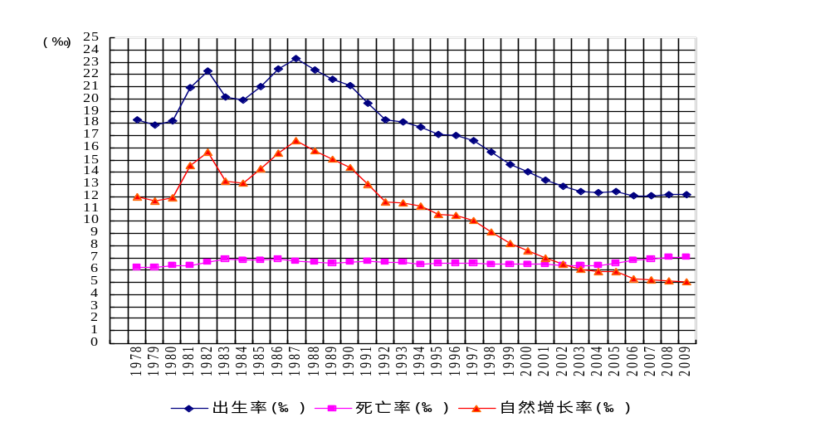
Birth rate (‰)
Death rate (‰)
Natural growth rate (‰)
Birth rate (‰)
(‰)
Source: China Statistical Yearbook 2009, China National Bureau of Statistics, September 2009; 2009 National Social and Economic Development Statistics Bulletin, China National Bureau of Statistics, February 2010.

Figure 3
Average life expectancy of the Chinese population (1981–2005)
(In years of age)
Year | Average life expectancy
Year | Combined average | Males | Females
1981 | 67.8 | 66.4 | 69.3
1990 | 68.6 | 66.8 | 70.5
2000 | 71.4 | 69.6 | 73.3
2005 | 73.0 | 70.8 | 75.3
Source: China Statistical Yearbook 2009, China National Bureau of Statistics, September 2009.

Figure 4
Age structure and dependency ratios of the Chinese population (1982–2009)
Year | Population at year end (in 10,000s) | Components by age |  |  |  |  |  | Overall dependency ratio (%) | Youth dependency ratio (%) | Elderly dependency ratio (%)
Year | Population at year end (in 10,000s) | Ages 0–14 |  | Ages 15–64 |  | Aged over 65 |  | Overall dependency ratio (%) | Youth dependency ratio (%) | Elderly dependency ratio (%)
Year | Population at year end (in 10,000s) | Population (in 10,000s) | Proportion (%) | Population (in 10,000s) | Proportion (%) | Population (in 10,000s) | Proportion (%) | Overall dependency ratio (%) | Youth dependency ratio (%) | Elderly dependency ratio (%)
1982 | 101 654 | 34 146 | 33.6 | 62 517 | 61.5 | 4 991 | 4.9 | 62.6 | 54.6 | 8.0
1987 | 109 300 | 31 347 | 28.7 | 71 985 | 65.9 | 5 968 | 5.4 | 51.8 | 43.5 | 8.3
1990 | 114 333 | 31 659 | 27.7 | 76 306 | 66.7 | 6 368 | 5.6 | 49.8 | 41.5 | 8.3
1995 | 121 121 | 32 218 | 26.6 | 81 393 | 67.2 | 7 510 | 6.2 | 48.8 | 39.6 | 9.2
1996 | 122 389 | 32 311 | 26.4 | 82 245 | 67.2 | 7 833 | 6.4 | 48.8 | 39.3 | 9.5
1997 | 123 626 | 32 093 | 26.0 | 83 448 | 67.5 | 8 085 | 6.5 | 48.1 | 38.5 | 9.7
1998 | 124 761 | 32 064 | 25.7 | 84 338 | 67.6 | 8 359 | 6.7 | 47.9 | 38.0 | 9.9
1999 | 125 786 | 31 950 | 25.4 | 85 157 | 67.7 | 8 679 | 6.9 | 47.7 | 37.5 | 10.2
2000 | 126 743 | 29 012 | 22.9 | 88 910 | 70.1 | 8 821 | 7.0 | 42.6 | 32.6 | 9.9
2001 | 127 627 | 28 716 | 22.5 | 89 849 | 70.4 | 9 062 | 7.1 | 42.0 | 32.0 | 10.1
2002 | 128 453 | 28 774 | 22.4 | 90 302 | 70.3 | 9 377 | 7.3 | 42.2 | 31.9 | 10.4
2003 | 129 227 | 28 559 | 22.1 | 90 976 | 70.4 | 9 692 | 7.5 | 42.0 | 31.4 | 10.7
2004 | 129 988 | 27 947 | 21.5 | 92 184 | 70.9 | 9 857 | 7.6 | 41.0 | 30.3 | 10.7
2005 | 130 756 | 26 504 | 20.3 | 94 197 | 72.0 | 10 055 | 7.7 | 38.8 | 28.1 | 10.7
2006 | 131 448 | 25 961 | 19.8 | 95 068 | 72.3 | 10 419 | 7.9 | 38.3 | 27.3 | 11.0
2007 | 132 129 | 25 660 | 19.4 | 95 833 | 72.5 | 10 636 | 8.1 | 37.9 | 26.8 | 11.1
2008 | 132 802 | 25 166 | 19.0 | 96 680 | 72.7 | 10 956 | 8.3 | 37.4 | 26.0 | 11.3
2009 | 133 474 | 24 663 | 18.5 | 97 502 | 73.0 | 11 309 | 8.5 | 36.9 | 25.3 | 11.6
Source: China Statistical Yearbook 2009, China National Bureau of Statistics, September 2009; 2009 National Social and Economic Development Statistics Bulletin, China National Bureau of Statistics, February 2010.

Figure 5
Gross domestic product of China (1952–2009)
(In 100 million yuan RMB)
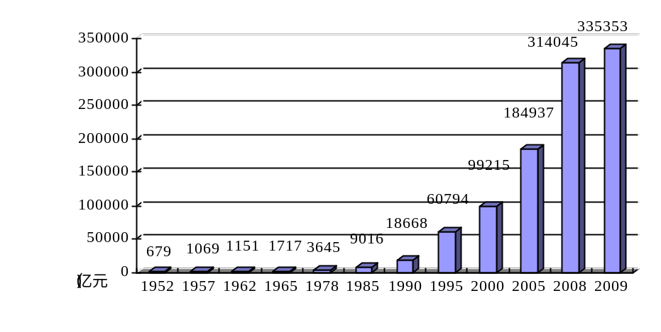

Source: 60 Years of New China, China National Bureau of Statistics, September 2009; China Statistical Digest 2010, China National Bureau of Statistics, May 2010.

Figure 6
Per-capita gross domestic product of China (1952–2009)
(In yuan RMB)
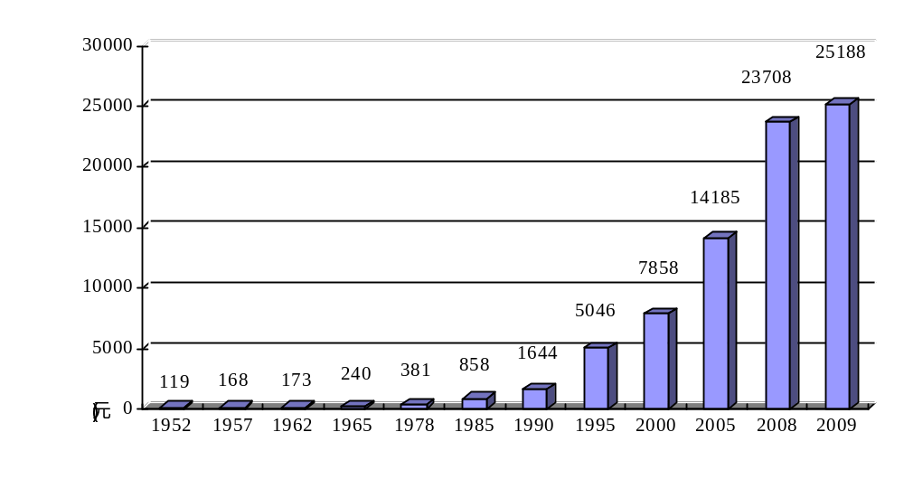

Source: 60 Years of New China, China National Bureau of Statistics, September 2009; China Statistical Digest 2010, China National Bureau of Statistics, May 2010.

Figure 7
Gross national income of China (1978–2009)
(In 100 million yuan RMB)
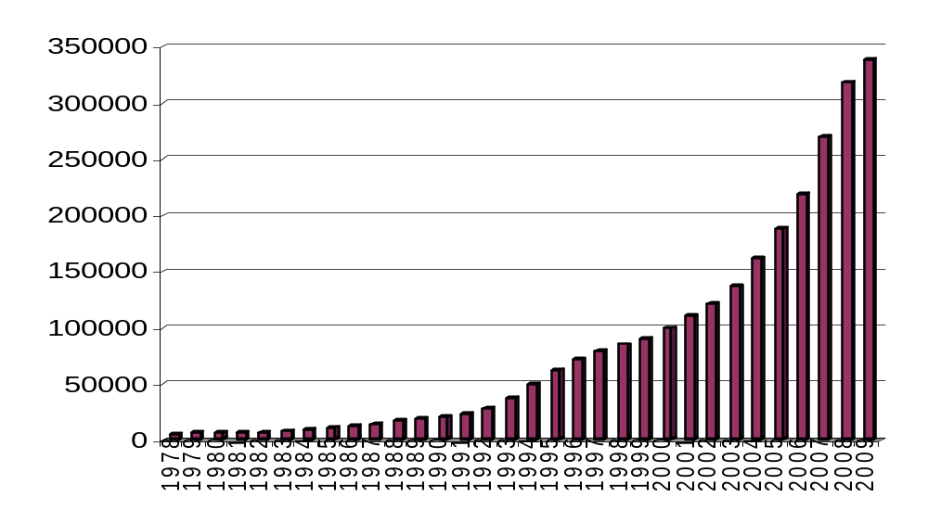
Source: China Statistical Yearbook 2009, China National Bureau of Statistics, September 2009; China Statistical Digest 2010, China National Bureau of Statistics, May 2010.

Figure 8
Consumer price index of China (1978–2009)
(Previous year = 100)
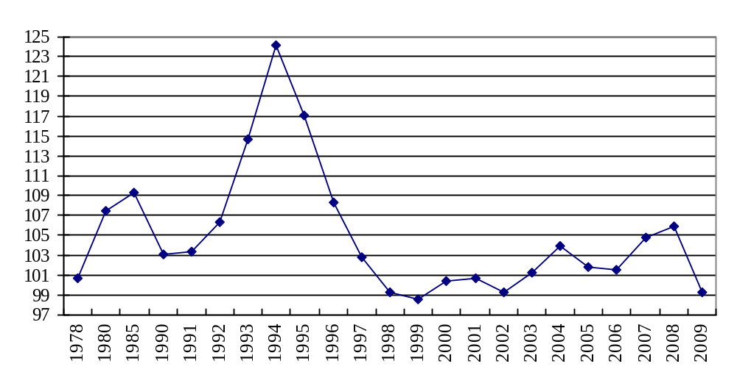
Source: China Statistical Digest 2010, China National Bureau of Statistics, May 2010.

Figure 9
Per capital urban disposable family income and per capita rural net family income in China (1978–2009)
(In yuan RMB)
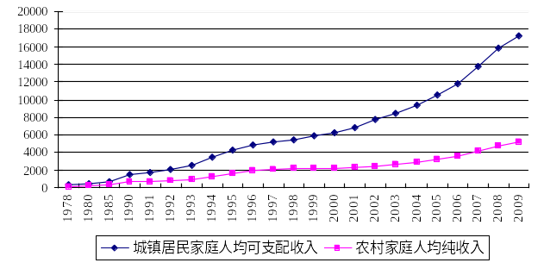
Per capita urban disposable fmily income
Per capita
Per capita urban disposable family income
Per capita rural net family income
Source: China Statistical Yearbook 2009, China National Bureau of Statistics, September 2009; 2009 National Social and Economic Development Statistics Bulletin, China National Bureau of Statistics, February 2010.

Figure 10
Engel coefficients for urban and rural families in China (1978–2009)
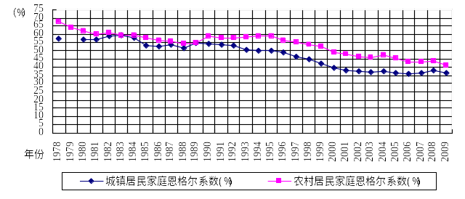
Engel coefficient for urban families (%)
Engel coefficient for rural families (%)

(%)
Engel coefficient for rural families (%)
Source: China Statistical Yearbook 2009, China National Bureau of Statistics, September 2009; 2009 National Social and Economic Development Statistics Bulletin, China National Bureau of Statistics, February 2010.

Figure 11
Per-capita expense structure for urban families in China
(Per cent of total expenses)
 | 1990 | 1995 | 2000 | 2007 | 2008
Food | 54.25 | 50.09 | 39.44 | 36.29 | 37.89
Clothing | 13.36 | 13.55 | 10.01 | 10.42 | 10.37
Housing | 6.98 | 8.02 | 11.31 | 9.83 | 10.19
Domestic appliances, goods and services | 10.14 | 7.44 | 7.49 | 6.02 | 6.15
Medical and health | 2.01 | 3.11 | 6.36 | 6.99 | 6.99
Transport and communication | 1.20 | 5.18 | 8.54 | 13.58 | 12.60
Education, culture, entertainment and services | 11.12 | 9.36 | 13.40 | 13.29 | 12.08
Misc. goods and services | 0.94 | 3.25 | 3.44 | 3.58 | 3.72
Source: China Statistical Yearbook 2009, China National Bureau of Statistics, September 2009.

Figure 12
Per-capita expense structure for rural families in China
(Per cent of total expenses)
 | 1990 | 1995 | 2000 | 2005 | 2007 | 2008
Food | 58.80 | 58.62 | 49.13 | 45.48 | 43.08 | 43.67
Clothing | 7.77 | 6.85 | 5.75 | 5.81 | 6.00 | 5.79
Housing | 17.34 | 13.91 | 15.47 | 14.49 | 17.80 | 18.54
Domestic appliances, goods and services | 5.29 | 5.23 | 4.52 | 4.36 | 4.63 | 4.75
Transport and communication | 1.44 | 2.58 | 5.58 | 9.59 | 10.19 | 9.84
Education, culture, entertainment and services | 5.37 | 7.81 | 11.18 | 11.56 | 9.48 | 8.59
Medical and health | 3.25 | 3.24 | 5.24 | 6.58 | 6.52 | 6.72
Misc. goods and services | 0.74 | 1.76 | 3.14 | 2.13 | 2.30 | 2.09
Source: China Statistical Yearbook 2009, China National Bureau of Statistics, September 2009.

Figure 13
The rural poor in China (1978–2009)
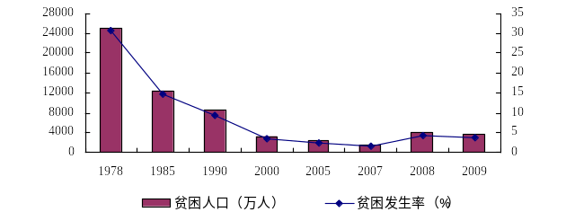
Poor population (in 10,000s)
Poverty rate (in per cent)
Source: 60 Years of New China, China National Bureau of Statistics, September 2009; 2009 National Social and Economic Development Statistics Bulletin, China National Bureau of Statistics, February 2010.
Note: China changed its poverty standard in 2008 to include the low-income population, and expanded the scope of poverty-assistance coverage accordingly.

Figure 14
Overall employment in China (1978–2009)
(In 10,000s)
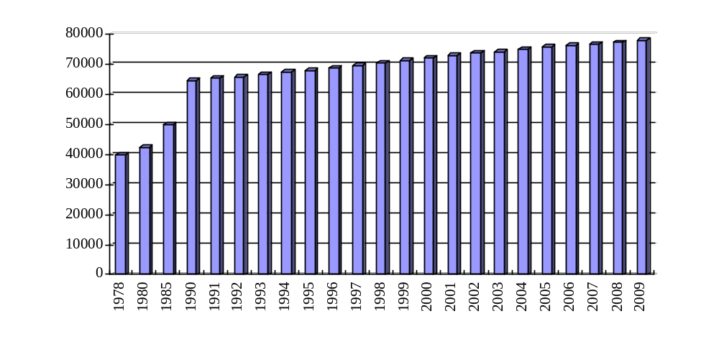
Source: China Statistical Yearbook 2009, China National Bureau of Statistics, September 2009; 2009 National Social and Economic Development Statistics Bulletin, China National Bureau of Statistics, February 2010.

Figure 15
Urban employment in China (1978–2009)
(In 10,000s)
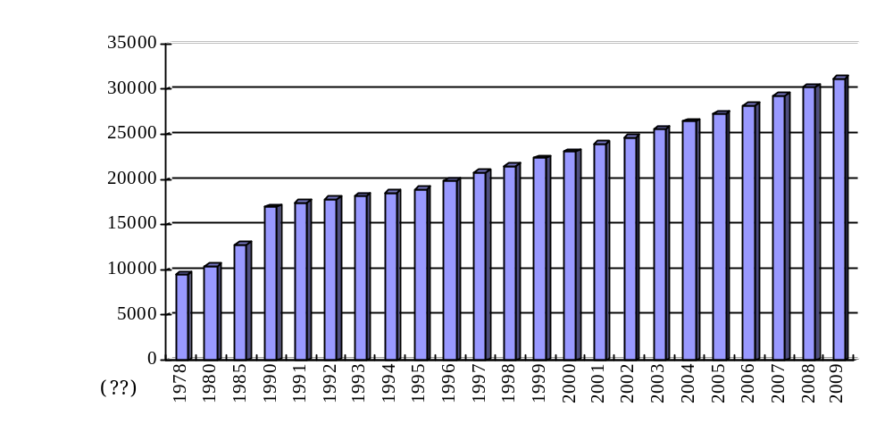
Source: China Statistical Yearbook 2009, China National Bureau of Statistics, September 2009; 2009 National Social and Economic Development Statistics Bulletin, China National Bureau of Statistics, February 2010.

Figure 16
Changes in Chinese industrial employment by economic sector
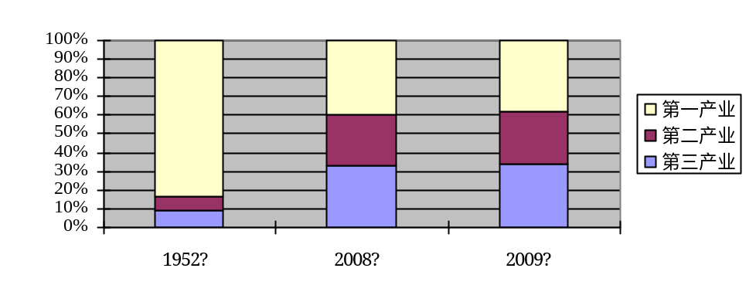
1952
2008
Yellow: Primary sector
Red: Secondary sector
Blue: Service sector
2009
Source: China Statistical Yearbook 2009, China National Bureau of Statistics, September 2009; China Statistical Digest 2010, China National Bureau of Statistics, May 2010.

Figure 17
Urban registered unemployment rate in China (2004–2009)
(In per cent)
2004 | 2005 | 2006 | 2007 | 2008 | 2009
4.2 | 4.2 | 4.1 | 4.0 | 4.2 | 4.3
Source: China Statistical Yearbook 2009, China National Bureau of Statistics, September 2009; 2009 National Social and Economic Development Statistics Bulletin, China National Bureau of Statistics, February 2010.

Figure 18

Proportion of Chinese workers participating in trade unions (1952–2008)
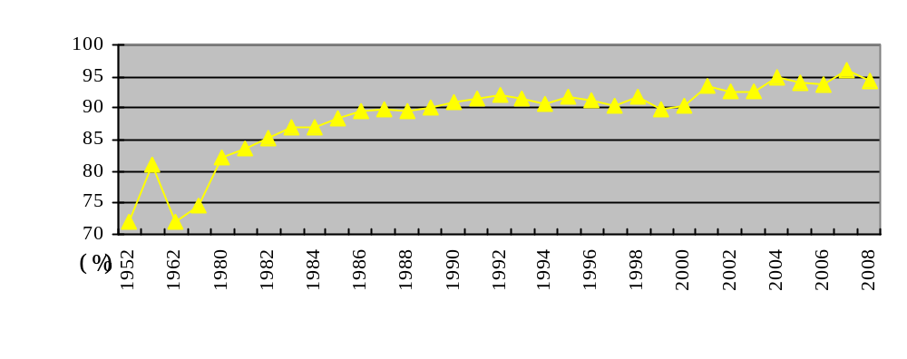

Source: China Statistical Yearbook 2009, China National Bureau of Statistics, September 2009.

Figure 19
Ten leading urban and rural causes of death (2008)
 | Urban residents |  |  | Rural residents
 | Ten leading causes of death | Specific mortality  (per 100,000) | Percentage of overall mortality | Ten leading causes of death | Specific mortality  (per 100,000) | Percentage of overall mortality
1 | Malignant tumours | 166.97 | 27.12 | Malignant tumours | 156.73 | 25.39
2 | Heart disease | 121.00 | 19.65 | Cerebrovascular disease | 134.16 | 21.73
3 | Cerebrovascular disease | 120.79 | 19.62 | Respiratory disease | 104.20 | 16.88
4 | Respiratory disease | 73.02 | 11.86 | Heart disease | 87.10 | 14.11
5 | Injuries and poisoning | 31.26 | 5.08 | Injuries and poisoning | 53.02 | 8.59
6 | Endocrine, nutritional, metabolic and immunological diseases | 21.09 | 3.43 | Digestive system diseases | 16.33 | 2.65
7 | Digestive system diseases | 17.60 | 2.86 | Endocrine, nutritional, metabolic and immu-nological diseases | 11.05 | 1.79
8 | Genito-urinary diseases | 6.97 | 1.13 | Genito-urinary diseases | 5.70 | 0.92
9 | Diseases of the nervous system | 6.34 | 1.03 | Diseases of the nervous system | 4.35 | 0.71
10 | Contagious diseases (not incl. pulmonary tuberculosis | 4.73 | 0.77 | Contagious diseases (not incl. pulmonary tuberculosis | 4.72 | 0.76
 | Total for all ten causes: |  | 92.55 | Total for all ten causes: |  | 93.53
Source: China Statistical Yearbook 2009, China National Bureau of Statistics, September 2009.

Figure 20
Incidence, mortality and case fatality rates for infectious diseases of categories A and B (2008)
Disease | Incidence  (per 10,000) | Mortality  (per 10,000) | Case fatality  (per cent)
Viral hepatitis | 106.54 | 0.08 | 0.07
Tuberculosis | 88.52 | 0.21 | 0.24
Bacterial and amoebic dysentery | 23.65 |  | 0.02
Syphilis | 19.49 |  | 0.02
Neonatal tetanus | 0.10 | 0.01 | 10.69
Measles | 9.95 | 0.01 | 0.08
Gonorrhoea | 9.90
Scarlet fever | 2.10
Brucellosis | 2.10
Malaria | 1.99 |  | 0.08
Typhoid and paratyphoid fever | 1.18 |  | 0.04
HIV/AIDS | 0.76 | 0.41 | 53.57
Epidemic hemorrhagic fever | 0.68 | 0.01 | 1.14
Epidemic encephalitis b | 0.23 | 0.01 | 4.77
Schistosomiasis | 0.22
Rabies | 0.19 | 0.18 | 96.23
Whooping cough | 0.18 |  | 0.04
Epidemic cerebrospinal meningitis | 0.07 | 0.01 | 11.93
Leptospirosis | 0.07 |  | 2.09
Anthrax | 0.03 |  | 0.30
Dengue fever | 0.02
Cholera | 0.01
Source: China Statistical Yearbook 2009, China National Bureau of Statistics, September 2009.
Note: Incidence and mortality figures for neonatal tetanus are per thousand.

Figure 21
Neonatal, infant and maternal mortality rates (1991–2009)
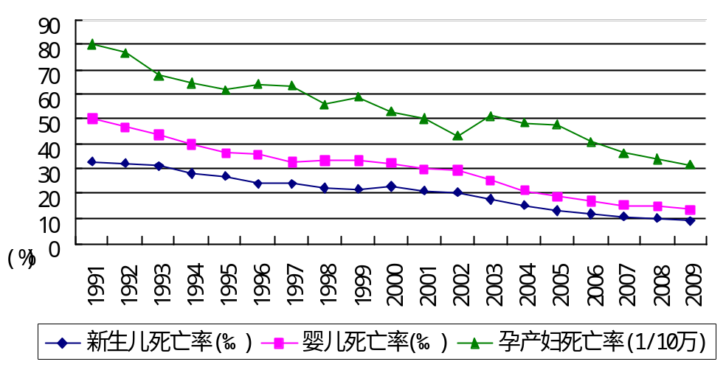
Infant mortality (‰)
Maternal mortality (per 100,000)
Neonatal mortality (‰)
(%)
Source: China Statistical Yearbook 2009, China National Bureau of Statistics, September 2009; 2009 National Social and Economic Development Statistics Bulletin, China National Bureau of Statistics, February 2010.

Figure 22
Enrollment rates of school-aged children and advancement rates in regular schools at all levels (1990–2009)
(In per cent)
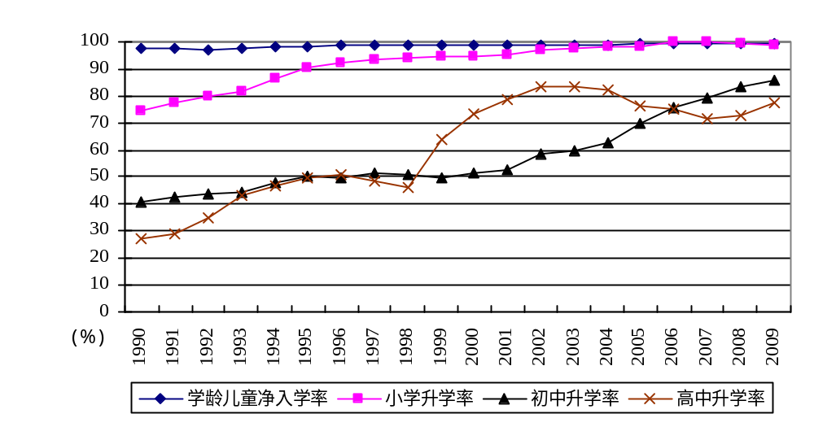
School-age enrolment
Primary-school advancement
Middle-school advancement
High-school
advancement
Source: China Statistical Yearbook 2009, China National Bureau of Statistics, September 2009; China Statistical Digest 2010, China National Bureau of Statistics, May 2010.

Figure 23
Student-teacher ratios in regular schools at all levels (2004–2009)
(In per cent)
Year | Primary schools | Middle schools | Regular secondary schools | Vocational secondary schools | Regular specialized secondary schools | Regular colleges | Undergrad.-level universities | Vocational colleges
2004 | 19.98 | 18.65 | 18.65 | 19.10 | 28.13 | 16.22 | 17.44 | 13.15
2005 | 19.43 | 17.80 | 18.54 | 20.62 | 31.02 | 16.85 | 17.75 | 14.78
2006 | 19.17 | 17.15 | 18.13 | 22.16 | 31.67 | 17.80 | 17.61 | 18.26
2007 | 18.82 | 16.52 | 17.48 | 23.50 | 31.39 | 17.28 | 17.31 | 17.20
2008 | 18.38 | 16.07 | 16.78 | 23.47 | 31.27 | 17.23 | 17.21 | 17.27
2009 | 17.88 | 15.47 | 16.30 | 23.65 | 27.82 | 17.27 | 17.23 | 17.35
Source: China Statistical Yearbook 2009, China National Bureau of Statistics, September 2009; China Statistical Digest 2010, China National Bureau of Statistics, May 2010.

Fig. 24
Urban participants in old-age retirement insurance (1989–2009)
(In 10,000s)
0
5000
10000
15000
20000
25000
1989
1990
1991
1992
1993
1994
1995
1996
1997
1998
1999
2000
2001
2002
2003
2004
2005
2006
2007
2008
2009
Source: China Statistical Yearbook 2009, China National Bureau of Statistics, September 2009; 2009 National Social and Economic Development Statistics Bulletin, China National Bureau of Statistics, February 2010.

Fig. 25
Participants in unemployment, work-injury, maternity and basic urban workers’ medical insurance (1994–2009)
(In 10,000s)
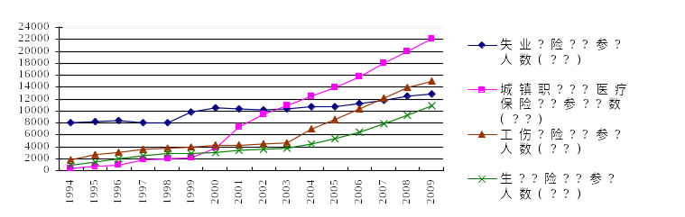
Participants in unemployment
insurance (at year-end)
Participants in work-injury
insurance (at year-end)
Participants in maternity
insurance (at year-end)
Participants in basic urban
workers’ medical insurance
(at year-end)
Source: China Statistical Yearbook 2009, China National Bureau of Statistics, September 2009; 2009 National Social and Economic Development Statistics Bulletin, China National Bureau of Statistics, February 2010.

Figure 26
The New Rural Cooperative Medical System (as of 2008–2009)
 | 2008 | 2009
Participants (in hundreds of millions) | 8.15 | 8.33
Participation rate (in percent) | 91.5 | 94.0
Capital raised for the year (in hundreds of millions of yuan RMB) | 785.0 | 944.4
Per-capita financing (in yuan RMB) | 96.3 | 113.4
Fund expenditure for the year (in hundreds of millions of yuan RMB) | 662.3 | 922.9
Beneficiary compensation (in hundreds of millions of person-times) | 5.85 | 7.59
Source: 2009 China Health Services Development Statistics Bulletin, China Ministry of Health, April 2010.

Figure 27
Numbers and categories of criminal cases filed by public-security organs (2007–2008)
Case category | Year filed |  |  | Percent of overall case load
Case category | 2007 | 2008 |  | 2007 | 2008
Total | 4 807 517 | 4 884 960 |  | 100.00 | 100.00
Murder | 16 119 | 14 811 |  | 0.34 | 0.30
Bodily injury | 167 207 | 160 429 |  | 3.48 | 3.28
Robbery | 292 549 | 276 372 |  | 6.09 | 5.66
Rape | 31 883 | 30 248 |  | 0.66 | 0.62
Trafficking of women and children | 2 378 | 2 566 |  | 0.05 | 0.05
Theft | 3 268 670 | 3 399 600 |  | 67.99 | 69.59
Fraud | 239 698 | 273 763 |  | 4.99 | 5.60
Smuggling | 1 107 | 1 042 |  | 0.02 | 0.02
Forgery or alteration of currency; sale, purchase, transport, possession or use of counterfeit currency | 1 755 | 1 345 |  | 0.04 | 0.03
Other | 786 151 | 724 784 |  | 16.34 | 14.85
Source: China Statistical Yearbook 2009, China National Bureau of Statistics, September 2009.
Note: A total of 2,411,476 criminal cases were solved in 2008.

Figure 28
Disabled examination candidates accepted at regular institutions of higher learning (2005–2009)
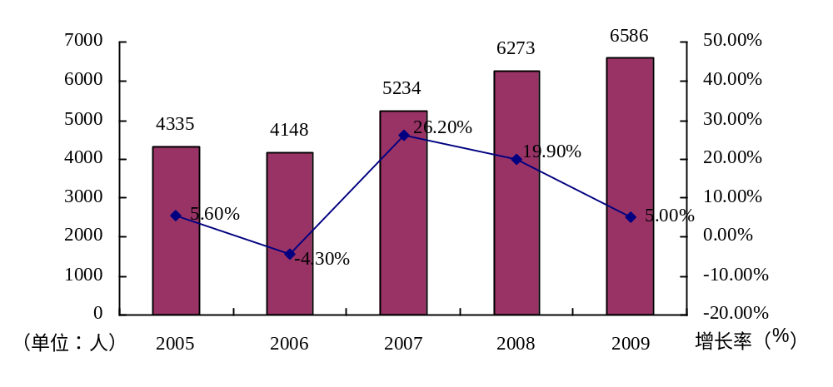
(Persons)
Growth rate (%)
Source: 2008 National Disabled Services Development Statistics Bulletin, China Disabled Persons’ Federation, April 2009; 2009 National Disabled Services Development Statistics Bulletin, China Disabled Persons’ Federation, April 2010.

Figure 29
Disabled persons accepting social assistance nationwide (2006–2009)
(In 10,000s)
2006
2007
2008
2009
283.3
591.8
308.1
759.1
330.4
848.2
364.4
969.3
0
100
200
300
400
500
600
700
800
900
1000
urban
rural
Source: 2009 National Disabled Services Development Statistics Bulletin, China Disabled Persons’ Federation, April 2010.

Figure 30
Dilapidated housing refurbished for poor rural disabled persons (2006–2009)
53221
88544
121766
167404
98432
139770
101959
140098
0
20000
40000
60000
80000
100000
120000
140000
160000
180000
2006
2007
2008
2009
Dwellings refurbished
Poor rural disabled beneficiaries
Source: 2009 National Disabled Services Development Staistics Bulletin, China Disabled Persons’ Federation, April 2010.

Figure 31
Number and proportion of minority-nationality delegates to National People’s Congresses (1952–2008)
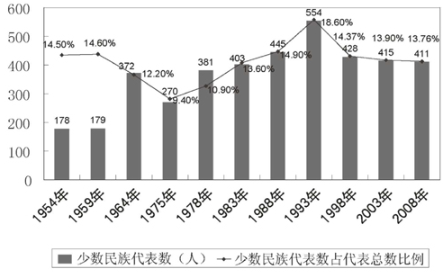
Number of min.-nat. delegates
Proportion of min.-nat. delegates overall
Source: China’s Ethnic Policy and Common Prosperity and Development of All Ethnic Groups (White Paper), State Council Information Office, September 2009.

Figure 32
Funding allocated for the “Three Rural Issues” by the central financial authorities (2003–2009)
(In hundreds of millions of yuan RMB)
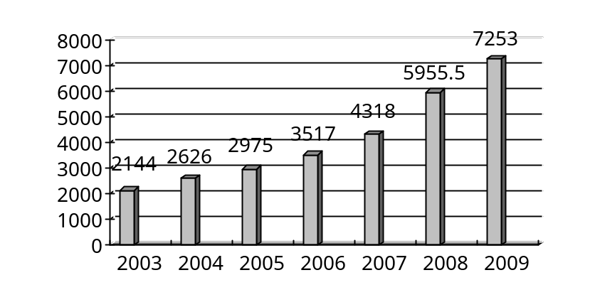
Source: Report on Implementation of the National Economic and Social Development Plan for 2008 and the Draft National Economic and Social Development Plan for 2009, National Development and Reform Commission, March 2009; Report on the Work of the Government, March 2010.

? The Engel coefficient (percentage) = total food expenses divided by total household or individual expenses, multiplied by 100%. This figure reflects the fact that as household or individual income increases, the proportion of income spent on food decreases. According to standards established by the United Nations Food and Agriculture Organization, an Engel coefficient of 59 per cent or greater indicates poverty; between 50 and 59 per cent: only basic needs are met; between 40 and 50 per cent: moderate prosperity; between 30 and 40 per cent: wealth; below 30 per cent: the wealthiest.
? Ratio of persons casting votes to the overall population of eligible voters.

