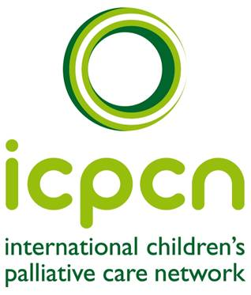
SUBMISSION TO THE
UN COMMITTEE ON THE RIGHTS OF THE CHILD
On : CHILDREN’S RIGHT TO HEALTH
6 January 2012The ICPCN was established in 2005 and is the only international organization bringing together individuals and organizations involved in the development and provision of palliative care for babies, children and young people. Present membership is from 81 countries. The vision of the ICPCN is a world where all life-limited children have access to palliative care services. The objectives of the ICPCN are Advocacy; Education and Research; Information- sharing and Networking; and Sustainability

Submitted by: Joan Marston
Chief Executive
PO Box 31021
Fichardt Park
Bloemfontein 9317
South Africa
E-mail: joan.marston@icpcn.co.za
Website: www.icpcn.org.uk
Cell: + 27 82296 4367

The ICPCN is a Registered Charity in the United Kingdom

PALLIATIVE CARE FOR BABIES, CHILDREN AND YOUNG PEOPLE
The International Children’s Palliative Care Network (ICPCN) encourages the Committee to specifically address the need for countries to provide palliative care services for babies, children and young people as an essential element of the child’s right to health, for children with chronic, life-threatening or life-limiting conditions. This includes neonates and children with disabilities.
The goal of palliative care is the relief of suffering and the improvement of quality of life. ICPCN believes that babies, children and young people with life-threatening, life-limiting and chronic diseases or conditions have the right to receive palliative care for the relief of their suffering and enhancement of quality of life. Countries would need to put the following in place
- education specifically for palliative care for children
- Relevant policies
- systems to provide care at primary, secondary and tertiary levels
- equitable access to pain-relieving and other palliative medicines, including opioids.
- Adequate funding

Many medications are unavailable in paediatric formulations and prescribers are often untrained in the use of pain medications, especially opioids, in children. Most adults have an inherent belief that children should not die and therefore ignore the needs of these children
While we believe that the primary focus of health care must be cure and the promotion of health, in reality, health care services for children with chronic conditions are often inadequate to meet the multiple and complex needs of these children and their families. Another sad reality is that children in developing countries often present at health services too late for cure. Added to this, there are still many childhood diseases and conditions which are, by their nature, incurable.

Children suffer physical pain, distressing symptoms and emotional and spiritual pain, but are often unable to express this due to their age, lack of verbal skills or disability. Few health care professionals are trained and skilled at evaluating children’s pain and suffering, and therefore this is left unrecognised, ignored and untreated. Acknowledgement and support for spiritual pain and conflict; and the impact of culture and language , is mostly ignored in children. Children dying in pain and suffering leave families and health care workers with complex emotions and feelings of guilt and inadequacy.

Children grieve differently to adults according to their particular developmental stage and these children are often left to grieve alone and unsupported.
“Being weak and meek in life makes these dying multitudes even more invisible in death.” UNICEF

“Palliative care for children is the active total care of the child’s body, mind and spirit, and also involves giving support to the family. It begins when illness is diagnosed, and continues regardless of whether or not the child receives treatment directed at the disease. Health providers must evaluate and alleviate a child’s physical, psychological and social distress. Effective palliative care requires a broad, multi-disciplinary approach that includes the family and makes use of available community resources; it can be successfully implemented even if resources are limited. It can be provided in tertiary care facilities, in community health centres, and even in children’s homes.” WHO (2002) (http://www.who.int/cancer/palliative/definition/en/)
The condition or illness begins while the child is either in utero or during childhood and can continue over many years and into adulthood. Therefore, palliative care for children and families can be provided before birth. It should not be regarded as just applicable at the end of life.
A family in Norway expressed their feelings about the lack of palliative care services when writing about their baby daughter, Evy, with Trisomy 18 in “A Life of Three Days” “I missed being given promises that I would not have to go through this alone...I long for a true right for these children to receive necessary treatment and care, including comfort care.”
ACT now Together for Short Lives (UK), has identified four categories of conditions in children where palliative care is the most relevant response.
Category 1
Life-threatening conditions for which curative treatment may be feasible but can fail and where access to palliative care services may be necessary when treatment fails.
(Examples: cancer, irreversible organ failure;. severe malnutrition; burns; trauma)
Category 2
Conditions where premature death is inevitable, where there may be long periods of intensive treatment aimed at prolonging life and allowing participation in normal activities.
(Example: cystic fibrosis; HIV with treatment.)
Category 3
Progressive conditions without curative treatment options, where treatment is exclusively palliative and may commonly extend over many years.
(Examples: Batten disease, mucopolysaccharidoses, muscular dystrophy., HIV without access to treatment; Trisomy 18)
Category 4
Irreversible but non-progressive conditions causing severe disability leading to susceptibility to health complications and likelihood of premature death.
(Examples: severe cerebral palsy, multiple disabilities such as following brain or spinal cord injury; neonatal trauma; foetal alcohol or drug syndrome)

Diagnoses relevant to children’s palliative care
Hain et al (2010) have compiled a list of 574 ICD10 diagnoses that have been judged by professionals working in paediatric palliative care to be life-limiting and drawn from admissions to children’s hospices and referrals to specialist paediatric palliative medicine.

Most common diagnoses of children needing palliative care
In an ICPCN online survey conducted by Professor Julia Downing in 2011 with 248 respondents from 84 countries, the following diagnoses were identified as the most common seen in children cared for in palliative care services:
- Malignancies
- Non-malignant
- Cardiac
- Neurological
- Metabolic/ Neurodegenerative
- Chromosomal/ Syndrome
- Respiratory
- Genetic blood diseases
- Other e.g. HIV, renal failure etc

The need for children’s palliative care services
There are no accurate figures on the number of children worldwide in need of palliative care services but is estimated to be approximately 20 million. If we take the WHO definition which states that palliative care should be provided or available from the time of diagnosis, the number increases considerably. In the developing world, severe malnutrition is often a life-threatening condition, either in itself or as a complication of other conditions such as HIV. Palliative care should always take into consideration the environment of the child and the provision of adequate food, shelter, clothing, education, opportunities to play and develop, and safety is inherent within palliative care programmes for children. A major challenge in estimating the number of children requiring palliative care is the fact that statistics of many of the conditions in children that would benefit from palliative care, are not collected at national and international level.
Quantification of the need is complicated by factors such as uncertainty of population numbers and the unpredictability of disease trajectories. Baum et al estimates that for every 50,000 children 50 will have a life-limiting/life-shortening illness (10: 10 000) half of whom will require specialised palliative care at any one time. Horrocks et al believes that while this is a useful rule of thumb in some places, in others it is an underestimate of the need. Worldwide there are not enough children’s palliative care services to meet the need. Palliative care services for children have been slower to develop than adult palliative care services. Fewer health professionals are trained in palliative care for children and facilities for training in this field are absent in most countries

The voice of the child is often ignored or unheard. . Palliative care includes the child as an essential member of the care team. Beulah, a 9 year-old orphaned girl in South Africa with AIDS, Karposi’s sarcoma and malnutrition expressed her pain of the body, mind and spirit as “ My feet burn so much I wish the doctors would cut them off and throw them away. When I try to sleep my back is sore and my whole body aches. I look ugly with the black spots(KS)... my heart is always very sore when I think of my mother...and I cannot go to school with my friends. “
Mapping of paediatric palliative care services
A systematic review to map children’s palliative care services worldwide carried out by Knapp, et al found there to be 78 countries where there were no known children’s palliative care activity, 41 countries where there was evidence of some capacity building in children’s palliative care, 80 countries with localised provision of services and 35 where the services were approaching integration with mainstream service providers. In a country such as India, with 44 million children, there are presently only four established palliative care services for children with some further development in the Maharashtra region.

Based on information from this review and its own information, the ICPCN has produced a map that indicates levels of service provision around the world. Palliative care services for children tend to develop in isolation and there are major disparities in provision, resources, capacity and infrastructure, especially in the developing world. Many only provide palliative care in the home and at the primary care level through home-based care programmes and mainly linked to non-governmental organizations and faith-based organizations with little or no government support. CT / RCPCH (1st Edition1997)

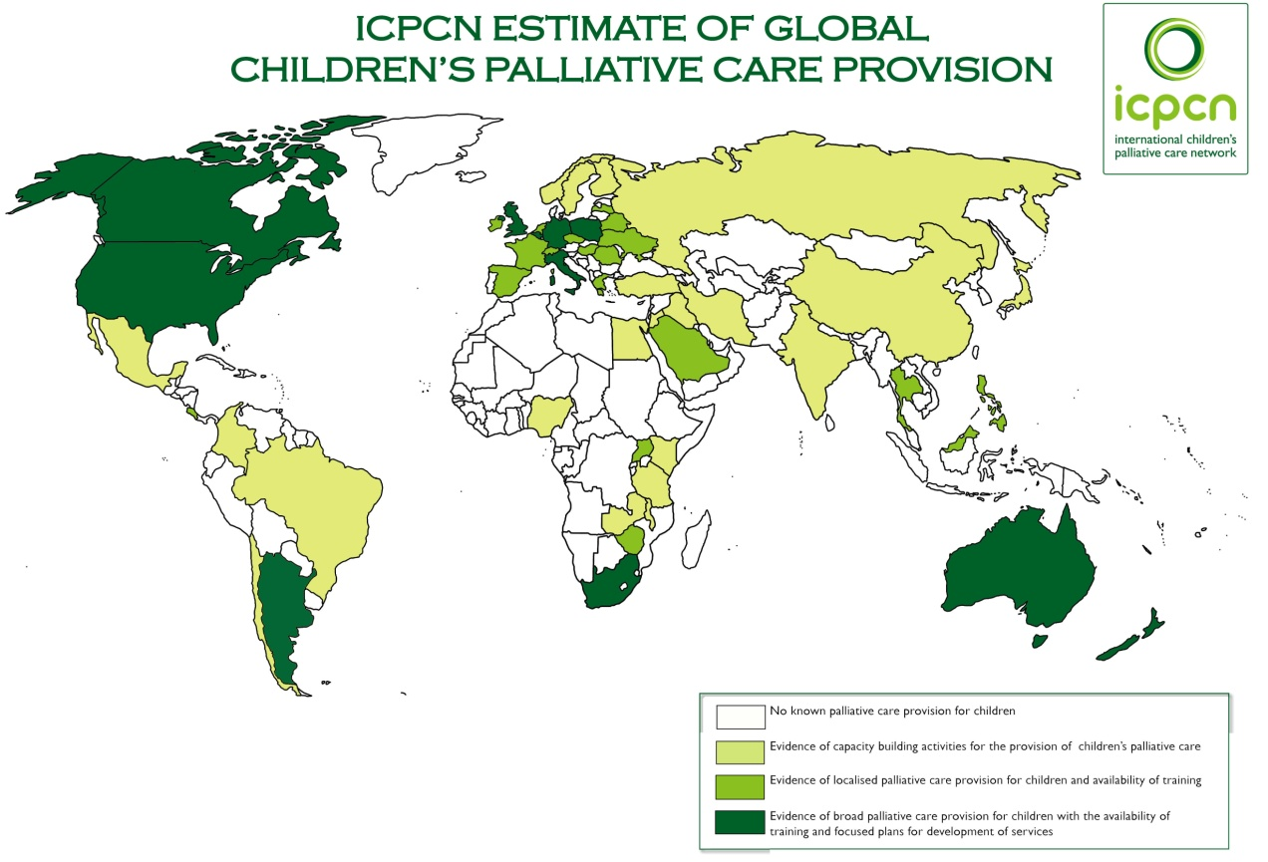

The result of lack of access to palliative care services for babies, children and young people, is unrelieved and unnecessary suffering. Children live and die in pain, pain that could be relieved with simple and inexpensive medications; supportive holistic care; and non-pharmacological interventions such as massage, hypnosis, distraction. A government response based on education, policies and access to adequate medications would be cost – effective, achievable and compassionate.
Several international statements have been documented by the palliative care community on the provision of palliative care as a human right, including the Cape Town Declaration (2002); the Korea Declaration (2005) the Montreal Statement on the Human Right to Essential Medicines (2005); Pope Benedict XVI on World Day for the Sick (2006) and the ICPCN Charter of Rights for Life-limited and Life-threatened Children (available in 22 languages at www.icpcn.org.uk)
Nelson Mandela stated that “There can be no keener revelation of a society’s soul than the way in which it treats its children”
Our request to the Committee
The ICPCN therefore urges the Committee to include palliative care for babies, children and young people within their general comment.
In Section vii.7 (on chronic diseases)
- A paragraph that acknowledges that babies, children and young people with chronic diseases require palliative care to relieve pain, distressing symptoms and suffering, and improve quality of life. This care should address the physical, spiritual, emotional, social developmental , and bereavement needs of the child; and that palliative care should be part of the continuum of care for these children, available from diagnosis of any life-threatening or life-limiting condition. This will ensure that no child suffers unnecessarily.
- Parents, siblings and families should be included in palliative care
- A paragraph that acknowledges that despite curative treatment many children will die due to late presentation, incurable conditions and treatment failure. Palliative care for children should include end-of-life care, respite care, and bereavement care and support
- Palliative care for children, including pain management, should be included in the undergraduate and postgraduate trainings of all health care professionals
In section 1V (on normative content)
- The essential medicines for children, including opioids and other pain-relieving medications, be available and in paediatric formulations

Boucher, S and Downing , J (2011) Touching Rainbows . ICPCN. Durban
Hain et al (2010), Directory of life-limiting diagnoses in children, based on ICD10 codes, Unpublished work on behalf of ACT
ICPCN International Survey conducted by Professor Julia Downing in 2011
Discussion with the author.(2009) Sunflower House. Bloemfontein
Pediatric Palliative Care Provision Around the World: A Systematic Review & Mapping, Caprice Knapp*, PhD, Lindsey Woodworth, BS, Rev. Michael Wright, PhD; Dr Julia Downing PhD

