
2
1
0
0

Core
Document Aruba

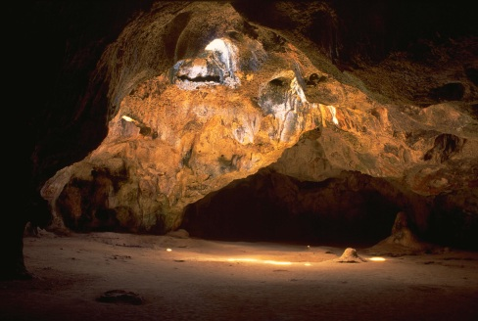
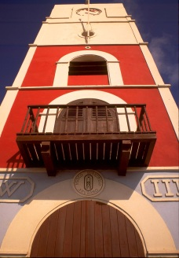

2010
Core Document Aruba

TABLE OF CONTENTS

INTRODUCTION
I. GENERAL INFORMATION
II. GENERAL POLITICAL STRUCTURE
III. GENERAL LEGAL FRAMEWORK WITHIN WHICH HUMAN RIGHTS ARE PROTECTED
IV. INFORMATION AND PUBLICITY
AnnexE I: Constitution of Aruba
AnnexE II: aruban Education system

INTRODUCTION

The present document is an update of the Core Document of 2003 and covers the period to June 2009. The document has been drawn up in connection with the various human rights reports that Aruba is obliged to submit at periodic intervals. The aim of this document is to complement the information provided in the reports and to give more background information on Aruba.

Chapter I contains information on the general characteristics of the island, its economy and labour market, social infrastructure, cultural infrastructure, education, health care and housing. Chapters III and IV respectively describe the general political structure in Aruba and the general legal framework within which human rights are protected. In Chapter IV information is provided on the procurement and dissemination of information required under the human rights conventions.

In October 2000 the Fourth Population and Housing Census was conducted on Aruba. For statistical information on Aruba relating to specific issues such as population, birth rate, public health, education and employment etc., please refer to the Statistical Yearbook 2009 produced by the Central Bureau of Statistics and submitted with this report.

In October 2010 the Fifth Population and Housing Census will be held.

I. GENERAL INFORMATION
Country and People

- Aruba, which until 1986 formed part of the Netherlands Antilles, is now an autonomous country within the Kingdom of the Netherlands. Aruba is an island of 70.9 square miles (193 square kilometres) situated in the Southern Caribbean, 18.6 miles (30 kilometres) from the northern coast of South America 12° north latitude and 70° west longitude. The island is geographically divided into eight regions, each of which is subdivided into several zones.

- Even though the island is located in the Caribbean, it is not characterised by the lush green typical of the tropics. Aruba has a dry, healthy climate. Its high temperatures are compensated for by the refreshing effect of the northeast trade winds. The lack of sufficient rainfall, however, inhibits agricultural subsistence.

- Aruba is one of the few islands in the Caribbean where traits of the native Indian population are still in evidence. The Aruban population of over 107,000 is made up of a mixture of Carib and Arawak Indians, combined with a European and African heritage. Dutch used to be the official language, while the native language was Papiamento, a mixture of modern languages and old native Indian words. On 21 May 2003, the Aruban Parliament proclaimed Papiamento and Dutch as official languages and both are now used for official purposes. In addition, Spanish and English are compulsory school subjects and are also widely spoken.

- In Aruba, at the end of 2009, a total of 102 nationalities were living in a unique and peaceful society. Between 2000 and 2009, the population increased by 17.65%, mainly due to immigration. In 2009 population density was 595 inhabitants per square kilometre compared to 374 in 1991. The main industry is tourism, and in 1991 the oil refinery resumed its operations after a six-year period of closure.

- The quality of life is reflected in the island's educational and health care systems, social provisions and housing. Average life expectancy is 76 years for women and 70 for men.

Economy and Labour market

- Aruba has an open economy that encourages free enterprise and competition, maintaining a clear distinction between the public and private sectors. Due to its small scale, minimal manufacturing and the absence of commercially exploitable mineral resources, the island is heavily dependent on imports, and therefore engages in foreign trade on a large scale. Every effort is made to maintain a proper balance of trade, with a constant search for ways of expanding exports.

- Experience shows that an open, small-scale economy is very vulnerable to external influences, which can have a significant economic impact. In order to maximise economic opportunities, the government’s policy is primarily focused on international developments. As a result, the economy’s most dynamic sectors are tourism, oil refining and transhipment, as well as international trade and finance.

- Until 1985, the oil industry was the leading sector, with tourism in second place. The closure of the Exxon refinery in March of that year, after almost sixty years of operation, marked the turning point in policy on the island’s economy. Besides having been a substantial job provider, the refinery was the largest contributor to the government’s total revenue and foreign exchange earnings. The closure led to a drop of approximately 50% in the government’s income and caused unemployment to rise to an estimated 27%. From 1983 on earnings from tourism and business on the island also suffered from a sharp decline in the Venezuelan market, as well as from the worldwide recession.

- Following the dramatic events of 1985, the government decided to develop Aruba’s potential as a tourism destination more fully. Thanks to a massive construction campaign, backed by government guarantees and favourable fiscal conditions, the number of hotel rooms increased dramatically. In 1985, the island had 2,040 hotel rooms. By the end of 1990, there were a total of 4,500 rooms on the island. And in 1995, Aruba had no fewer than 6,500 rooms. Several well-known international hotel chains have developed luxury hotels on the island. In 2009 Aruba had approximately 30 hotels with a total of 7,459 rooms.

- The government also found a firm willing to reopen the abandoned oil refinery. In 1989, the Coastal Aruba Refining Company started to rehabilitate the infrastructure of the former Exxon refinery with the objective of achieving a refining capacity of 180,000 barrels a day. In 1990, the refinery became officially operational; it now employs approximately 670 people (excluding sub-contractors) and contributes to the foreign exchange reserve. In 2009 the company was producing 235,000 barrels a day. The company operated under the El Paso Corporation from 2001 to 2004, and since March 2004 has been operated by the Valero Energy Corporation.

- Aruba has achieved a relatively high level of prosperity, with a per capita income among the highest in the region. At present, tourism is the principal source of income.

- The number of visitors passed one million for the first time in 2000, reaching 1.2 million in that year. A total of 721,224 stay-over visitors stayed on the island in 2000 while another 490,148 cruise passengers visited Aruba in the same year.

- In 2008 Aruba achieved its highest number of stay-over visitors, with a 14.6% rise on 2000. A total of 826,774 stay-over visitors arrived on the island in 2008, and a further 556,090 cruise passengers visited in the same year, bringing the total to 1,382,864 visitors in 2008. In 2009 the number of stay-over visitors dropped by 1.7% compared to 2008, falling by a little over 14,000. This was due mainly to the financial and economic situation worldwide. Despite this, however, Aruba managed to keep the number of stay-over visitors above 800,000, while cruise passenger numbers reached their highest level ever.

- The number of cruise passengers passed the 600,000 mark for the first time in 2009, increasing by 23.8% compared to 2000, and 9.1% up on 2008. Aruba welcomed just over 606,000 cruise passengers in 2009.

- Aruba reached its highest level of dependence on the US market in 2004, when almost 74% of the total stay-over market was accounted for by visitors from the United States. This percentage dropped to 65% in 2009, when the market share of Venezuelans rose to almost 13%. The market share of Venezuelans increased from 8.1% in 2004 to 12.9% in 2009. This indicates that Aruba’s visitor market is now more diverse and less dependent on the US, although 65% is still a high percentage share of the total market. One of the major contributing factors to the downturn in the number of stay-over visitors in 2001 was the economic situation in the United States, which was aggravated by the September 11th attacks. The United States (65% of stay-over visitors in 2001) is the most important market for Aruba, followed by Venezuela (15.8%).

- The average daily expenditure of stay-over visitors increased by 6.2% in 2009 compared to 2008, after a slight fall of 1.1% from 2007 to 2008. Tourism expenditure in Aruba increased by a mere 0.4% in 2009 compared to 2008. This was due to higher average daily expenditure per stay-over visitor, despite the fall in the total number of stay-over visitors and the drop in the average length of stay. Estimated total tourism expenditure declined by 6.0% compared to 2008. In 2008 the stay-over visitors market was worth an estimated total of USD 858,120,740 in tourism expenditure; in 2009 this figure dropped to USD 806,450,590. Expenditure by visitors has a major impact on GDP, as tourism is the most important driver of the Aruban economy.

The economic development of Aruba over the last fifteen years would not have been possible without a large influx of foreign labour.

TABLE I: Labour market indicators (as at December 2007)

Year
1991
1994
1997
2000
2007
Population
66,687

78,534

87,767

90,506
104,006
Population aged 15 and over
50,423

60,061

67,538

69,619
82,670
Labour Force
31,111
38,412

44,840
45,037
54,730
Employment
29,220
35,936

41,501
41,918
51,605
Unemployment
1,891
2,476

3,339
3,119
3,124
Unemployment %
6.1
6.4
7.4
6.9
5.7
Participation rate (%) Labour Force/Pop. aged 15 and over
61.9
64.0
62.7
65.4
66.2
Source: CBS
Key indicators Labour Force
Source: Central Bureau of Statistics, Aruba
1) The expenditure figures for 2009 are provisional, and are based on the Tourism Profile Annual Report 2009.

- The Labour Force Survey 2007 shows that the total labour force in that year numbered 54,730, while total employment rose to 51,605 in the same year. The group of employed persons is still growing faster than the total population in Aruba. The total population grew by 15% in the period 2000- 2007, while the employed population grew over the same period by 23%. However, growth in the employed population was lower than in the preceding period. One of the possible causes of this decline in growth is the decline in the total number of migrants arriving in 2007.

- Foreign workers still constitute a significant part of the local labour market. In 2007 51,605 people aged 15 and over had a job, 32,252 of whom were born on Aruba and 19,353 elsewhere. This means that 38% of the employed population came to Aruba from abroad, 48% of them men and 52% women.

- The increase in employment followed the demand for labour, as witnessed by a further increase in vacancies and continued relatively low unemployment. See the table above for a summary of developments in labour market indicators.

TABLE II: GROSS DOMESTIC PRODUCT
Year
2000
2001
2002
2003
2004
2005
2006
2007
2008
2009
GDP (nominal, million AWG)
3,353.5
3,437.3

3,474.6
3,618.1
3,982.9
4,158.7
4,334.1
4,658.0
4,996.0
4,695.0
Nominal growth (%)
8.70
2.50
1.10
4.10
10.10
4.40
4.20
7.50
7.30
-6.00
Real growth (%)
4.51
-0.36
-2.16
0.46
7.36
0.98
0.58
-1.87
0.68
-7.59
GDP (nominal) per capita (in AWG)
36,960
37,422

37,237
38,055
40,784
41,321
42,147
44,786
47,451
43,982
Source: CBS
Economic Indicators
Source: Central Bureau of Statistics, Aruba
1) Figures for 2007, 2008 and 2009 are preliminary estimates from the CBS.
2) Includes "Changes of inventories".

- Nominal gross domestic product (GDP) increased by 7.5% in 2007. If the effects of real percentage inflation are corrected for, a negative growth rate of -1.9% remains. It is estimated that nominal GDP will experience negative growth of 6.0% in 2009, following nominal GDP growth of 7.3% in 2008. Real GDP growth in 2009 is expected to be -7.6%.

- The statutory limit on working hours is 8½ hours a day for a five-day working week, not exceeding 42½ working hours a week, or a maximum of eight hours daily not exceeding 45 hours for a six-day working week, except in enterprises such as hotels, casinos, restaurants and oil refining, for which shift work is required and a maximum of 48 hours per week applies.

- Employees are free to affiliate with workers’ organisations and trade unions. Each employee is legally entitled to paid holiday of at least 15 working days per year. Employees whose employment has been terminated for reasons not attributable to them are entitled to severance pay equal to one week’s salary per year of service up to ten years; in addition, compensation equal to 1¼ weeks’ salary for years 11-20 and two weeks’ salary for any subsequent years of service over and above 21 years is payable.

Social Infrastructure

- Despite the economic expansion that Aruba has enjoyed in recent years, some residents are unable to provide for themselves, either temporarily or for a longer period of time. To address this problem, a social security system is provided for under national legislation.

- Although in principle all Arubans are responsible for supporting themselves through income from labour, the National Social Care Ordinance and the National Income Support Ordinance provide assistance in the form of a financial contribution to cover basic living costs for families or households that have no income or not enough income to support themselves and are not covered by any other statutory schemes or benefits.

- The following persons are entitled to income support:
a. Dutch nationals born in Aruba.
b. Dutch nationals who were not born in Aruba, but who have resided in Aruba for at least three years.
c. Foreign nationals married to persons referred to at a or b provided they are members of the same household.
d. Unmarried minor foreign nationals who are members of the same household as persons referred to at a or b.
e. Foreign nationals who have filed an application for naturalisation.

- Where applicable, income support is supplemented with foster child benefit or special disability benefit.

- Both employer and employee contribute to a social security plan which provides coverage for medical expenses, an old age pension and widows' and orphans' benefits. At the age of 60 every citizen is entitled to an old age pension.

- The Accident Insurance Ordinance provides employees who have suffered an accident at work with financial compensation. Every employee, regardless of income, must be insured by his employer against workplace accidents. If the employee dies as a result of the accident, the scheme entitles his or her surviving dependants to financial compensation.

- The Health Insurance Ordinance provides employees with financial compensation in the event of illness. For the purposes of this legislation, illness includes pregnancy and childbirth. The beneficiaries are all those who work for an employer, whether on a permanent basis or under a fixed-term contract. Public officials are likewise ensured by the government.

- Severance pay legislation provides employees with a compensatory payment in the form of a lump sum if their employment is terminated through no fault of their own. All employees are entitled to this benefit, with the exception of persons employed by public law bodies and officials or teachers in state-aided schools.

- Since the introduction of the General Medical Insurance Ordinance on 1 January 2001 the existing free medical insurance legislation has been repealed. The new general medical insurance legislation provides access to medical care to all who are registered at the national registry office. It provides a basic package of medical care, including access to family physicians, medical specialists, limited dental care, physiotherapy and medical services abroad. The introduction of this General Medical Insurance has removed the need for free medical insurance legislation, as it provides universal access to medical care.

Cultural Infrastructure

- The economic expansion in Aruba has changed the demography of Aruba dramatically. It is often the case that economic progress also causes culture to flourish. However, cultural life in Aruba has not developed as might be expected.

- Even though a great deal of attention has been paid to conserving the cultural heritage of Aruba, comprehensive legislative support is lacking. For instance, Parliament did not adopt the Ordinance for Architectural Monuments until the end of 2009, even though the primary concept dates from 1991. Awareness and recognition of Aruba’s cultural heritage therefore have to be fostered in a sustainable way.

- Our native tongue illustrates how local cultural elements and foreign influences can coexist. Papiamento is positioning itself as an undisputed key player in the daily life of society and in the education system, and the Aruban population is quite multilingual.

- Linking culture to educational programmes should contribute to a widespread re-evaluation of culture. This process is boosted by the involvement of the whole community, as well as established institutions. Museums, for example, play a major role in safeguarding our cultural identity and promoting our cultural diversity.

- With several ethnic groups and a myriad of nationalities on Aruba, integration of the different cultures is of major importance. The population must be able to live harmoniously, in a society where everybody can proudly display their own culture and enjoy respect and tolerance from each other.

- The basis for mutual understanding is knowledge of and dialogue between cultures. Stimulating cultural expression, and especially participation in cultural events, can help bring different cultures closer together.

- Facilitating cultural participation helps foster a well-developed cultural infrastructure. Support for emerging creative industries will undoubtedly contribute to both cultural and economic development.

Education

- Article 1.20 of the Constitution of Aruba states that ‘education shall be an object of constant concern on the part of the Government’. This article also stipulates that education may be freely received, without prejudice to restrictions laid down by National Ordinance, with due respect for every person's religion or belief. Furthermore, the Constitution stipulates that the Government must submit annual reports on the state of education to Parliament.

- The literacy rate is 98% (among the population aged 10-75). Education spending dropped from 4.75% of GDP in 2000 to 3.9% in 2008. Public expenditure on education as a percentage of total public expenditure is approximately 10.9%.

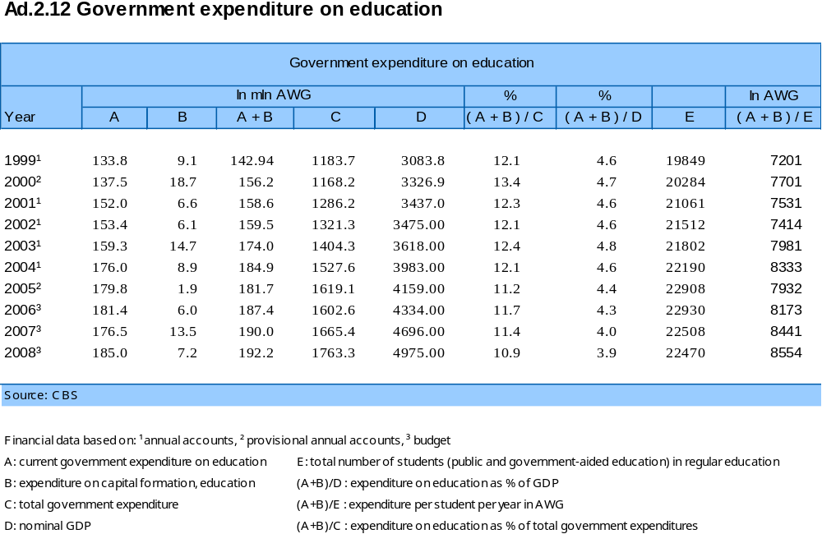

- The government provides after-school care for children in pre-primary and primary education in Aruba. Children from special schools are also admitted to places in regular after-school care. There is also a facility that provides special after-school care for children with learning disabilities.

- At present, education in Aruba is not compulsory. However, moves in this direction are far advanced, partly because of the obligations under article 14 of the International Covenant on Economic, Social and Cultural Rights and article 28 of the Convention on the Rights of the Child. School attendance is voluntary, and in this light ASER (Age Specific Enrolment Ratio) percentages are all the more encouraging (an average of 98% at age 4 and 5, 98% at age 6-11, and 91% at age 12-17 in 2008). The ASER shows the education participation rate of the population of a particular age. Source: CBS of Aruba, Research and Statistics section of the Education Department of Aruba, Regional Workshop on Education, Indicators in the Caribbean, Georgetown, Guyana, 13-17 March 1995.

- GER is the total enrolment in a specific level of education, regardless of age, expressed as a percentage of the official school-age population corresponding to the same level of education in a given school year (www.uis.unesco.org/i_pages/indspec/tecspe_ger.htm). It indicates the capacity of the education system to enrol students from a particular age group.

- GER (%)
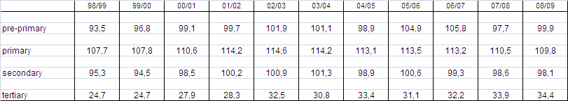

- The Aruban education system is modelled on the Dutch system. The total number of pupils in 2008 was 22,470, of whom 2,707 were in pre-primary education. Primary schools had 9,860 pupils, 524 of whom were receiving special primary education. In total 7,635 students were in secondary education, 2,013 of them in vocationally-oriented secondary education. In 2008 a total of 1,635 students participated in intermediate level vocational education and 633 in higher education. All these figures include enrolment at private schools.

Ad2.01 Enrolment by gender, Pre-primary education
School year
98/99
99/00
00/01
01/02
02/03
03/04
04/05
05/06
06/07
07/08
08/09
Male
1381
1460
1461
1493
1485
1408
1420
1522
1451
1373
1388
Female
1331
1349
1406
1394
1421
1428
1374
1458
1433
1340
1298
Pre-primary education, total
2712
2809
2867
2887
2906
2836
2794
2980
2884
2713
2686
Source: Department of Education, Statistical Yearbooks
Ad.2.02 Enrolment by gender, primary education
School year
98/99
99/00
00/01
01/02
02/03
03/04
04/05
05/06
06/07
07/08
08/09
BO/Incorporative ed., male
4,473
4,580
4,662
4,867
4,927
5,034
5,002
5,008
4,986
4,698
4,701
BO/Incorporative ed., female
4,332
4,406
4,502
4,672
4,668
4,733
4,804
4,909
4,857
4,813
4,635
BO/Incorporative ed., total
8,805
8,986
9,164
9,539
9,595
9,767
9,806
9,917
9,843
9,511
9,336
SO, male
179
181
184
204
221
225
250
275
311
327
354
SO, female
112
96
88
81
81
91
103
117
131
139
170
SO, total
291
277
272
285
302
316
353
392
442
466
524
Primary education, total
9,096
9,263
9,436
9,824
9,897
10,083
10,159
10,309
10,285
9,977
9,860
Source: Department of Education, Statistical Yearbooks
BasisOnderwijs
BO
primary education
Speciaal Onderwijs
SO
special education
Incorporative Education
special tracks for pupils who have not mastered the instructional language

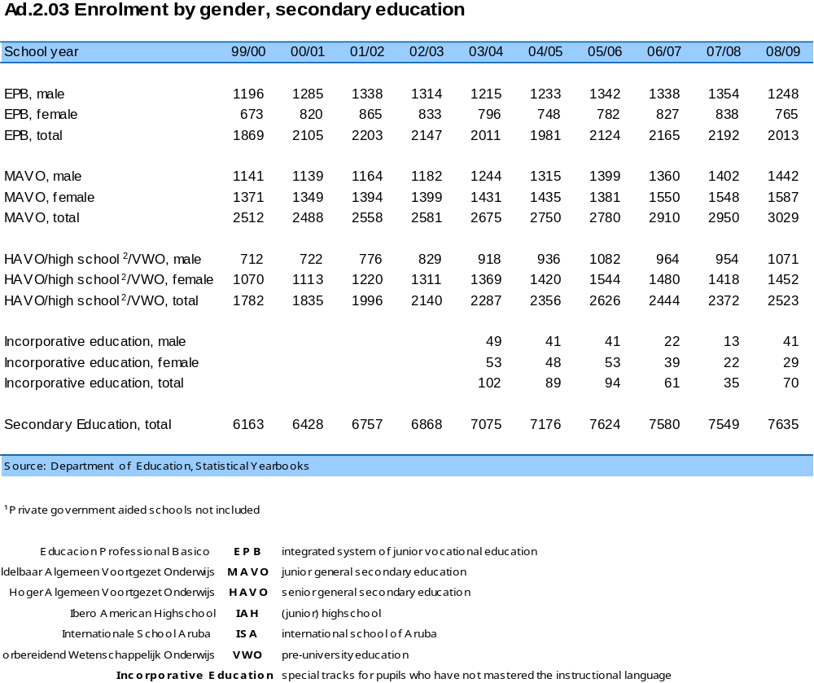

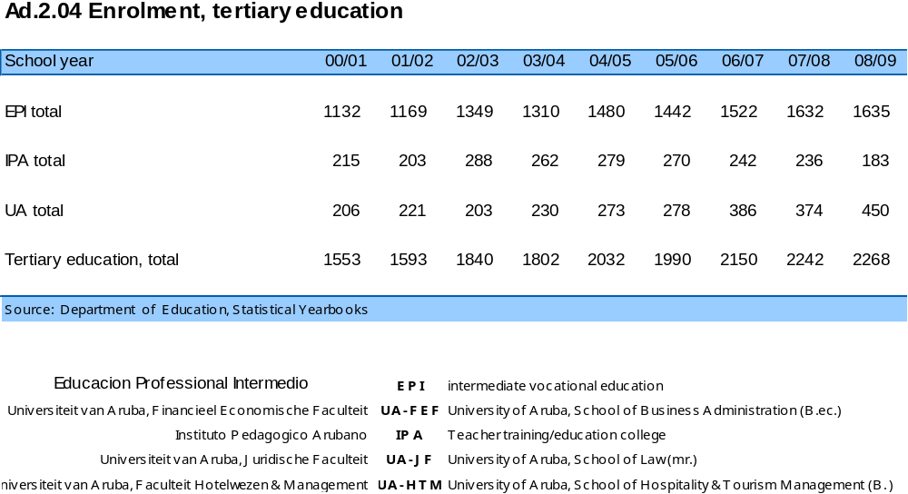

- The Government offers students financial support (loans) to enable them to continue their education. The total number of Arubans studying in the Netherlands is about five times higher than in any other foreign country. Since the range of subjects offered by higher education institutions in Aruba has expanded, students have had more options for remaining in Aruba to study. Both higher education institutions – the IPA and UA – are currently in the process of acquiring accreditation for their study programmes.

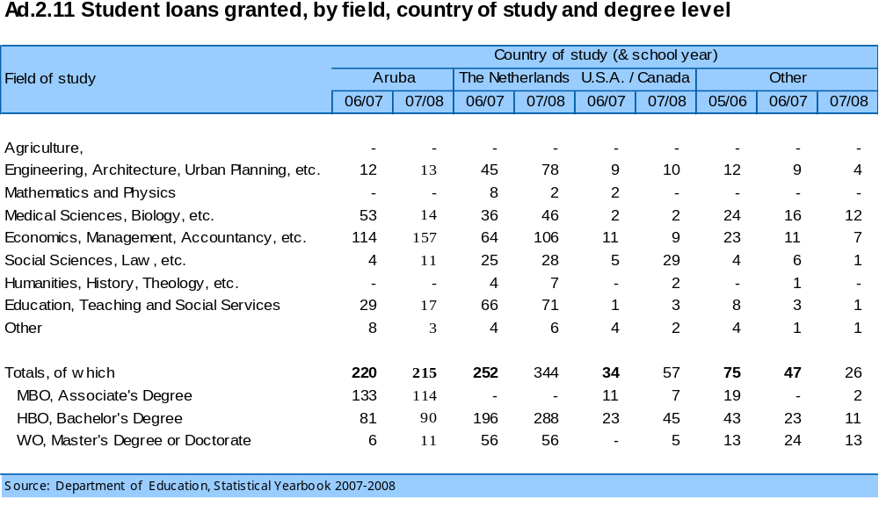
Number of loans granted in school year 2001 – 2007/2008 by country of study

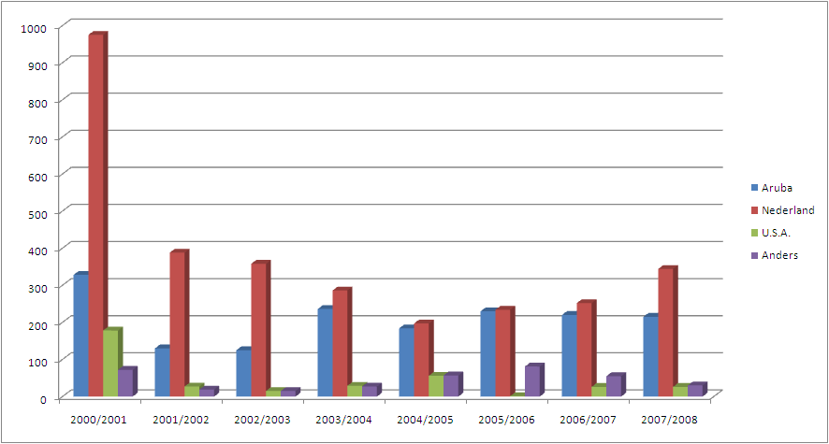
*Nederland is Netherlands, Anders is Others

- In the early 1990s the Prisma project was launched with the aim of familiarising non-Dutch speaking lateral students with the Dutch language as soon as possible to enable them to follow the regular school programme. Prisma started as a pilot programme at a public primary school and was later extended to all public primary schools in Aruba. Now the Prisma project is running in all primary schools, supporting all children who need help with the Dutch language, including Aruban children. A group of teachers attended special training for the programme.

- The 1999-2008 Strategic Plan for restructuring pre-primary, primary and special education includes a proposal to restructure language use in schools to reflect the current sociolinguistic situation in Aruba, where nearly 70% of the population have Papiamento as their mother tongue (Censo 2000), while still recognising the fact that Dutch is the language of instruction in secondary education and that this is likely to remain the case for some time to come. This has led to a proposal to introduce Papiamento as both a language of instruction and a school subject in primary education, retaining Dutch as the second language of instruction. The government approved introduction of Papiamento as a language of instruction up to and including 4th grade. The project started in two pilot schools and has so far been implemented in pre-primary education only. The biggest challenge in implementing the project in primary schools lies in the fact that the material/methods in Papiamento are not ready.

- Student population, by mother tongue – September 2008, Statistical Yearbook 2008-2009, Department of Education

 | Papiamento | Dutch | Spanish | English | Other | Total
EPB | 72% | 3% | 15.5% | 6.5% | 3% | 100%
MAVO | 68% | 6% | 15.5% | 8.5% | 2% | 100%
HAVO/VWO | 62% | 15% | 14% | 6% | 3% | 100%
TOTAL % | 67.5% | 8% | 15% | 7% | 2.5% | 100%
Total abs. | 4,964 | 596 | 1,105 | 516 | 188 | 7,369

- In adult education, policy focuses on making education more accessible, with the aim of raising the general level of education among the population, and introducing a culture of lifelong learning in Aruba. More investment in competences and education should allow Aruba to participate more successfully in the global economy.

- A strategic ten-year national education plan has been approved, highlighting problems and points of concern in the education system. Activities to tackle focus areas are now being developed.

Health Care

- Health care in Aruba is of a relatively high standard and is available to everyone. The Department of Public Health consists of several departments which provide mostly preventive health services. For example, the department of contagious diseases registers cases of such diseases as well as providing counselling and vaccinations. There are also departments for youth health care, information and education, the inspection of medical care, epidemiology and research, vector control, and sociopsychiatric services.

- Aruba has one hospital, the Dr Horacio Oduber Hospital, which is a private non-profit institution administered by a foundation. The hospital was built in 1970 and has a reputable staff and modern, sophisticated equipment. It is situated in the northwestern part of the island. The services provided by the hospital are: internal medicine, surgery, cardiology, urology, gynaecology and obstetrics, paediatrics, otorhinolaryngology, ophthalmology, neurology, neurosurgery, orthopaedics, dermatology, plastic surgery, oncology and psychiatry.

- The Dr Horacio Oduber Hospital is considered an average-size hospital, having 290 beds for inpatient care, plus 40 beds in its psychiatric ward. The outpatient care facilities provide consultation rooms for most of the specialists. It also offers haemodialysis and auxiliary facilities such as physiotherapy, wound care and radiology.

- The Dr Rudy Engelbrecht Medical Center is located in the southeast of Aruba. It is a central facility providing medical care for the residents of this part of the island, as well as prisoners at the ICN prison. The centre offers mainly primary care, as well as some secondary health care. The centre has an emergency room that operates 24 hours a day under the supervision of a general practitioner. However, most inpatient curative care is concentrated at Dr Horacio Oduber Hospital.

- There is also a Public Health Laboratory which is equipped with modern analytical instruments and a well-trained staff, including professionally qualified bio-analysts and laboratory specialists. The laboratory is enrolled in a number of external quality control programmes, including those run by the College of American Pathologists, the Centers for Disease Control (CDC), the Caribbean Epidemiological Center (CAREC) and the Dutch hospital laboratory quality control organisation SKML.

- The White and Yellow Cross Foundation provides home care primarily for elderly patients with chronic diseases such as diabetes. It also offers preventive healthcare services for newborns and toddlers including the National Vaccination Programme, in cooperation with the Department of Public Health. Other services include the activities of the Family Planning Foundation, the Red Cross and the Blood Bank Foundation.

- In May 1999 a UNAIDS Theme Group was established in Aruba. The principal objective of this group is to get more sectors involved in the strategy against HIV/AIDS. The group consists of several government departments, non-governmental organisations, and the private sector. The UNDP representative for Trinidad chairs the Theme Group.

Housing

- Due to the accelerated growth of the economy and the related influx of thousands of foreigners, there is currently still a great demand for rented accommodation. Numerous housing projects have been realised, alleviating the housing shortage to some extent.

- The number of households grew from 19,276 in 1991 to 29,246 in 2000. Although no actual data on the number of households are available, the Geographical Information System operated by the CBS indicated a total of 37,700 living units in June 2009. A large number of new houses have been built since 2000. Many homeowners have also decided to build apartments around their property. In 2009 5,971 households were living in an apartment, compared to 4,838 households in 2000.

- According to the Geographical Information System operated by the CBS, a total of 37,700 living units were occupied in June 2009. Most of them were ‘normal living units’, a total of 29,673 houses. 5,971 apartments were also occupied, as well as 185 cuartos and 923 trailers.

- Social housing on the island is coordinated by the ‘Fundacion Cas pa Comunidad Arubano’, the Community Housing Foundation (FCCA). In May 2010 approximately 4,548 individuals in 1,472 households were living in accommodation rented from the FCCA, including 21 studio apartments.

II. GENERAL POLITICAL STRUCTURE

Political History and Framework
- The present constitutional structure of the Kingdom of the Netherlands may be described as follows. Aruba is part of the Kingdom, which consists of three autonomous partners: the Netherlands, the Netherlands Antilles and Aruba. The relationship between the three Kingdom partners is stipulated in the Charter of the Kingdom of the Netherlands.

- Until 1986, Aruba formed part of the Netherlands Antilles. Although from 1951 onwards Aruba had its own island government within the political structure of the Netherlands Antilles, Aruba continued to strive for a greater say in internal matters. This struggle intensified in the early 1970s, culminating in a public referendum in March 1977, when the majority of Arubans opted for autonomy in the form of separation from the Netherlands Antilles. On 1 January 1986, an amendment to the Charter of the Kingdom of the Netherlands was passed, giving Aruba the autonomous status within the Kingdom of the Netherlands ("Status Aparte") to which it had long aspired.

- During the 1983 Round Table Conference, where agreement was reached on this separate status, the Netherlands urged that it be granted for a period of ten years, after which (i.e. in 1996) Aruba should become constitutionally independent. Article 62, paragraph one of the Constitution stated:
‘With regard to Aruba, the constitutional order laid down in the Charter shall end as of 1 January 1996’.

- From the outset, most Arubans resented this contentious condition, and Aruban politicians constantly expressed their rejection of what was perceived as an imposed independence. In 1990 Dutch policy was revised, with the Dutch government declaring its willingness to postpone Aruba's independence for an indefinite period. On 13 July 1990, the Minister for Netherlands Antillean and Aruban Affairs and the Aruban Prime Minister agreed that article 62 would be repealed and that both Caribbean countries (the Netherlands Antilles and Aruba) would retain the right to secede from the Kingdom.

- In 1993, the three Kingdom partners discussed the future status of the Kingdom at two conferences. With regard to Aruba, the parliaments of the Netherlands, the Netherlands Antilles and Aruba agreed to delete article 62 of the Kingdom Charter, which stated that Aruba would become independent as of 1 January 1996. In December 1994 a Kingdom Act was signed to this effect.

The Charter of the Kingdom of the Netherlands
- The Charter (‘Statuut’), the highest constitutional instrument of the Kingdom, is a legal document sui generis, based upon its voluntary acceptance by the three countries. It consists of five paragraphs. The first two paragraphs define the association between the three countries, which is federal in nature. The fact that the three countries together form one sovereign entity implies that a number of matters need to be administered jointly. These are called Kingdom affairs. They are enumerated in the Charter, and include the maintenance of independence, defence and foreign relations.

- The third paragraph deals with the relationship between the countries as autonomous entities. This partnership implies that the countries respect each other and give one another support and assistance, material or otherwise, and that they consult and coordinate in matters which are not Kingdom affairs but in which a reasonable degree of coordination is in the interest of the Kingdom as a whole.

- In accordance with article 3 of the Charter, foreign affairs (including the authority to conclude treaties with other States and/or organisations) are Kingdom affairs, and as such are dealt with by the Council of Ministers of the Kingdom. This Council consists of the Cabinet of the Netherlands, supplemented by a Minister Plenipotentiary each for Aruba and the Netherlands Antilles.

- It is also laid down in the Charter that each of the countries is responsible for promoting fundamental human rights and freedoms, but that the safeguarding of these rights is a Kingdom affair (article 43).

Type of Government

- Aruba's system of government is a parliamentary democracy. The head of State is the Queen of the Netherlands, represented by a Governor, who is appointed for a six-year period of office by the Queen upon the recommendation of the Aruban Council of Ministers.

- The Council of Ministers is accountable to a 21-member Parliament (‘Staten’) consisting of one House. Members of Parliament are chosen in general elections according to a system of proportional representation every four years, on the basis of a multi-party system. The Governor and the Council of Ministers jointly form the Government of Aruba.

Government
- The executive powers are vested in a Council of Ministers headed by the Prime Minister. The Ministers currently hold portfolios in 1. General Affairs, 2. Justice and Education, 3. Finance, Communication and Utilities 4. Public Health & Sport, 5. Integration, Infrastructure and Environment, 6. Economic Affairs, Social Affairs and Culture and 7. Tourism, Transportation and Labour. The Minister Plenipotentiary, residing in The Hague, represents Aruba's interests in the Netherlands.

Parliament
- The principal task of parliament is to enact legislation in cooperation with the government. Every national law has to be decided upon jointly by government and parliament. Apart from this co-legislative task, parliament supervises and monitors the government in order to ensure that the executive power functions properly.

Judiciary
- The judiciary is independent of the legislative and executive powers. Judges are appointed for life by the Crown. Since 1 January 1986, the organisation and composition of the judiciary in the Netherlands Antilles and Aruba have been regulated according to the same procedure. In both countries proceedings are conducted before the Court of First Instance, with scope for appeal to the Joint Court of Justice of the Netherlands Antilles and Aruba and for appeal in cassation to the Supreme Court in The Hague.

Advisory bodies
The Advisory Council plays an important part in the preparation of legislation. The Government submits every draft ordinance to the Advisory Council for its comments. Only after the Advisory Council has made its recommendations is the draft ordinance sent, together with these recommendations, to parliament.

- Apart from advising the Government on draft legislation, the Advisory Council can also make recommendations on its own initiative concerning matters related to its work. At the Government's request the Advisory Council can give advice on any matter, in which case the Government is obliged to give the Council all the relevant information.

- Besides the recommendations it receives from the Advisory Council, the Government also receives advice from the General Auditor and the Social and Economic Council. The reports of these three advisory bodies are public and are available to any citizen who wishes to consult them, unless this would be contrary to the national interest or the interests of the Kingdom.

III. GENERAL LEGAL FRAMEWORK WITHIN WHICH HUMAN RIGHTS ARE PROTECTED

- The main frame of reference for fundamental human rights (including civil and political rights) in Aruba is the Constitution (‘Staatsregeling’), Chapter I of which, and to some extent the other chapters (for example, article V.22 on sufficient employment and article V.23 on the provision of sufficient living accommodation) enshrine the most important basic human rights. The catalogue of rights is extensive and is based on international conventions such as the Universal Declaration of Human Rights, the European Social Charter, the International Covenant on Civil and Political Rights, the International Covenant on Social, Economic and Cultural Rights, the American Convention on Human Rights and the European Convention for the Protection of Human Rights and Fundamental Freedoms, in addition to the Constitution of the Netherlands and generally acknowledged principles of fundamental rights.

- In addition, since Aruba attained its current Status Aparte (autonomous status) in 1986, the relationship between the Netherlands Antilles and Aruba has been governed by the Cooperation Agreement (‘Samenwerkingsregeling’), article 3 of which directs the countries to incorporate human rights, as enshrined in the European Convention on Human Rights of 4 November 1950, into their legislation.

- Furthermore, Aruba is a party to the following human rights treaties and periodically submits reports in accordance with its obligations as defined in these treaties.
(a) International Covenant on Civil and Political Rights and Optional Protocol;
(b) International Covenant on Economic, Social and Cultural Rights;
(c) International Convention on the Elimination of all Forms of Racial Discrimination;
(d) Convention on the Elimination of All Forms of Discrimination against Women and Optional Protocol;
(e) Convention against Torture and Other Cruel, Inhuman or Degrading Treatment or Punishment;
(f) Convention on the Rights of the Child;
(g) European Convention for the Protection of Human Rights and Fundamental Freedoms and Protocols;
(h) European Convention for the Prevention of Torture and Inhuman or Degrading Treatment or Punishment;
(i) European Social Charter.

- Article 14 of the Charter of the Kingdom of the Netherlands implies that the articles dealing with Kingdom affairs in the Dutch Constitution also apply to Aruba. Thus the articles of the Dutch Constitution which stipulate the order of precedence of international conventions and national guidelines also apply to the constitutional order of Aruba. The provisions of these articles solve the problems which arise should the application of provisions of a convention or decision by a human rights organisation, which are binding on each individual, conflict with the statutory provisions of the country concerned. In such cases the provision of the convention or of the human rights organisation take precedence over domestic statutory provisions. The words ‘binding on each individual’ are of crucial relevance.

- As of 1 January 2002 the New Civil Code entered into force for Aruba. With the introduction of Book 1 of the New Aruban Civil Code the old law of persons and family law was replaced. The revision of this law has abolished a large number of discriminatory provisions. The radical modernisation of the law of persons and family law is the result of the human rights instruments concluded over the last 50 years, especially the European Convention for the Protection of Human Rights and Fundamental Freedoms and the International Covenant on Civil and Political Rights. Developments in society also made it necessary to revise the legislation, which dated from 1869. As regards the interpretation of the European Convention for the Protection of Human Rights and Fundamental Freedoms, the rulings of the European Court of Human Rights are binding on Aruba.

- The principles of a fair and public hearing are enshrined in the Constitution and in other regulations. The equality of all persons before the law is expressed in statutory regulations on procedural law. All parties in legal proceedings, whether these are criminal, civil or administrative proceedings, have the same rights and obligations. Statutory provisions provide for free legal counsel for residents who have an income from employment that is equal to, or less than, the statutory minimum wage. Aliens who are not residents of Aruba but who fulfil the other requirements of this law are also eligible for free legal assistance.

- Many statutory regulations provide for the right of appeal against certain decisions by administrative bodies. Public servants can appeal to the Public Servants' Tribunal. The courts involved are independent and impartial. In a number of cases, the Governor or a Minister acts as an administrative appeal body. Partly as a result of the judgment of the European Court of Human Rights of 23 October 1985 (Benthem), which ruled that appeal to the Crown, in Aruba represented by the Governor, may not be regarded as independent and impartial justice, preparations were made to introduce a law of administrative procedure under which all exceptional appeal and objection procedures are to be replaced by one administrative procedure. Under this system, appeal may be lodged with a court of first instance against any decision by an administrative body that has legal consequences, provided an obligatory objection procedure has first been completed. It should be noted that since its introduction many citizens have had recourse to this procedure.

- In those cases which are not provided for in the above-mentioned legislation, the individual may initiate civil proceedings on the grounds of tort on the part of the government (article 6:162 of the New Civil Code of Aruba). Such proceedings are conducted before the Court of First Instance, with scope for appeal to the Joint Court of Justice of the Netherlands Antilles and Aruba and appeal in cassation to the Supreme Court in The Hague.

- The New Code of Criminal Procedure entered into force for Aruba in 1997. This was a milestone in the history of Aruba’s criminal law system. As a consequence, the general system regarding the manner in which the powers of control of the Government are used was revisited and harmonised, thus establishing a clear new system. The New Code provides fundamental safeguards against unlawful action by the authorities. The application of coercive measures to a suspect has been made subject to precise rules. Very importantly, provision is made in many places for the assignment of defence counsel. If necessary, the assistance of counsel may be provided free of charge under a legal aid order. This means that from the moment of initial contact with the criminal justice authorities a suspect can be assisted by a lawyer who monitors the lawfulness of the treatment accorded to the suspect in the course of the criminal proceedings and can apply to the court in the event of any irregularities. This provides a strong safeguard against arbitrary and unlawful action by the authorities.

- The introduction of the New Code of Criminal Procedure has also strengthened the victim’s position. An injured party may join criminal proceedings at first instance, provided certain conditions are met (e.g. for a claim not exceeding AWG 50,000 and not yet submitted to the civil courts). A victim may register as an injured party even during the preliminary phase of the proceedings. If an injured party indicates that he/she will claim compensation or wishes to be informed about the progress of proceedings, mention of this should be made in the official report. If the injured party requires help and support, the necessary assistance must be provided. The police and Public Prosecutor have a duty to help victims obtain any assistance or support they may require.

- When an interested party as defined in the Aruban Code of Criminal Procedure believes that there has been a failure to prosecute after a criminal offence has been committed, he may complain to a court of justice (article 15 of the New Code of Criminal Procedure). If the court reaches the same conclusion as the complainant, it may instruct the relevant official at the Public Prosecution Service, after having received the official's report on the matter, to institute, or order the institution of, criminal proceedings, or to expedite existing criminal proceedings.

- Complaints about the alleged misconduct of public officials are investigated by the Public Prosecution Service. Its head, the Attorney-General, is empowered to issue to officials in charge of the police whatever instructions for the prevention of indictable or non-indictable offences he may deem necessary in the interest of the proper dispensation of justice. The National Bureau of Criminal Investigation conducts criminal investigations into the alleged misconduct of public officials in general and police officers in particular. The Bureau is subject to the authority of the Attorney- General and is directly accountable to him; it thus operates independently of the police.

- Victims of ill-treatment by a government official may seek compensation along a variety of routes. If the official concerned is prosecuted under criminal law, the New Code of Criminal Procedure offers the victim the possibility of joining the criminal proceedings. If the victim wishes to receive a larger sum in compensation, he can present his claim before a civil court. By invoking article 6:162 of Aruba's New Civil Code, he may hold either the official concerned or the State of Aruba liable for material or non-material damage suffered.

- In 1999, a National Ordinance on public information was passed by parliament, providing every citizen with the right to request and receive information that the Government used to reach certain decisions or prepare legal measures. The Government has an obligation to provide this information. The information may be withheld only in certain cases for reasons of public safety and national security, as well as the prosecution of criminal offences. In such a case, however, the citizen has the right to go to court to oblige the Government to comply with the principle of public information if the initial refusal is found to be unlawful.

IV. INFORMATION AND PUBLICITY

- In connection with the various human rights reports that Aruba is obliged to draw up at periodic intervals, a suitable structure had to be devised for procuring the necessary information from government bodies. To this end, an Aruban human rights committee was appointed in 1991, its members drawn from government bodies and NGOs, which together provide the material for the reports.

- The institution of a human rights committee had two beneficial effects: firstly, it designated certain persons as permanent liaison officers, and secondly, it raised awareness of the existence and importance of human rights within the relevant government bodies.

- By decision of the Council of Ministers of 29 September 1993, the human rights committee was given a formal basis, and has the following tasks:
1. To advise the government on human rights issues;
2. To comply with reporting obligations in pursuance of international human rights conventions;
3. To promote general awareness among the public regarding human rights.

- Informing the public about human rights is one of the tasks of the human rights committee. This has given rise, among other things, to workshops, lectures in schools and an art exhibition marking the anniversary of the Universal Declaration in 1998. In addition, booklets have been published on the Universal Declaration and a drawing competition was organised for primary schools in Aruba. Booklets have also been published on the Convention on the Elimination of All Forms of Discrimination against Women and the Convention on the Rights of the Child.

- The Convention on the Rights of the Child entered into force for the Kingdom of the Netherlands with respect to Aruba on 17 January 2001. A committee consisting of representatives of both governmental and non-governmental organisations was established by Ministerial Decree of the Prime Minister of 12 April 2001. In addition to making periodic reports to the UN, and advising the government the Committee also has the task of promoting general public awareness of children’s rights in Aruba.

- The Committee on the Rights of the Child intends to fulfil this promotional task primarily by supporting and encouraging existing initiatives by NGOs and government agencies. The Convention on the Rights of the Child will be translated into explanatory materials of varying levels of difficulty in the national language, Papiamento, and in Dutch, English and Spanish. The realisation of these activities depends, of course, on the availability of adequate resources. The committee will also have to ensure that its reports are circulated and publicised within Aruba.

- Long before the ratification of the Convention on the Rights of the Child a range of governmental and non-governmental organisations were organising activities and drawing attention to the Declaration and the Convention on the Rights of the Child. In 1994, the government responded to calls from the Children Foundation to designate 20 November National Children’s Day. The aim behind this initiative is to raise public awareness of children’s rights in Aruba. Every year since then, on and around this day NGOs, the media and the government have drawn attention to children’s rights.

- In October 2002, as part of the Year of the Child and prompted by the participation of Aruba in the UN Children’s Summit, the youth affairs section of the Social Affairs Department organised a youth forum entitled ‘My Rights’. The forum was centred on youth participation and the right of young people to express an opinion on matters directly affecting them. During the forum the young people considered the government’s plan to establish a Youth Parliament and had the opportunity to present proposals on observance of the rights of the child in the national parliament.

- The Department of Foreign Affairs is currently preparing to launch a website which will make it possible to publish information on human rights issues, including the reports of Aruba and the recommendations of the international committees.

AnnexE I: Constitution of Aruba

AnnexE II: aruban Education system

The Aruban education system currently offers the following types of education:
- Pre-school education for the 0-3 age group
- Pre-primary education for the 4-5 age group
- Primary education for the 6-11 age group

Besides regular primary education, Aruba also has:
- Special education, divided into:
- education for children with learning difficulties (MLK)
- education for children with severe learning difficulties (ZMLK)
- education for hearing impaired children

- Secondary education (AVO/LBO) for the 12-15 to 17 age group, divided into:
- educacion profesional basico (EPB) (junior vocational education) with a basic cycle and a vocational cycle, as well as a preparatory vocational cycle, divided into:
- technology sector (T)
- economics sector (E)
- care sector (V)
- junior general secondary education (MAVO)
- senior general secondary education (HAVO)
- pre-university education (VWO)

- Post-secondary education (MBO/HBO/WO) for those over 15 to 17, divided into:
- educacion profesional intermedio (EPI) (intermediate vocational education)
  - Ciencia & Tecnología (Science and Technology) unit (CT)
  - Salubridad & Servicio (Health and Services) unit (SS)
  - Hospitalidad & Turismo (Hospitality and Tourism) unit (HT)
  - Economico (Economics) unit (E)
- teacher training (IPA)
- the University of Aruba, which offers the following:
  - FdR: Faculteit der Rechtsgeleerdheid (Faculty of Law)
Programmes: Bachelor’s and Master’s in Aruban law
  - FEF: Financieel Economische Faculteit (Faculty of Finance and Economics)
Programmes: Bachelor’s in Business Economics and Bachelor’s in Commercial Economics
  - FHTSM: Faculty of Hospitality & Tourism Management Studies
Programmes: Bachelor’s in International Tourism Management and Master’s in International Tourism & Business
  - FAS: Faculty of Arts and Science
Programmes: Bachelor’s in Organisation, Governance & Management
Bachelor’s in Social Work & Development and Master’s in Social Work & Development
  - Graduate school

- Adult education for school leavers aged 15 and over

Diagram of Aruban education system

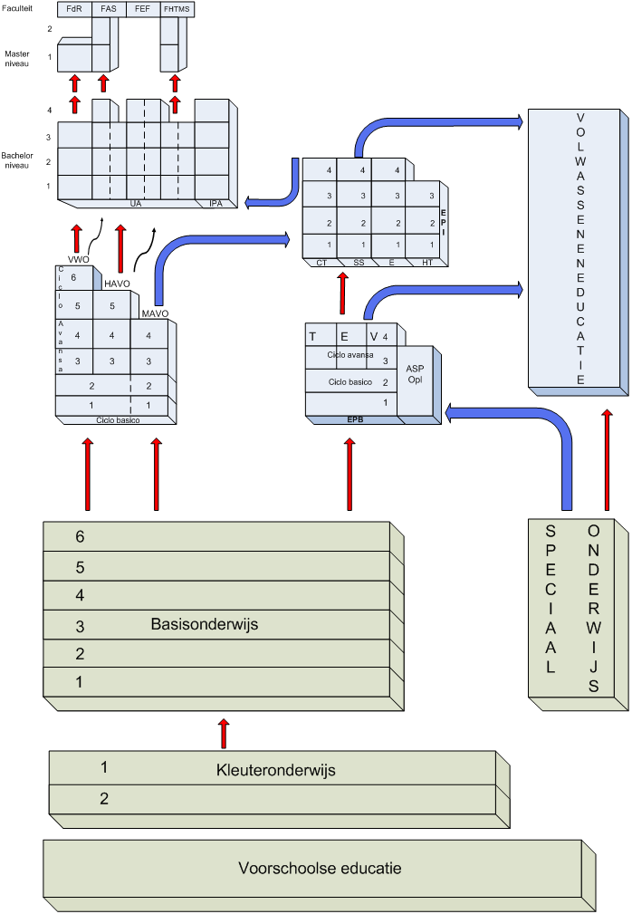
Faculteit = Faculty
Master niveau = Master’s
Bachelor niveau = Bachelor’s
Volwasseneneducatie = Adult education
Basisonderwijs = Primary education
Kleuteronderwijs = Pre-primary education
Voorschoolse educatie = Pre-school education
Speciaal onderwijs = Special education

